ENGLISH AS A ‘LINGUA FRANCA’

- WHY STUDY ENGLISH, AND MORE SPECIFICALLY BUSINESS ENGLISH?

ENG -> English as a Lingua Franca (Global Language)

ENGLISH AS A LINGUA FRANCA = a 3rd language used for communication between foreign speakers
ALSO CALLED -> ‘’Common Language’’
-> ‘’Bridge Language’’
-> ‘’Link Language’’
-> ‘’Vehicular Language’’

Previous ELFs
In ancient times, other languages have served as ‘global languages:
- Aramaic [Western Asia, 8th century BC],
- Sanskrit [Ancient and Medieval India],
- Koine Greek, the official language of the Byzantine Empire, so this kind of Greek was sth between Ancient Greek and the modern Greek we use today,
- Latin.

In the modern world,
some other lingua francas are: English, Spanish, French, German, Arabic, Portuguese, Chinese and Swahili, whose speakers are spread in over 14 countries in South East Africa.

‘’Three circle model of World Englishes’’
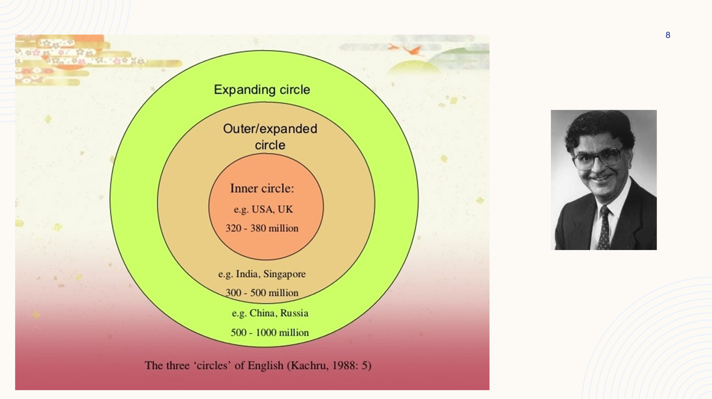

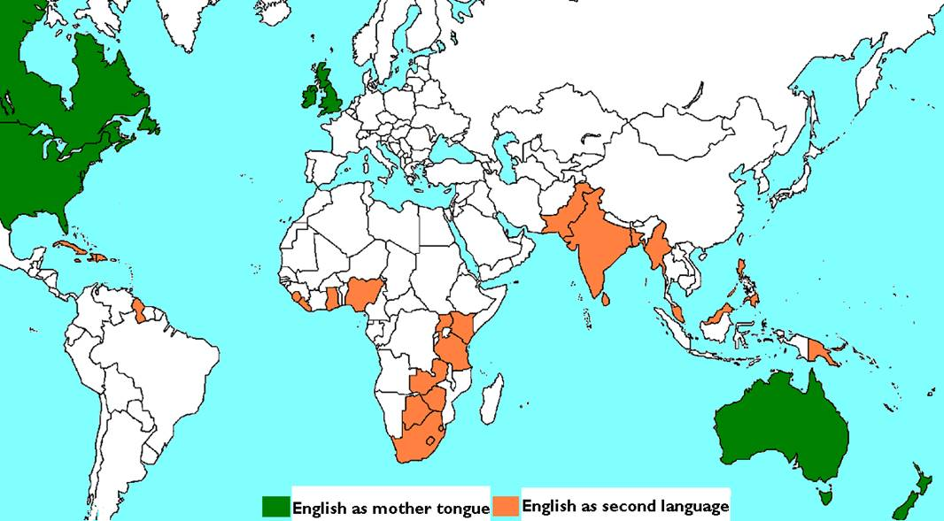

Πηγή: https://courses.nus.edu.sg/course/elltankw/history/global.htm

1st KWL CHART

TOPIC / TERM | I KNOW | I WANT TO KNOW | I [THINK] I’VE LEARNT
Gen Eng
EAP
ESP

General English -> Everyday use of language

EAP -> not ‘ELF IS…’ but ‘ELF REFERS TO’, Skimming/Scanning Scientific Articles [Skimming is reading rapidly in order to get a general overview of the material. Scanning is reading rapidly in order to find specific facts.], Bibliography, Plagiarism, Paraphrasing, Note taking techniques, Google scholar, (HIF Impact Factor), Abbreviations (eg – example given)

ESP -> (Medical, Economic, Tourism, Scientific, …) Terminology, E-mails, Memos, Interviews, CVs, Cover Letters, Linkedin, etc.

ENGLISH CERTIFICATES (ΑΣΕΠ)

LEVEL MICHIG LRN MSU PTE KPG CAMB NOCN
C2 ECPE C2 MSU-CELP LEVEL 5 Γ2 CPE LEVEL3
C1 ALCE C1 - LEVEL 4 Γ1 CAE LEVEL2
B2 ECCE B2 MSU-CELC LEVEL 3 Β2 FCE LEVEL1
B1 BCCE B1 Β1
A2 Α2
A1 Α1

LEVEL TIE ESB TOEIC EDI BULATS IELTS
C2 C2 LEVEL3 - LEVEL3 90-100 8.5-9
C1 C1 LEVEL2 785-900 LEVEL2 75-89 7-8
B2 B2 LEVEL1 505-780 LEVEL1 60-74 5.5-6.5
B1 B1
A2 A2
A1 A1

- IELTS – Ισχύ για 2 έτη.
- Υπόλοιπα, αναγνωρίζονται στο εξωτερικό μόνο κατά τη διακριτική τους ευχέρεια, και να τα έχουμε λάβει πρόσφατα.

QUALIFICATION LEVELS

QUALIFICATION LEVELS
Level 8 | Qualifications are:  - Doctorate (PhD)
Level 8 | To apply for a Level 8 qualification, you need: Level 6-7 qualification
Level 7 | Qualifications are:  - MA ie, Master’s Degree in Arts  - MSc ie, Master’s Degree in Science or equivalent
Level 7 | To apply for a Level 7 qualification, you need: Level 5-6 qualification
Level 6 | Qualifications are:  - BA (Hons) ie, Bachelor of Arts Degree  - BSc (Hons) ie, Bachelor of Science Degree
Level 6 | To apply for a Level 6 qualification, you need: Level 3-5 qualification
Level 5 | Qualifications are:  - NVQ 5  - Diploma of Higher Education (= second year at university)  - Foundation Degree  - Higher National Diploma
Level 5 | To apply for a Level 5 qualification, you need: Level 3-4 qualification
Level 4 | Qualifications are:  - NVQ 4  - Certificate of Higher Education (= first year at university)
Level 4 | To apply for a Level 4 qualification, you need: Level 3 qualification
Level 3 | Qualifications are:  - NVQ 3  - A levels  - International Baccalaureate  - BTEC National Certificate/Diploma  - Advanced Diploma  - Advanced Apprenticeship  - Access to HE course (adults)
Level 3 | To apply for a Level 3 qualification, you usually need: 4-5 GCSEs at grade A*-C. It is possible to apply with Level 2 qualifications such as: GNVQ Intermediate (Merit) or BTEC First Diploma (Merit).
Level ? | Not sure of your qualifications or experience?
Level ? | If you are unsure where you fit into the levels shown then please contact the Information and Guidance Unit for assistance on 01227 768896.

