Needs & Wants

Role of business in society
A business is an organisation that makes, buys or sells goods or provides a service. All businesses aim to satisfy consumer needs and wants.

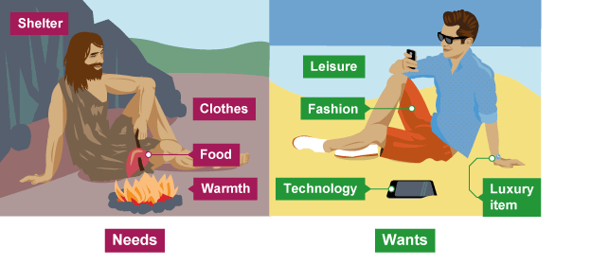

Needs are the basic requirements that are essential for survival such as food, water, clothing, shelter and warmth.
Wants are things we would like to have but don’t need to survive. These include luxuries such as mobile phones or holidays.
For a business to survive, it needs to satisfy the needs and wants of the consumer. Business can satisfy needs and wants by providing goods and services to the consumer.
Goods are products that you can see and touch (tangible) such as laptops, clothes or food.
Services are products that you cannot hold or touch (intangible) such as public transport, a haircut or a visit to the cinema.

For a business to be able to provide goods and services it will need to combine a variety of resources. These are known as the factors of production [παραγωγικοί συντελεστές].
Factors of production are the resources people use to produce goods and services; they are the building blocks of the economy. Economists divide the factors of production into four categories: land, labour, capital, and entrepreneurship [επιχειρηματικότητα].

Source: https://www.bbc.co.uk/bitesize/guides/zmx47nb/revision/1

