PESTLE ANALYSIS –
ADVANTAGES AND DISADVANTAGES OF A PESTLE ANALYSIS

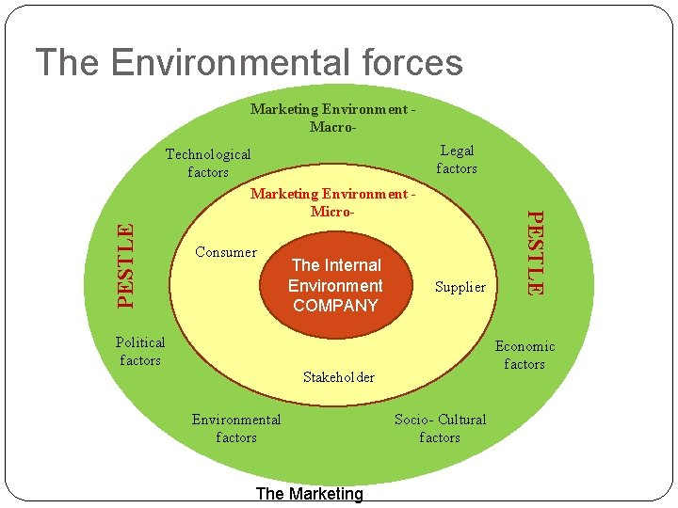

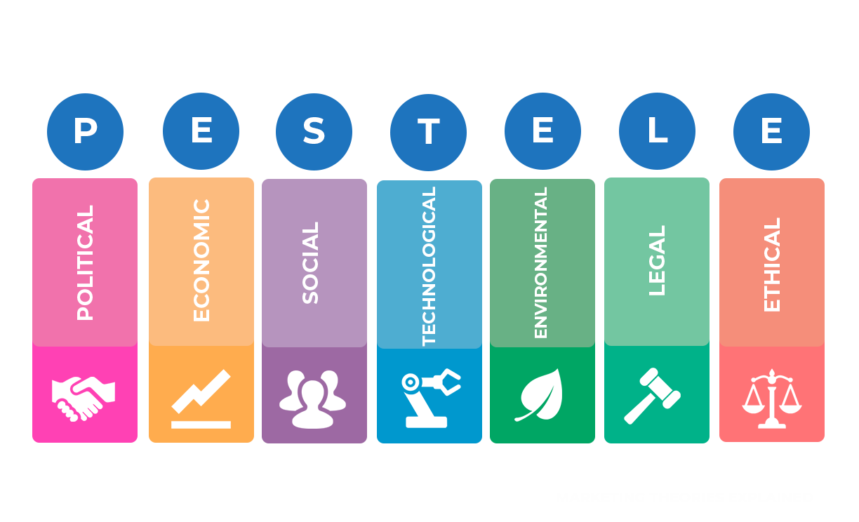
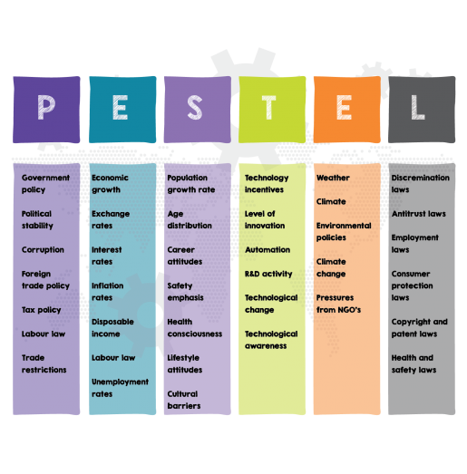

VIDEO
https://www.youtube.com/watch?v=bYn4CyL3r5w (pestle explained)
https://www.youtube.com/watch?v=z7dmIiCUrJg&t=1s (Mc Donalds)
https://www.youtube.com/watch?v=BO0FlrveCts (why Netflix struggles in India)
https://www.youtube.com/watch?v=GFVKKTwkANY (pestle explained)
https://www.youtube.com/watch?v=z7dmIiCUrJg https://www.youtube.com/watch?v=TCIyMUQatYU (How politics affect business) …………………………………………………………………………………………………………………………………………………………

Advantages and disadvantages of a PESTLE analysis
Advantages:
- It’s a simple framework.
- It facilitates an understanding of the wider business environment.
- It encourages the development of external and strategic thinking.
- It can enable an organisation to anticipate future business threats and take action to avoid or minimise their impact.
- It can enable an organisation to spot business opportunities and exploit them fully.
Disadvantages:
- Some PESTLE analysis users oversimplify the amount of data used for decisions – it’s easy to use insufficient data.
- The risk of capturing too much data may lead to ‘paralysis by analysis’.
- The data used may be based on assumptions that later prove to be unfounded.
- The pace of change makes it increasingly difficult to anticipate developments that may affect an organisation in the future.
- To be effective, the process needs to be repeated on a regular basis.

Source: https://www.cipd.co.uk/knowledge/strategy/organisationaldevelopment/pestle-analysis-factsheet#gref

