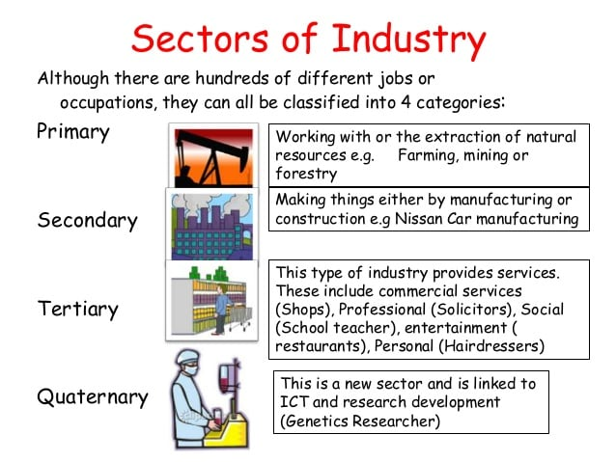

ICT – Information and Communications Technology
Source: http://geoigcsewiki.blogspot.com/2016/04/unit-6-economic-development-and-its_49.html

Role of business in society
A business aims to satisfy customers’ needs and wants. Businesses operate in the private, public or third sectors of the economy and in the primary, secondary, tertiary or quaternary sectors of industry.

Sectors of industry
The main sectors of industry in which a company can operate are:
- primary
- secondary
- tertiary
- quaternary /kwate’rneri:/

Primary
The primary sector of industry is concerned with the extraction of raw materials or natural resources from the land. Any business that grows goods or extracts materials from the land would be classed as a primary sector business.
Examples of businesses that operate in the primary sector would be farming, mining, fishing or oil production.
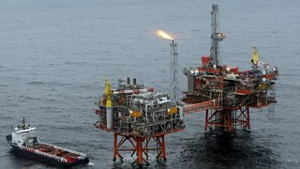

Secondary
The secondary sector of industry is concerned with manufacturing. This would involve taking the raw materials from the primary sector and converting them into new products.
Examples of businesses that operate in the secondary sector would be car manufacturers, food production or building companies.
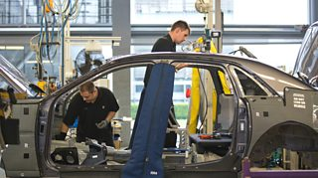
Workers at a car assembly plant

Tertiary
The tertiary sector of industry is concerned with providing a service. Services are activities that are done by people or businesses for consumers.
Examples of businesses that operate in the tertiary sector would be doctors, teachers, lawyers, accountants, doctors, travel agents, policemen, hairdressers, banks, mechanic or plumber services, supermarkets or cinemas.

Hairdressing is a service in the tertiary sector
- Quaternary /kwate’rneri:/
The quaternary sector consists of those industries providing information services, such as computing, ICT (information and communication technologies), consultancy (offering advice to businesses) and R&D (research, particularly in scientific fields).
The quaternary sector is sometimes included with the tertiary sector, as they are both service sectors. The tertiary and quaternary sectors make up the largest part of the UK economy, employing 76 per cent of the workforce.


R&D (research, particularly in scientific fields) is a service in the quaternary sector.

R&D = Research and Development

Source: https://www.bbc.co.uk/bitesize/guides/zmx47nb/revision/2

