BUSINESS ENGLISH II

Which belongs to ESP (Specific Purposes) / EPP (Professional Purposes) / EAP (Academic Purposes)?

• Public Speaking (Presentations)
• English for Tourism
• Articles
• Emails / Netiquette
• Intercultural Business Communication
• English for Business Contexts
• Journals
• LinkedIn
• Note-taking methods
• Europass CV
• Interviews

……………………………………………………………………………………………….

- English for Specific Purposes (ESP)
Εξειδικευμένη ορολογία για συγκεκριμένο κλάδο (industry-specific language).
- English for Business Contexts
- English for Tourism

- English for Professional Purposes (EPP)
Αγγλικά για εργασία & επαγγελματικό περιβάλλον [καριέρα, επαγγελματική επικοινωνία, business skills]
- LinkedIn
- Interviews
- Europass CV
- Emails / Netiquette
- Public Speaking (Presentations)
- Intercultural Business Communication
3. English for Academic Purposes (EAP)
Αγγλικά για το Πανεπιστήμιο (κατανόηση άρθρων και γρήγορη ανάγνωση)
- Note-taking methods
- Articles
- Journals

…………………………………………………………………………………………….
QUICK REVISION

SECTORS OF ECONOMY

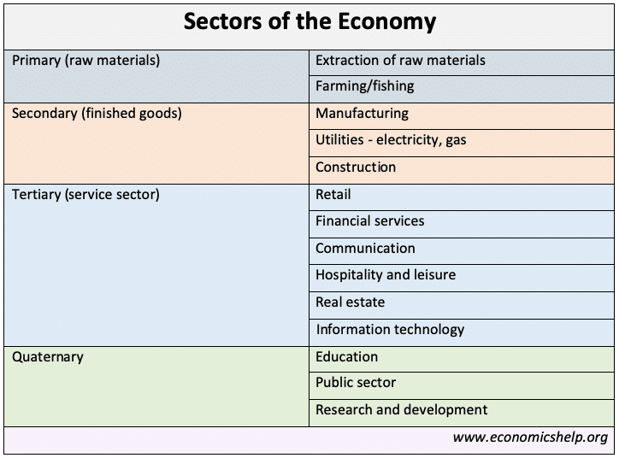

SECTORS CHALLENGE — Real Companies

Match the Company to the Sector
A. Primary Sector (raw materials)
B. Secondary Sector (manufacturing/production)
C. Tertiary Sector (services)
D. Quaternary Sector (knowledge/technology/research)

- Shell — oil extraction → ______
- Tesla — electric car production → ______
- Hilton Hotels — accommodation services → ______
- Google — data and information services → ______
- Microsoft — software development → ______
- Nestlé — food production → ______
- Local farm producing vegetables → ______
- University research lab → ______
- Amazon Web Services — cloud computing → ______
- Fishing company → ______

Discussion Question

Can one company belong to more than one sector? Give an example.

ANSWER
Yes, one company can belong to more than one sector, because large companies perform different types of activities.

Examples:
- Amazon
  - Tertiary → retail and delivery services
  - Quaternary → cloud computing (Amazon Web Services)
- Tesla
  - Secondary → manufacturing cars
  - Quaternary → research and innovation in battery technology and AI
- Shell
  - Primary → oil extraction
  - Secondary → refining petroleum products
Many modern companies operate across sectors, especially large global businesses.
………………………………………………………………………………………………………………………….

MICROECONOMICS - MACROECONOMICS
- Micro = individual markets, firms, consumers
- Macro = whole economy (inflation, GDP, unemployment)

MICRO vs MACRO — Business Owner Game

👉 “You are business owners. You have problems.
Decide: Is the problem MICRO or MACRO?”
MICRO = internal / close environment / controllable
MACRO = external / big environment / not controllable

Situations: WHY?
- A competitor opens next door.
- Coffee prices increase worldwide.
- Customers complain about your service.
- The government introduces new hygiene laws.
- Economic recession reduces demand.

ANSWERS
1️⃣ competitor opens → MICRO (close environment)
2️⃣ global price increase → MACRO (global economy)
3️⃣ service complaints → MICRO (internal problem)
4️⃣ new law → MACRO (government)
5️⃣ recession → MACRO (economy)

Extension
👉 Which problems can you control?
👉 Which cannot you control?

SO,
I need to understand micro factors because these are the day-to-day decisions that directly affect my business.
Examples:
- How much to charge for a product
- How many workers to hire
- How much to produce
These decisions affect the profit and survival of my business.
At the same time, I, as a business owner must also understand macro factors because the national and global economy influences my future success.
Examples:
- If inflation (πληθωρισμός) rises → costs increase
- If unemployment (ανεργία) is high → customers may buy less
- If interest rates (επιτόκιο) go up → loans (δάνεια) become more expensive
So:
Micro = internal business decisions
Macro = external environment and big-picture trends (τάσεις)

…………………………………………………………………………………….

Business Management/Departments, Units

Operations | Marketing | HR | Finance | Research &  Development  R&D
-production processes  and methods  -ordering and storing  raw materials | -consumer needs  -market research  -prices  -advertising | -hiring and firing  -contracts  -promotion  -health and safety  -industrial relations  -equal pay | -flow of money  -business performance | -developing new products

INPUT – TRANSFORMATION – OUTPUT

INPUT  [Factors of Production/Συντελεστές παραγωγής] |  | OUTPUT
1.Enterpreneurship (επιχειρηματικότητα, setting up a business) / Planning:  -carry out some market research  -make a business plan  -learn about regulations and hygiene  -design the items and the process  2. Capital  -find the money to start a business  3. Land / Premises  -buy or rent a suitable building  -rearrange the building to suit the business  -invest in equipment and machinery  -buy and store the raw materials  4. Labour / Training  -hire the necessary personnel  -train the staff to help make and sell the food | TRANSFORMATION | Goods (tangible, i.e. that we can touch)  Durable [Διαρκή]  furniture, cars, bicycles, computers, televisions, land  (i.e., they last a long time)  Non-durable [Καταναλωτά]  food, drinks, newspapers, petrol, paper products, cleaning products,  cigarettes  (i.e., they are consumed soon after purchase)  Services (intangible, i.e. that we cannot touch)  Insurance  Repairs  Downloadable music  Mobile apps

……………………………………………………………………………………………………………………………….

TYPES OF ENTERPRISES

PERSONAL ENTERPRISES / ΠΡΟΣΩΠΙΚΈΣ
SOLE  PROPRIETORSHIP  (ατομική επιχείρηση)  1 owner → personal capital → unlimited liability | PARTNERSHIP  (Εταιρεία)  2+ owners → shared capital → often unlimited liability
 | General Partnership  (Ομόρρυθμη εταιρεία Ο.Ε.) | Limited Partnership  (Ετερόρρυθμη εταιρεία Ε.Ε.)

CAPITAL ENTERPRISES / ΚΕΦΑΛΑΙΟΥΧΙΚΈΣ ΕΤΑΙΡΕΊΕΣ
LIMITED LIABILITY COMPANY (LLC)  (Εταιρεία Περιορισμένης Ευθύνης)  shareholders → shares/investors → limited liability | ‘’ΙΚΕ’’ [GR]  (Ιδιωτική Κεφαλαιουχική Εταιρείας) | CORPORATION (S.A.)  (Ανώνυμη Εταιρεία)

SOCIAL ENTERPRISES / ΚΟΙΝΩΝΙΚΕΣ ΕΤΑΙΡΕΙΕΣ
NON-PROFIT  (Μη κερδοσκοπική εταιρεία)  mission-based → reinvest revenue → social sector | START - UP  (Νεοφυής εταιρεία)  innovation → growth-oriented → flexible structure | COOPERATIVE (COOP)  (Συνεταιρισμός)  member-owned → democratic → shared benefit

…………………………………………………………………………………………………………

Micro and Macro Environment of a Business

QUESTION: You open a coffee shop. What can affect your business?
“Tell me anything.”
[To write on board, in 2 columns]

QUESTION 2: Which of these can you control?

QUESTION 3: Which cannot you control?

Every business is affected by two types of environment:
- the micro environment -> things close to the business
- the macro environment -> big external forces

- Micro Environment -> the immediate environment of the business.
It includes:
- customers
- suppliers
- competitors
- employees
✔ it directly affects the operation of the business
✔ there is some degree of control or direct interaction

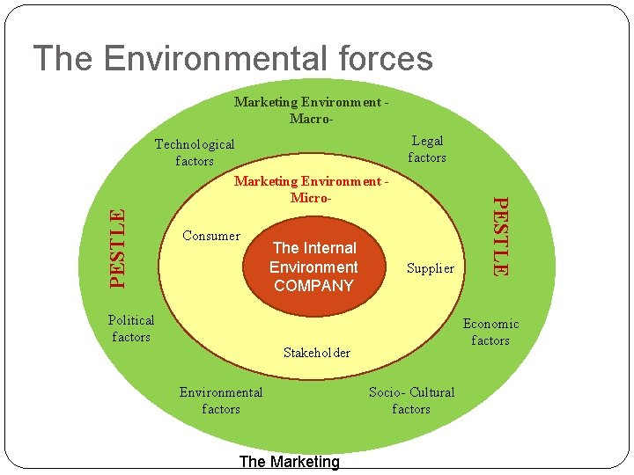

Examples:

Competitors
A nearby café reduces the price of coffee from €3 to €2 → the business must change its prices or its offer.
✔ direct impact
✔ close environment → micro

  - Suppliers
The flour supplier delays the delivery → the bakery cannot produce bread.
✔ directly affects production
✔ direct relationship with the business

  - Customers
Customers start demanding vegan products → the business changes its menu.
✔ direct change in operations
✔ direct interaction with the business
Micro environment = πελάτες, προμηθευτές και ανταγωνιστές που επηρεάζουν άμεσα τις καθημερινές αποφάσεις της επιχείρησης.

B. Macro Environment -> refers to the major external forces of the economy and society.
It includes:
- the economy (inflation, unemployment)
- laws and government
- technology
- social trends
- the environment
✔ the business cannot control these factors
✔ it must adapt to them
Examples:
An increase in inflation → costs increase.
Loans become more expensive → businesses reduce investment.
New government law or regulation → Companies must change their operations (e.g.
new hygiene rules).

Economic recession → Consumers spend less → sales decrease.

Technological innovation → Businesses must adopt new technology to stay

competitive.

Change in social trends → More people prefer healthy food → restaurants change

their menu.

Environmental regulations → Companies must reduce pollution or change production

methods.

High unemployment → Consumers have less money → demand decreases.

Macro environment = big external changes in the economy, society, laws, or technology that affect all businesses.

The distinction between MICRO & MACRO ENVIRONMENT helps a business to:
- understand what it can control and what it cannot control
- predict risks
- make better decisions
- adapt to changes in the market

……………………………………………………………………………………………….

PEST or PESTLE or PESTEL ANALYSIS
PESTLE analysis -> a tool used to analyze the external macro-environment of a business.
In other words, we examine the major external factors that affect a business and to which it must adapt.
✔ it concerns the macro environment
✔ it helps in making strategic decisions

What PESTLE stands for
- P — Political → government, policies, taxes
- E — Economic → economy, inflation, interest rates
- S — Social → society, trends, lifestyle
- T — Technological → technology, innovation
- L — Legal → laws, regulations
- E — Environmental → environment, sustainability

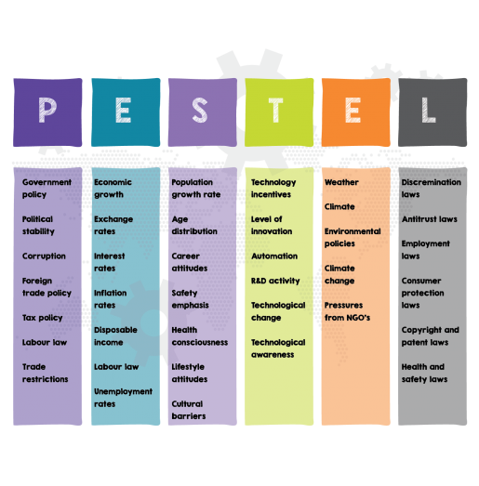
Example 1:
PESTLE — Coffee Shop
Imagine we open a coffee shop.

P — Political
- Αύξηση φόρων στα τρόφιμα → αυξάνονται τα κόστη.

E — Economic
- Πληθωρισμός → αυξάνεται η τιμή καφέ και γάλακτος.

S — Social
- Οι πελάτες θέλουν vegan γάλα.

T — Technological
- Νέες μηχανές espresso πιο αποδοτικές.

L — Legal
- Νέοι κανόνες υγιεινής.

E — Environmental
- Πίεση για οικολογικά ποτήρια.
Συμπέρασμα:
Η επιχείρηση δεν ελέγχει αυτά τα factors — πρέπει να προσαρμοστεί.

Example 2:
Αν μια ελληνική εταιρεία θέλει να μπει στην Τουρκία:
PESTLE θα εξετάσει:
- Political stability
- Inflation rate
- Currency volatility
- Legal restrictions
- Cultural differences
- Environmental regulations
Αν ο κίνδυνος είναι υψηλός → δεν επενδύει.

…………………………………………………..
ACTIVITΙES

Identify the PESTLE factor & Write the correct letter (P, E, S, T, L, E).
- New government tax on businesses → ______
- Increase in inflation → ______
- Customers prefer healthy food → ______
- New AI technology for production → ______
- New labor law → ______
- Climate change regulations → ______

B.
- Identify the external problem (PESTLE factor).
- Discuss the risks.
- Propose 1–2 solutions.
- Reach a final decision.
Time: 10–12 minutes discussion + 2-minute presentation.

CEO  Your role  - Lead the meeting  - Ask questions  - Make the final decision  Focus on  - company strategy  - long-term success  - risks and opportunities  Ask questions like:  - What is the main risk?  - What are our options?  - What is the long-term impact?  - Can we agree on a strategy? | Finance Manager  Your role  - Focus on money and financial impact  Think about  - costs  - profit  - investment  - budget  Consider:  - Is this solution affordable?  - Will this increase revenue?  - What are the financial risks? | Marketing & Operations Manager  Your role  - Focus on customers + daily operations  Think about  - customer preferences  - brand image  - competition  - efficiency  Consider:  - How will customers react?  - Does this improve our image?  - Can we implement this easily?
Giving Opinions  - In my opinion…  - From a financial perspective…  - From a marketing point of view…  - I strongly believe that… | Agreeing  - I agree with you.  - That’s a valid point.  - I completely agree. | Disagreeing Professionally  - I see your point, however…  - I’m not entirely convinced.  - That might be risky because…
Making Suggestions  - We should…  - We could consider…  - I suggest that we…  - It would be advisable to… | Reaching a Decision  - Can we agree on this?  - Let’s move forward with this plan.  - So our final decision is…  - To summarise, we will…

- Identify the main problem.
- Discuss the risks.
- Suggest possible solutions.
- Agree on ONE final strategy.

🎭 REMEMBER YOUR ROLES
- CEO → lead & decide
- Finance Manager → focus on costs & profit
- Marketing/Operations Manager → focus on customers & implementation

After the presentation, other groups ask:
- Why did you choose this strategy?
- What are the risks?
- How will this affect customers?

…………………………………………………………………………………………………………………………..

SCENARIO 1 — LOCAL RESTAURANT IN CRETE (PESTLE-Economic + Social)

Situation
A traditional restaurant in Crete faces problems because:
- food prices have increased (inflation)
- tourists spend less money
- customers prefer healthier or vegan food options
- competition from fast-food chains is growing
Sales are decreasing.

Your Task:
You are the restaurant management team.
Decide how to improve the business.

Possible Student Solutions
- introduce vegan or healthy menu options
- reduce costs or change suppliers
- offer special deals or discounts
- promote traditional Cretan food experience
- improve online marketing / delivery services
- create a premium local product strategy

……………………………………………………………………………………………………….

SCENARIO 2 - CRETE TRAVEL AGENCY
A medium-sized travel agency in Crete is facing serious challenges.
- More tourists book holidays online through platforms (Booking, Airbnb, direct airline websites).
- Customers compare prices easily and choose cheaper options.
- Airlines increase ticket prices due to fuel costs.
- Geopolitical instability in some countries reduces tourist arrivals.
- Online reviews strongly influence customer decisions.

The agency’s sales have decreased by 25% in the last year.

Your Task:
You are the management team of the travel agency.

During this meeting, you must:
- Identify the main external problems (PESTLE factors).
- Analyse the risks.
- Propose strategic solutions.
- Agree on ONE clear strategy.

Hints:
Think about:
- Technology
- Economic conditions
- Political/geopolitical issues
- Customer behaviour

Realistic Solutions — Crete Travel Agency (for class use)

🌍 Offer Complete Holiday Packages
- flight + hotel + airport transfer + excursions
- organised weekly tour programmes
- all-inclusive holiday planning
👉 advantage: convenience — tourists don’t need to organise everything themselves.

🏝 Sell Local Experience Packages
- Samaria Gorge hiking trips
- Knossos and archaeological tours
- boat trips and island excursions
- Cretan food and wine tours
- traditional village visits
👉 online platforms usually don’t provide full local experiences.

🤝 Cooperate with Local Businesses
- agreements with hotels and Airbnb hosts
- partnerships with car rental companies
- cooperation with local tour guides
- deals with restaurants and activity providers
👉 very common practice in Crete tourism.

👥 Provide Personalised Service
- custom travel plans
- multilingual customer support
- face-to-face assistance
- local advice and emergency support
👉 traditional travel agencies compete through personal service.

📱 Improve Digital Presence
- simple online booking system
- strong Google reviews management
- active social media promotion
- communication via WhatsApp or email
👉 helps compete with online platforms.

🧳 Specialise in Niche Tourism
- hiking and nature tourism
- gastronomy tourism
- cultural tourism
- religious tourism
- eco-tourism
👉 differentiation strategy.

💸 Offer Competitive Pricing Options
- group discounts
- family packages
- last-minute deals
- off-season offers
👉 responds to inflation and price competition.

Question: So, why should tourists choose a local travel agency instead of booking online?

………………………………………………………………………………………………………………..

Advantages and disadvantages of a PESTLE analysis
Advantages:
- It’s a simple framework.
- It facilitates an understanding of the wider business environment.
- It encourages the development of external and strategic thinking.
- It can enable an organisation to anticipate future business threats and take action to avoid or minimise their impact.
- It can enable an organisation to spot business opportunities and exploit them fully.
Disadvantages:
- Some PESTLE analysis users oversimplify the amount of data used for decisions – it’s easy to use insufficient data.
- The risk of capturing too much data may lead to ‘paralysis by analysis’.
- The data used may be based on assumptions that later prove to be unfounded.
- The pace of change makes it increasingly difficult to anticipate developments that may affect an organisation in the future.
- To be effective, the process needs to be repeated on a regular basis.
…………………………………………………………………………………………..

Why PESTLE Analysis Is Important
PESTLE is a tool for analyzing the macro external environment of a business.
We do not use PESTLE to “discover what is happening.”
Everyone already knows about inflation, new laws, new technology, cultural changes, etc.
We use PESTLE to decide how the business should respond strategically.

Without PESTLE | With PESTLE
We only observe the situation. | We analyze how the situation affects the business.
We see the problem. | We develop a strategy to adapt.
Decisions are based on guesswork. | Decisions are informed and professional.

Why PESTLE Matters Even More in Foreign Markets
When a company operates only in its home country, it already understands:
- the laws
- the culture
- the economy
- consumer behavior
But when a business enters a foreign market, everything is different.
PESTLE helps the business understand the new environment so it does not make costly mistakes.

1. Political Example
A hotel chain expands from Greece to Turkey.
- Turkey has different tourism taxes and government licensing rules.
- The company must negotiate differently and follow new rules.
Why PESTLE matters:
→ Avoid penalties and choose the right market-entry strategy.

2. Economic Example
A Greek food company wants to sell olive oil in the UK.
- The UK is facing high inflation and customers are more price-sensitive.
- The company may need to offer smaller, cheaper packaging.
Why PESTLE matters:
→ Products must match the economic conditions of the new country.

3. Social Example
McDonald's in India.
- Many people do not eat beef due to religion.
- McDonald's removed beef burgers and created McAloo Tikki (potato burger).
Why PESTLE matters:
→ Cultural norms must be respected to avoid failure or offense.

4. Technological Example
Hotels in Japan use robots for check-in.
- A Greek hotel brand expanding there must match the high-tech expectations.
Why PESTLE matters:
→ Technology expectations differ between cultures.

5. Legal Example
A pharmaceutical company selling medical products in Germany.
- Germany has stricter safety testing laws.
- The company must submit additional documentation.
Why PESTLE matters:
→ Understanding legal differences prevents lawsuits and bans.

6. Environmental Example
A coffee company wants to expand to Switzerland.
- Switzerland has strong sustainability requirements.
- The company must adopt recyclable packaging to be accepted in the market.
Why PESTLE matters:
→ Environmental expectations vary strongly between countries.
PESTLE is important in foreign markets because every country has different rules, culture, economy, technology, and expectations.
PESTLE prevents mistakes and guides good market-entry decisions.

…………………………………………………………………………………………………………….

MONEY

TELL US WHAT YOU THINK OR MORE ABOUT YOUR SPENDING BEHAVIOUR..
• How do you pay most often?
• Do you use cash?
• Is money becoming digital?
• Do you trust banks?
- What do you usually spend most of your money on?
- Do you plan your monthly expenses or spend spontaneously?
- Do you compare prices before buying something?
- What was your last expensive purchase? Was it worth it?
- Do discounts influence your buying decisions?

Basic (B2)
- I think that…
- I believe that…
- In my opinion…
- From my point of view…
- As far as I’m concerned…

More advanced (C1-C2)
- Personally, I would argue that…
- It seems to me that…
- From my perspective…
- I strongly believe that…
- I am convinced that…
- My view is that…

Giving Reasons (Δικαιολόγηση)
- because…
- due to the fact that…
- the reason is that…
- this is because…
- this happens because…
- one reason is…

Functions, Types and Characteristics of Money (adapted)

- The Economic Lowdown Podcast Series

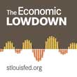

Money is something that people use every day. We earn it and spend it but don't often think much about it.
Economists define money as any good that is widely accepted as final payment for goods and services. Money has taken different forms through the ages; examples include cowry shells in Africa, large stone wheels on the Pacific island of Yap, and strings of beads called wampum used by Native Americans and early American settlers.
A. FUNCTIONS OF MONEY
What do these forms of money have in common? They share the three functions of money:
- First: Money is a store of value. If I work today and earn 30 dollars, I can hold on to the money before I spend it because it will hold its value until tomorrow, next week, or even next year.
- Second: Money is a unit of account. If you are shopping for a new computer, the price could be quoted in terms of t-shirts, bicycles, or corn. So, for instance, your new computer might cost you 100 to 150 bushels of corn at today's prices, but you would find it most helpful if the price were set in terms of money because it is a common measure of value across the economy.
- Third: Money is a medium of exchange. This means that money is widely accepted as a method of payment. In fact, U.S. paper money carries this statement: "This note is legal tender for all debts, public and private." This means that the U.S. government protects my right to pay with U.S. dollars.

B. TWO BASIC TYPES OF MONEY

1. Commodity money (Περιεκτικό Χρήμα)

[Έχει αξία ίση με την εμπορευματική του αξία π.χ. ζώα, τα βόδια ή όστρακα (Αυστραλία και κοινωνίες του Ειρηνικού), τσάι, αλάτι, μετάξι. Για πολλά χρόνια το χρήµα ήταν αποκλειστικώς περιεκτικό.
Αργότερα, συνήθως ένα πολύτιµο µέταλλο, χρυσό ή άργυρο, που συγκέντρωνε τις αναγκαίες ιδιότητες του µη φθαρτού, του µη αλλοιώσιµου, τις δυνατότητας εξυπηρέτησης µεγάλης ποικιλίας συναλλαγών και της τυποποίησης (χρυσά και αργυρά νοµίσµατα, ενώ για τις µικρότερες συναλλαγές χρησιµοποιείτο ο χαλκός ή και ο σίδηρος)].

Commodity money, on the other hand, is money that derives its value from a commodity of which it is made. It can be exchanged on demand for a specific commodity. For example, commodities that are used as a medium of exchange include, copper, gold, silver, large stones, alcohol, tobacco, cigarettes, cocoa beans and barley. The gold standard is a good example of commodity money where people do not have to carry gold for trading goods. If a gold coin is made, the value of that coin would be measured in terms of the value of gold rather than its face value.
2. Fiat money, Representative money (Παραστατικό Χρήμα)
[Είναι το χρήμα του οποίου η αναγραφόμενη αξία αντιστοιχεί σε αξία μεγαλύτερη από την αξία του υλικού που το αποτελεί π.χ. χαρτονομίσματα, κέρματα]

A fiat money is a legal claim as it attains all its properties from the law. It is just like a purchase voucher that can be used as an exchange for goods and services and its purchasing power varies.

C. BASIC CHARACTERISTICS OF MONEY

- Durability. A cow is fairly durable, but a long trip to market runs the risk of sickness or death for the cow and can severely reduce its value. A 20-dollar bill is fairly durable and can be easily replaced if they become worn.

- Portability. While the cow is difficult to transport to the store, the currency can be easily put in my pocket.

- Divisibility. A 20-dollar bill can be exchanged for other denominations, say a 10, a 5, four 1s, and 4 quarters. A cow, on the other hand, is not very divisible!!

- Uniformity. Cows come in many sizes and shapes and each has a different value; cows are not a very uniform form of money. A 20-dollar bill is always the same size and shape and value. All 20-dollar bills are very uniform.

- Limited supply. In order to maintain its value, money must have a limited supply. While the supply of cows is fairly limited, if they were used as money, you can bet ranchers would do their best to increase the supply of cows, which would decrease their value.

- Acceptability. Even though cows have intrinsic value, some people may not accept cattle as money. In contrast, people are more than willing to accept 20-dollar bills. In fact, the U.S. government protects your right to use U.S. currency to pay your bills.

To summarize, money has taken many forms through the ages, but money consistently has three functions: store of value (αποθήκη αξίας, δηλ. που κρατά την αξία του με το χρόνο), unit of account, and medium of exchange. Modern economies use fiat money which share some basic characteristics.
Source: https://www.stlouisfed.org/education/economic-lowdown-podcast-series/episode-9-functions-of-money
…………………………………………………………………………………………………………

The strangest things that have been used as money around the world [adapted]
Talia Avakian
Apr 19, 2016, 9:26 PM

1. Rai /ray/ stones
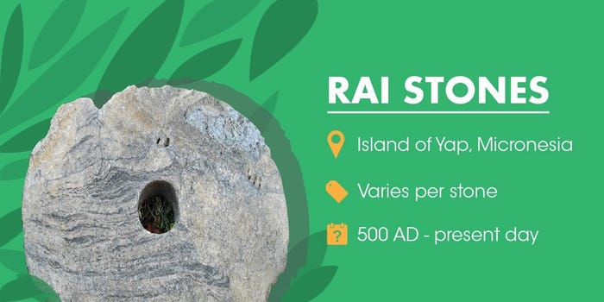
Where: Island of Yap, Micronesia (near Australia)
When: 500 AD - today
Value: Each stone has its own unique value
These large and round discs are carved from limestone /ασβεστόλιθος/. They are still used as gifts in a marriage, political deals, sign of an alliance, or, rarely, in exchange for food.
The stones have different values that depend on their history rather than their size, for example whether it was brought by a famous sailor, or whether people died during its transport.

2. Tea bricks [compressed tea]
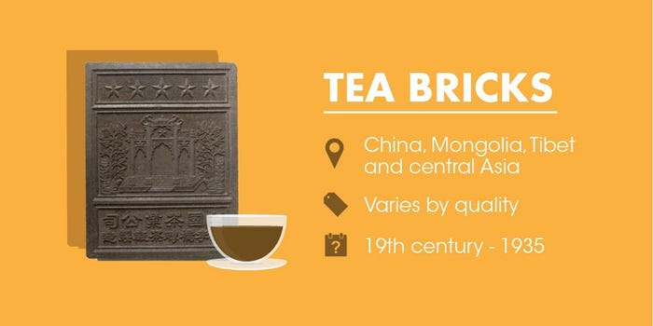
Where: China, Mongolia, Tibet, and Central Asia
When: 19th century - 1935
Value: Varied depending on the quality of leaves and the distance and accessibility of the market
Tea bricks are blocks of ground tea leaves that are packed into molds /καλούπι/ and pressed. The bricks were used as a form of currency up until the beginning of WWII, when the value of tea skyrocketed in many parts of Asia.
Tea blocks were actually said to be favoured over coins in places like Siberia and Tibet, as they could be used to treat coughs and colds or even eaten if food was scarce.

3. Canadian Tire money [CTM]
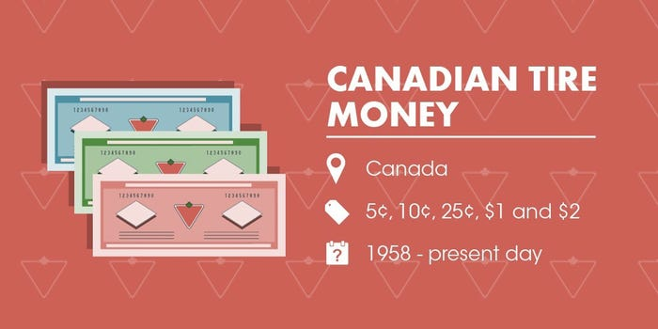

Where: Canada
When: 1958 - today
Value: 5¢, 10¢, 25¢, 50¢, $1 and $2 denominations
Created by Canadian Tire (Μεγάλη αλυσίδα καταστημάτων στον Καναδά που πουλάει κυρίως είδη αυτοκινήτου (λάστιχα, ανταλλακτικά), εργαλεία & είδη σπιτιού, αθλητικά είδη, εποχιακά προϊόντα (κήπος, camping κ.λπ.) back in 1958, this money was originally conceptualized as a customer reward tactic. Customers would get coupons that featured a tire and dollar sign running hand-in-hand. They were issued by the company and resembled real banknotes.
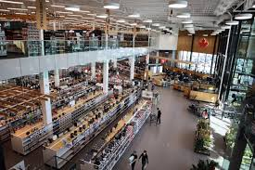

The concept became so popular that other businesses began accepting Canadian Tire Money as well. Some privately owned businesses in Canada accept CTM as payment (see history below), since the owners of many such businesses shop at Canadian Tire. 1 Canadian Tire Dollar = 1 Canadian Dollar.
Δηλ. αγοράζεις εργαλεία αξίας $100 → κερδίζεις π.χ. $4 σε Canadian Tire Dollars → τα χρησιμοποιείς για έκπτωση στην επόμενη αγορά.
Είναι σύστημα επιβράβευσης πελατών, όχι κανονικό χρήμα.

3. Parmigiano-Reggiano
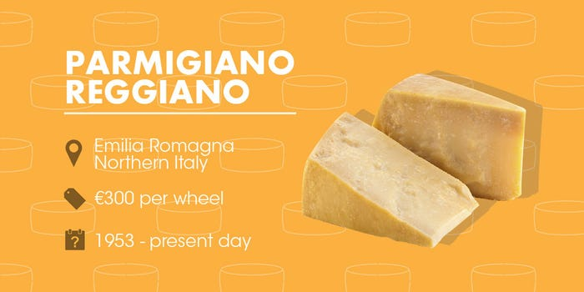

Where: Emilia Romagna, Northern Italy
When: 1953 - today
Value: 300 euros (around $341) per wheel
Italian bank Credito Emiliano accepts Parmigiano-Reggiano cheese as collateral /εγγύηση, ενέχυρο/ for loans, helping to assist cheese-makers during periods of recession.
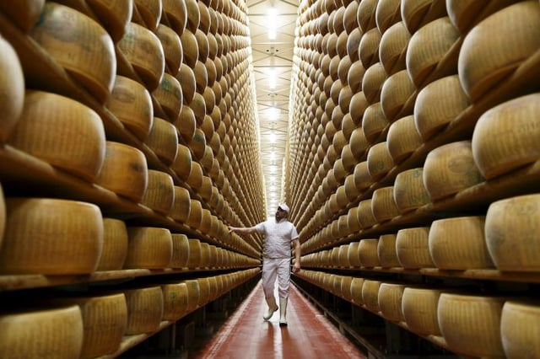

The bank's warehouses are said to hold as much as 17,000 tons of the cheese, which is valued at around $187.5 million in total.
Each wheel of the cheese has a serial number so that it can be traced if it is ever stolen. The bank allows loans for as long as 34 months, which is equal to the approximate time it takes for the cheese to age.

4. Bottle caps
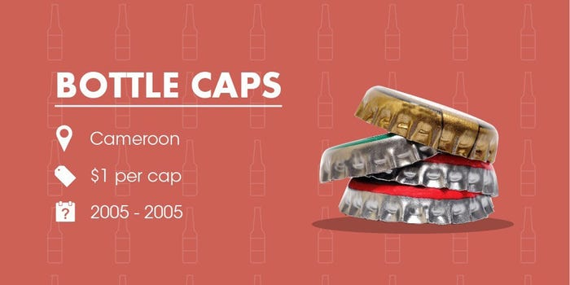

Where: Cameroon
When: 2005
Value: Varied depending on the prize
In 2005, a brewery in Cameroon started a competition where buyers could win prizes placed under beer caps.
Other companies started offering the competition as well, and prizes started to come up in almost every cap. The prizes on offer ranged from mobile phones and luxury cars to more beer. People even used them to start paying for taxi rides.

5. Shell money
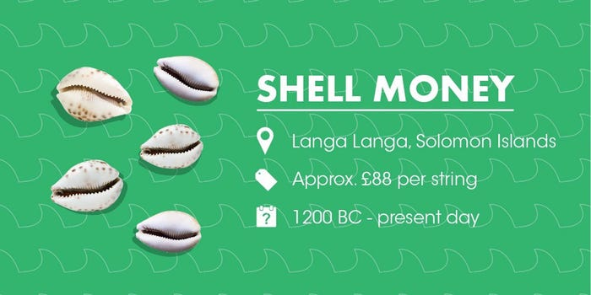

Where: Langa Langa Lagoon, Solomon Islands
When: Archaeologists believe that shell money could have been in use as early as 1200 B.C., and it's still in use today
Value: One string of shell money is worth 1,000 Solomon dollars
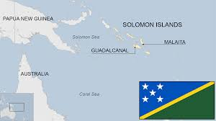


In the Langa Langa Lagoon, located in the Solomon Islands, shells were traditionally used for dowries /προίκα/ compensation and to buy land.
Since the shells have become increasingly rare over time, their value has also increased.

6. Mobile phone minutes
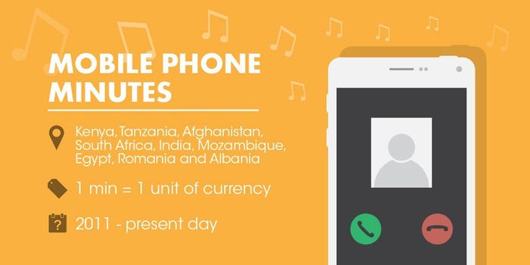

Where: Various countries, including Kenya, Nigeria, Egypt, Zimbabwe, and Romania
When: 2011 - today
Value: The value of the airtime being transferred is equal to the value of the items or goods being purchased (1:1)
In several countries around the world, people are using their pre-paid mobile airtime minutes [the minutes you have available to talk on the phone] in exchange for cash, or as barter for goods and services.
Often, the pre-paid minutes can be swapped or spent in shops for small transactions.

7. Notgeld (emergency money)
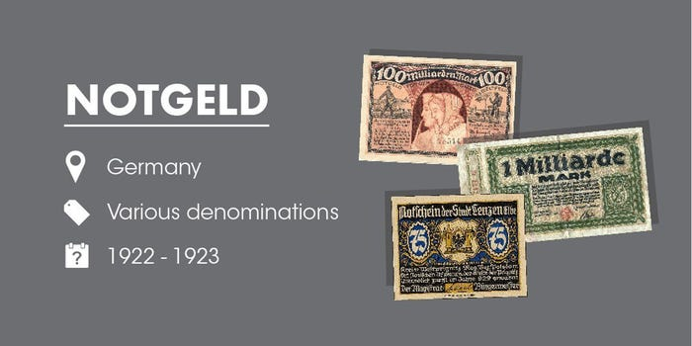

Where: Germany, but there have also been instances of this in Ireland, Sweden, Belgium and France
When: 1914-1923
Value: Much like banknotes, where the value was printed on the item
As the war progressed, metal was needed for more pressing issues than currency, such as the production of war supplies. By 1919 low-value coins had disappeared, and substitute money, Notgeld, made from paper rather than metal, was issued by municipalities and other regional bodies.
Source: https://www.businessinsider.com/alternative-forms-of-currency-2016-4#100-quintillion-pengo-10

………………………………………………………………………………………………..

………………………………………………………………………………………………………..

