https://www.ispringsolutions.com/blog/10-powerpoint-tips-to-make-your-slides-more-effective

10 PowerPoint Tips to Make Your Slides More Effective
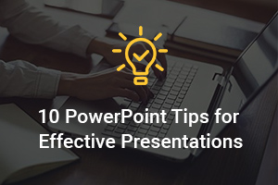
A well-designed PowerPoint can help deliver your message to the audience.

1. Keep it short and to the point
PowerPoint is a tool to support your story. Avoid putting the literal text on the screen. Instead, try and shorten your bullets and keep it to the point. This causes your audience to focus on you instead of the slides on the screen.
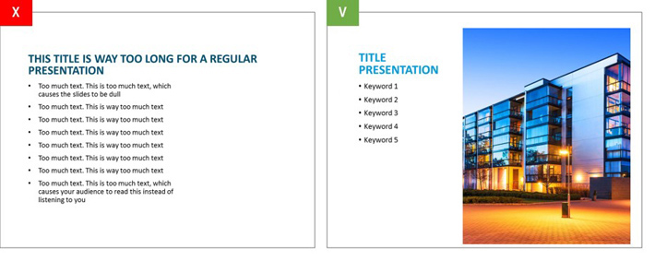

2. Choose the right font
Try and pick a classic font instead of a creative one. Picking the wrong font can easily cause your text to be unreadable for your audience. Besides that, if the computer you are presenting on does not have the font you used installed, PowerPoint will replace it with a random one. Verdana, Calibri and Helvetica, for example, are all safe choices. These fonts are available on all computers.
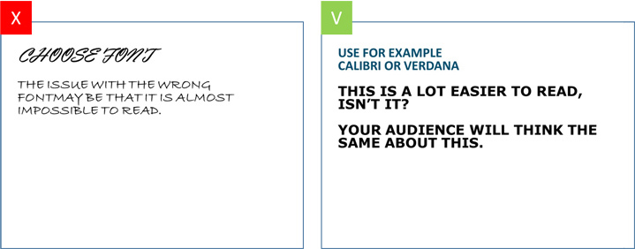

3. Size matters
Your audience needs to be able to read whatever you put on the screen. But you don’t want your text to dominate the space on your slide.
For headers the minimum is around 20pt, while for the body you have a minimum of 18pt. With these sizes you can be assured your text will be legible in every situation. This goes for laptops, computers, tablets, TVs and beamers.
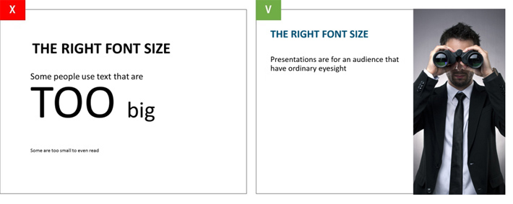

4. Contrast
Besides the looks and size of your font, it is important to take contrast into account. If you’re using text on a photo, make sure that your font is readable by either placing a border or casting a shadow around it.
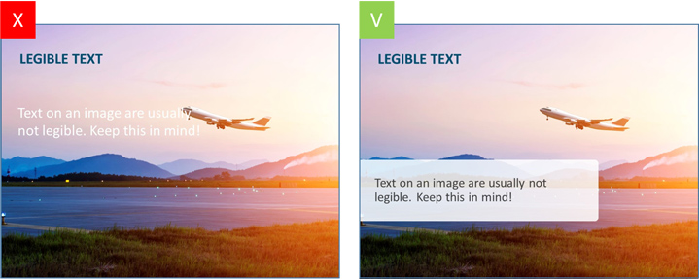

5. Relevance and quality are key
We often see that when people are talking about a car, the first picture on Google images is picked. This results in inconsistency because some images tend to be illustrations and drawings, making your presentation look unprofessional or even childish. Make sure you select high quality images that support your message.
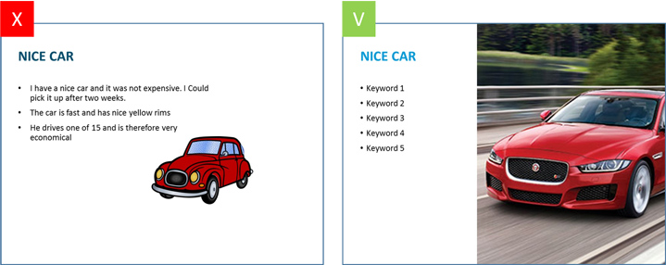

6. Screenshots or diagrams? Make use of mock-ups!
Diagrams, schemes and screenshots are usually not beneficial to your presentation. They make boring slides with too much information and detail, although the information is usually quite important to your story. A quick fix for these slides is to combine the diagram, scheme or screenshot with an image. These can easily be combined with an image of an iPad, laptop or computer.
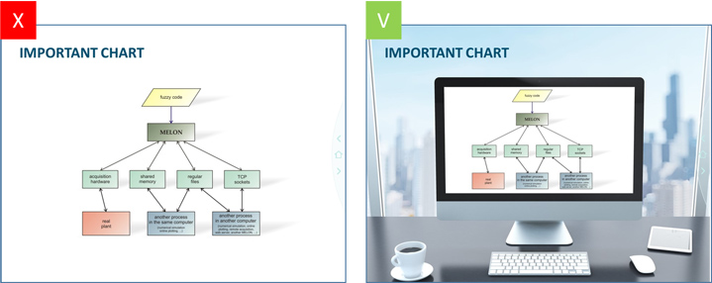

7. Showing data on your slide? Visualize these as much as possible!
Whenever your presentation contains a lot of data, it might be easier to communicate this data by using visuals instead of just using text. Graphs might give you the results you are looking for. PowerPoint offers a wide variety of ‘donut-graphs’, which are ideal for making comparisons.
For example, pick the donut-graph to show your percentages in the middle of the graph. This way your audience immediately knows what you mean.
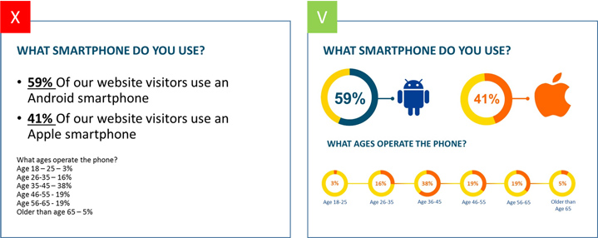

8. Simplify your tables as much as possible
Tables are usually crammed with information and numbers. This causes the slide to look crowded and chaotic. In this case it is important to visualize the tables as simple as possible. Delete unnecessary outlines, colours and borders. ‘Keep it simple’ and ‘less is more’ are key phrases to take in mind whilst designing tables.
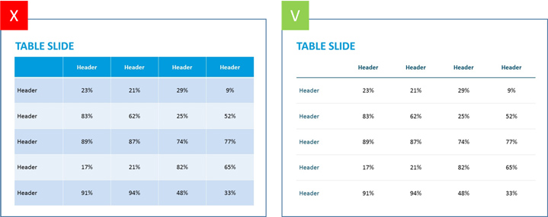

9. Minimize the variety of transitions
After creating a PowerPoint presentation people usually conclude that the presentation comes off as boring or static. At this point they start to use to use transitions. Different transitions are then used to ‘breathe life’ into the presentation. However, this is not the way to do it. PowerPoint offers the most diverse transitions, which are usually experienced as distracting and childish. A simple ‘fade’ effect to go from slide to slide is more than enough. Again, the phrase ‘less is more’ is applicable.

10. Solely use basic colouring
Colours are often used to give the slide some ‘flair’. When picking colours it is important to define your audience and the purpose of the presentation. It’s good to use vibrant colours in a presentation for a primary school. However, when in a formal setting, you will have to define your colours based on your target audience.
