https://24slides.com/presentbetter/bad-powerpoint-examples-you-should-avoid

PPT Presentations you should avoid at all costs!

- Too much text
PowerPoint is a great tool, but it’s just that: a tool. It should not overshadow you. To exploit the presentation as a visual aid, you want it to complement the speaker, not to repeat word for word everything it’s being said. Too much text can be an important factor in the “death by PowerPoint” phenomenon. Just from seeing whole blocks of text, people watching your presentation can feel immediately overwhelmed.

People are usually visually-focused since, as a species, it’s the sense we have developed the most. Chances are that, as soon as people see the slide, they’re going to start reading it from start to finish. And doing so, they’ll be paying less (or no) attention to the speaker in front of them – in this case, you!
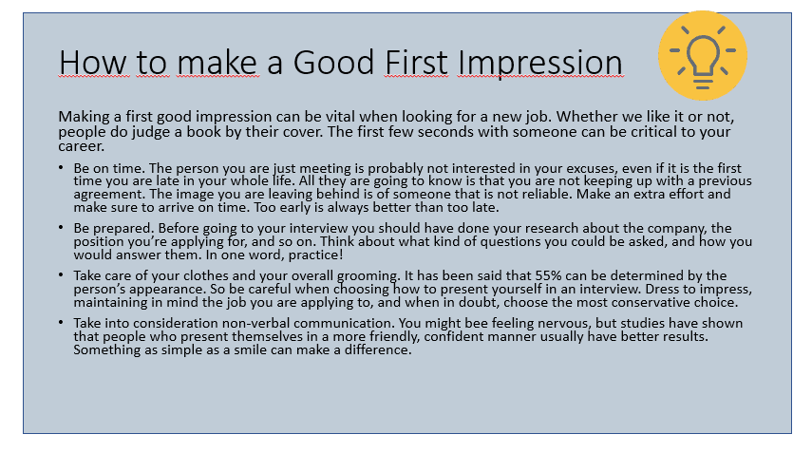
Focus on your keywords, in the most important concepts or ideas that you want your public to take with them. People have limited capacity for retention, and focusing on key points will make your presentation easier to digest.
For example, check out the slide our designers fixed:
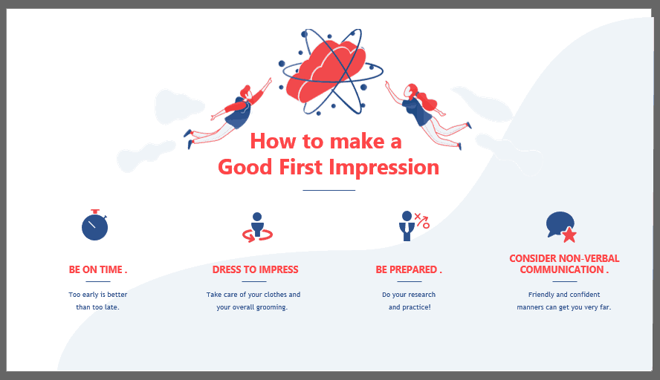

- Animations
PowerPoint has over 150 animations, and some presentations seem to have made it their personal goal to try all of them!

Each element of the slide is animated separately, so it takes much longer to finally show them all. Also, each element has more than one animation. It makes the slide look overloaded and distracts the audience.
There is no “correct” amount of animations. Most presentations can be more than fine with none at all. The key to work with animations without overusing them is to give them an emphasis purpose. See what I did there? If the whole paragraph was in bold letters, it would be difficult to pick out quickly which was the most important idea behind it. But since it is just one word, now “emphasis” is the idea that will stand out.
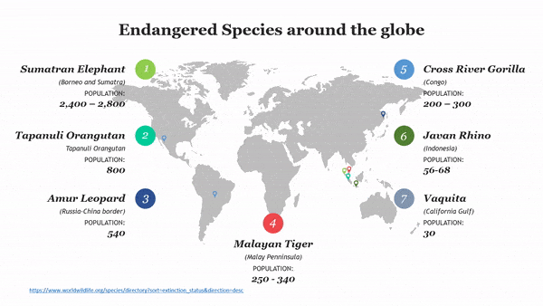
For example, in this slide, the animations are used to shift the focus from topic to topic. Having all these arrows around might be confusing for the public, but with the colors and the arrow shifting, you can redirect your audience’s attention to wherever you like.

- “Rainbow” Presentations
Make it easy to read! Loud, bright colors, like orange, or lime green, are probably not the best for a presentation.

Also, take into consideration that for your public to be able to read easily you need to contrast your colors. For example, black letters on a white background, despite looking very simple, is also very easy to read. While something like light grey on white will probably give your audience problems. For example, check out this yellow text on a lime green background. It’s not very friendly, is it?
Now, if you want to go a step further and give your PowerPoint a more professional look, you should pick a color palette. Microsoft Office has thousands of templates you can pick from, and even some of our own. But if you don’t wish to use one, you can also pick a premade color palette. This will ensure that the colors on your presentation don’t clash together. Something as easy as this can give your presentation a much more polished look.
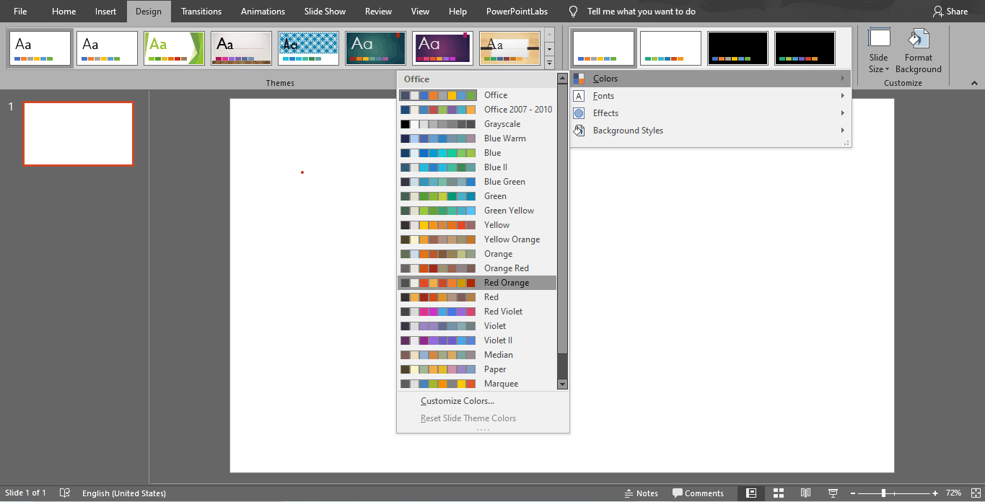

- The Fake Minimalistic
Sometimes people can take too far the saying “less is more”. While having different color palettes in one single presentation may make it look unprofessional and eye-straining, an all-white presentation is not the answer either.
An all-white presentation can make you look lazy, or that you didn’t put any effort into it. It can affect the way people perceive your work too.
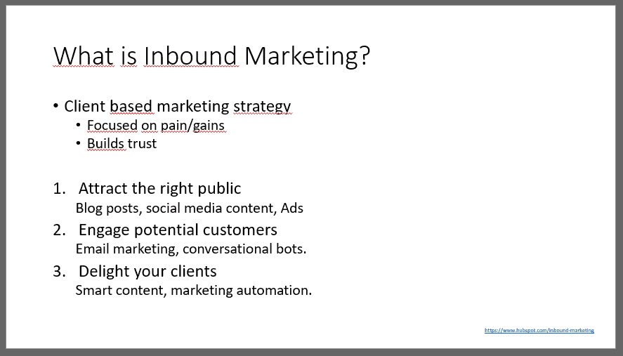
Keep it simple, but elegant!
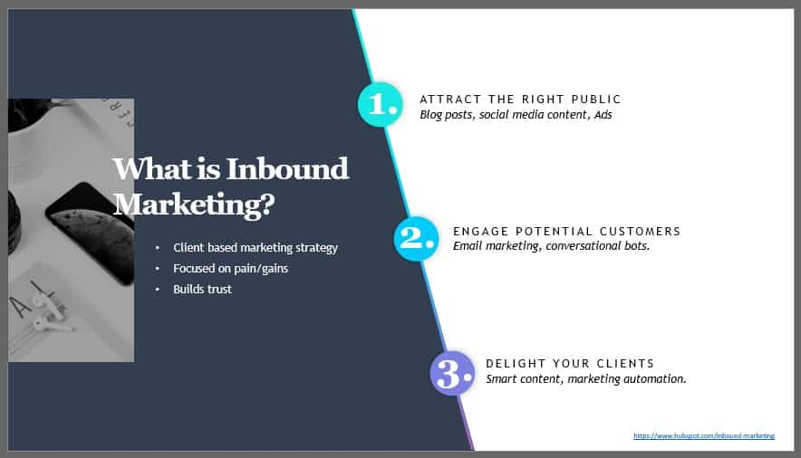
This is the slide fixed by our designers. No one can say it doesn’t professional, but it’s not boring either. You can check out this Minimalistic Design Templates for more inspiration.

- Pictures and Fonts
Your priority should be your audience’s ease when reading. For example, a font like Impact, that has too little space between the letters, is probably not the best choice. In general, it should never go below 20 pts. The easiest way to see if your font size is good enough is to go to the farthest possible point of the room where you’ll be giving your presentation in. You should still be able to read it easily.
Choose your images smartly! Too many images can also be distracting to the public, especially if they overlap. When considering several images, ask yourself if you really need all of them, or if one can stand for some of the others as well. Too many of them will make the presentation look outdated.

Also, avoid clipart! It has been a while since the 2000s, so there is no reason for you to be using Screen Beans.

What all these bad PowerPoint examples have in common
In summary, there are two basic rules for a great PowerPoint presentation. It must be visually engaging and it must be clear.
Avoid “death by PowerPoint” and engage your audience. Use everything in your power to catch their attention and keep it.

