Bank Management System

Textual Analysis

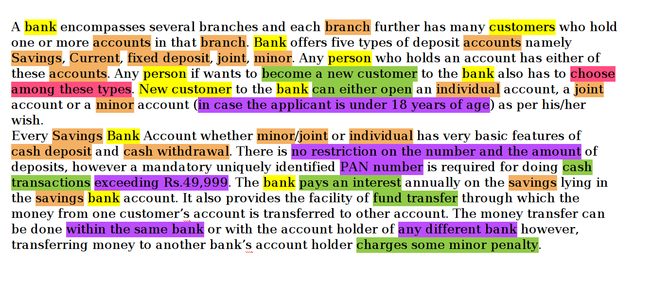

Actor
Use Case
Requirement
Class
Activity

Use Case Diagram

