HELLENIC MEDITERRANEAN UNIVERSITY
SCHOOL OF ENGINEERING
DEPARTMENT OF ELECTRICAL AND COMPUTER ENGINEERING

PATTTERN RECOGNITION

Professor: George Papadourakis, Ph.D.

ASSIGNMENT #2

- For the following categories:
C₁ = {[2,1], [2,2], [3,2], [3,1]}
C₂ = {[-2,-1], [-2,-2], [-3,-2]}
C₃ = {[1,-1], [1,-2], [2,-2]}
C₄ = {[-2,2], [-3,2]}
- Calculate the representative vectors (average vector) z₁ , z₂ , z₃ , z₄ of the categories C₁ , C₂ , C₃ , C₄ .
- Design a minimum distance classifier and classify the following unknown patterns:
[1,1], [7,1], [-1,1], [3,-1], [0,0], [-3,-1]

- Calculate the Eucledean, Hipodamian and Chebyshev distance of the following vectors:
x = [1.5, -2.2, 4.4, 3.2 ]^{T} , y = [0.5, 1.2, -2.6, -6.5]^{T}

- Calculate the Hipodamian, Hamming distance and Tanimoto metric of the following vectors:
x = [0, 1, 1, 0, 1, 1, 0, 0, 1, 0]^{T} , y = [0, 0, 0, 0, 1, 0, 1, 1, 1, 1]^{T}

- The representative vectors of categories C₁ , C₂ , C₃ are:
z₁ = [2,3] ^{T} , z₂ = [3,-2]^{T} , z₃ = [-2,2]^{T}
classify the following unknown patterns:
[3, 1], [1,−1], [2,−2], [−2, 1], [0, 3], [3, 0]
Using a) Euclidian distance, b) dot product (cosine), c) Tanimoto metric.

- Classify the unknown characters in either D or O categories using template matching

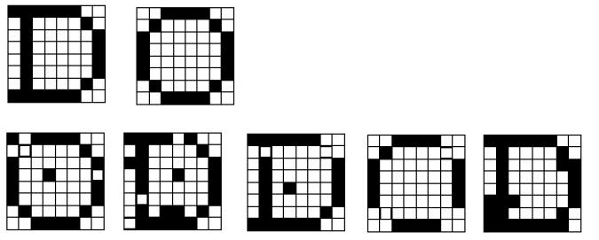
- Estimate the coordinates of the representative patterns of each category using a ruler. Design a minimum distance classifier and classify the unknown patterns 1 and 2.

