**Lines Parallel to Axes**

In two-dimensional geometry, there are two axes, which are the x-axis and the y-axis. A line that is parallel to the y-axis is of the form 'x=k', where 'k' is any real number and 'k' is the distance of the line from the y-axis. For example, the equation of a line which is of the form x = 3 is a line parallel to the y-axis and is 3 units away from the y-axis. Similarly, lines can be drawn parallel to the x-axis also. A line that is parallel to the x-axis is of the form 'y=k', where 'k' is a real number and is also the distance of the line from the x-axis. For example, the equation of a line which is of the form y = 2 is a line that is parallel to the x-axis and is 2 units away from the x-axis.

**Line Parallel to x-axis**

A line that is parallel to the x-axis is of the form 'y = k', where 'k' is a constant value.  In a [coordinate plane](https://www.cuemath.com/geometry/coordinate-plane/), a straight line can be represented by an equation. To put the equation of this [parallel line](https://www.cuemath.com/geometry/parallel-lines/) in a more generalized form, we can write it as 'y = k', where 'k' is any [real number](https://www.cuemath.com/numbers/real-numbers/). Also, 'k' is said to be the distance from the x-axis to the line 'y=k'. For example, if the [equation of a line](https://www.cuemath.com/geometry/equation-of-a-line/) is y = 5, then we can say that it is at a distance of 5 units above the x-axis line. All the points on a line that is parallel to the x-axis are at the same distance away from it.

Consider the equation y = 2, or  y - 2 = 0. This is an equation with a single variable *y*. However, we can think of it as a two-variable linear equation in which the coefficient of *x* is 0:

0(x) + 1(y) + (-2) = 0.

Let us plot the graph for the equation, and find how the line 'y=2' will look.

|  |  |  |  |  |  |  |  |  |  |
| --- | --- | --- | --- | --- | --- | --- | --- | --- | --- |
| x | -4 | -3 | -2 | -1 | 0 | 1 | 2 | 3 | 4 |
| y | 2 | 2 | 2 | 2 | 2 | 2 | 2 | 2 | 2 |

Therefore, we can see that though the value of 'x' changes, the value of 'y' remains unchanged. Thus, all solutions of this [linear equation](https://www.cuemath.com/algebra/linear-equations/) are of the form (k,2), where *k* is some real number. The graph of the line 'y=2' is given below.

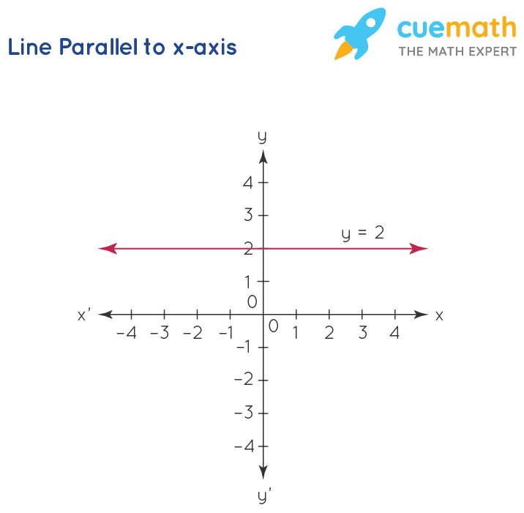

This is a line parallel to the *x*-axis. Thus, an equation of the form y = a represents a straight line parallel to the *x*-axis and intersecting the *y*-axis at (0,a).

**Line Parallel to y-axis**

A line that is parallel to the y-axis is x = k, where 'k' is a constant value. This means that for any value of 'y', the value of 'x' is the same. A more generalized way to represent an equation of a [straight line](https://www.cuemath.com/geometry/straight-line/) parallel to the y-axis is x = k, where 'k' is a real number. Here, 'k' represents the distance from the y-axis to the line 'x=k'. For example, if we have the equation of a line as 'x =2', it says that the line is at a distance of 2 units away from the y-axis. All the points on a line that is parallel to the y-axis are at the same distance away from it.

Now, consider the equation x = 3. This can also be written as a two-variable linear equation, as follows:

1(x) + 0(y) + (-3) = 0.

Let us plot the graph for the equation, and find how the line 'x=3' will look.

|  |  |  |  |  |  |  |  |  |  |
| --- | --- | --- | --- | --- | --- | --- | --- | --- | --- |
| x | 3 | 3 | 3 | 3 | 3 | 3 | 3 | 3 | 3 |
| y | -4 | -3 | -2 | -1 | 0 | 1 | 2 | 3 | 4 |

Substituting different values of 'y' in the equation, 1(x) + 0(y) + (-3) = 0,  the value of 'x' remains unchanged. For example, if y = -3, then the value of 'x' is,  
1(x) + 0(-3) +(-3) = 0.  
x + 0 - 3 = 0  
x -3 = 0  
Therefore, x = 3.  
Let us take a positive value for 'y'. Say 'y=2'. On substituting the value of 'y=2', we get,  
1(x) + 0(2) + (-3) = 0  
x + 0 -3 =0  
Therefore, x = 3.   
We can observe that for any value of 'y', the value of x = 3. Thus, the solutions of this equation are all of the form (3,k), where *k* is some real number. The graph of this equation will consist of all points whose *x*-coordinate is 3, that is, a line parallel to the ­*y*-axis, and passing through (3,0). The graph of the line whose equation is x = 3 is shown in the figure below.

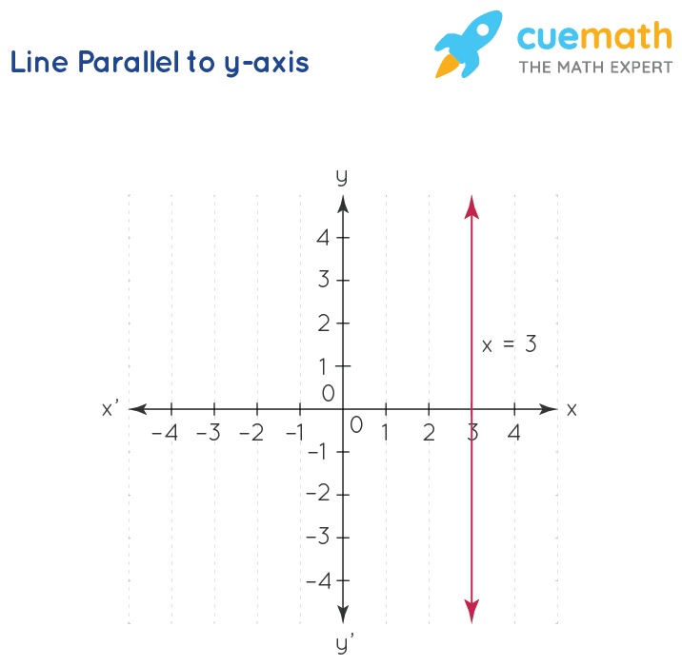

In general, an equation of form x = a represents a straight line parallel to the *y*-axis and intersecting the *x*-axis at (a,0).

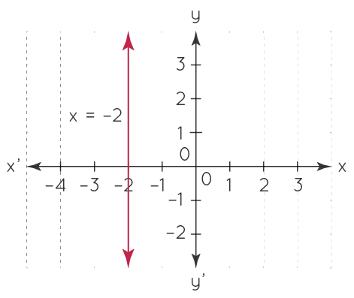

1. **Example 2: The following figure shows four lines, each of which is parallel to one of the two axes. Determine the equation of each line.**

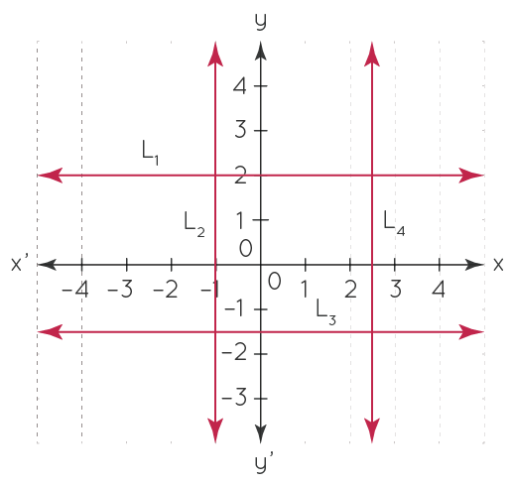

**Solution:** L1

is parallel to the *x*-axis and passes through (0, 2). Thus, the equation of L1 will be y = 2. L2 is parallel to the *y*-axis and passes through (-1, 0). The equation of L2

will be x = -1.

Similarly, the equation of L3

will be y=−3/2 and that of L4 will be x=5/2

**FAQs on Lines Parallel to Axes**

**What Does Parallel to the Axes Mean?**

Parallel to axes means the lines that are parallel to either the x-axis or y-axis. A line parallel to the x-axis is a horizontal line whose equation is of the form y = k, where 'k' is the distance of the line from the x-axis. Similarly, a line parallel to the y-axis is a vertical line whose equation is of the form x = k, where 'k' is the distance of the line from the y-axis.

**What is the Equation of the Line Parallel to x-axis?**

The equation of the x-axis is given by y = 0. The equation of the line parallel to the x-axis is y = k, where 'k' is any real number. For example, considering the equation of a line, y = 2, for any value of 'x' the value of 'y' is always equal to 2. This can be understood by substituting various values of 'x' in the line equation, 0(x) + 1(y) - 2 = 0, which always results in y =2. This line is parallel to the x-axis.

**What is the Equation of the Line Parallel to y-axis?**

The equation of the y-axis is given by x = 0. The equation of the line parallel to the y-axis is x = k, where 'k' is any real number. For example, considering the equation of a line, x = 3, for any value of 'y' the value of 'x' is always equal to 3. This can be understood by substituting various values of 'y' in  the line equation, 1(x) + 0(y) - 3 = 0, which always results in x = 3. This line is parallel to the y-axis.

https://www.cuemath.com/algebra/lines-parallel-to-axes/