Integrated GIS and remote sensing analysis for landslide susceptibility mapping in Crete

Kouli Mariaª, SoupiosPantelisª and Vallianatos Filippos ^{*a}
ª Technological Educational Institute of Crete, Department of Environmental and Natural Resources Engineering, Romanou 3, Chalepa, 73133 Chania Greece; Tel; E-mail:fvallian@chania.teicrete.gr

ABSTRACT

The Rethymnon Prefecture in the Crete Island, Greece, suffers from severe landslide phenomena due to its complicated geological structure with intensive tectonic fragmentation. This research applies the analytical hierarchy process (AHP) method for landslide susceptibility analysis in the Potamon watershed located inside the Rethymnon Prefecture. The following landlside conditioning factors were selected: geological formations, slope angle, aspect, curvature, distance to faults, distance to roads, distance to rivers, land use types and normalized difference vegetation index (NDVI) extracted from a Landsat-ETM satellite image. A landslide susceptibility map is prepared on the basis of available digital data. The landslide susceptibility map is validated through the comparison of the results with the already documented landslides occurring in the study area. The results indicate that the predicted susceptibility map is in good agreement with the past landslide occurrences, and, therefore, the map is trustworthy for future land-use planning of the study watershed.
KEY WORDS: Analytical hierarchy process, Potamon Watershed, landslides

- Introduction

Landslides are considered to be one of the most dangerous natural hazards due to the fact that they cause human casualties and extensive damages worldwide. A landslide hazard map depicts areas prone to landslides by integrating the conditioning factors of landslides with data concerning the past distribution of slope failures [1,2]. Crucial factors for the construction of reliable susceptibility maps are the quality and the amount of available data and the selection of the best method for the analysis. The process of creating these maps involves different approaches and methods, generally distinguished as: qualitative, semi-quantitative and quantitative [3, 4].

Quantitative methods are based on mathematical expressions of the correlation between conditioning factors and landslides. On the other hand, qualitative methods are based on expert opinions [2, 5, 6, 7, 8 and 9]. The basic types of qualitative methods use landslide index to identify areas with similar lithological and geomorphologic characteristics that are susceptible to landslides.

Moreover, there are qualitative methodologies which use weighting and rating procedures and these are known as semi-quantitative methods. Such kinds of methodologies are the Analytic Hierarchy Process (AHP) by Saaty [10, 11, 12, 13, 14, 15 and 16] and the Weighted Linear Combination (WLC) [17, 18, 19, and 20]. The AHP methodology involves the creation of hierarchy of conditioning factors and the comparison between different pairs of the causal factors in order to assign a weight and a consistency ratio for each one of them. In most cases of the literature AHP method is used only to assign the weighting factors for landslide conditioning factors but not for the different classes of the conditioning factors. Nevertheless there are several researches in which AHP is used to assign weight factors for both the conditioning factors and the different classes of the conditioning factors [12, 14, and 15].

* fvallian@chania.teicrete.gr, phone +302821023016

The goal of the present study is the implementation of the AHP method in an area which suffers from severe landslide phenomena, situated within the geographic limits of Rethymno Prefecture in Crete Island. The AHP method is used herein in order to assign weights to both the conditioning factors and the different classes of each conditioning factor. The significant contribution of GIS and RS methods in landslide susceptibility zonation and therefore in land use planning is also presented.

- study area

The study area is situated in the central part of Rethymnon Prefecture. The total area of the Potamon watershed is 131 km² and is geographically defined from the sea to the north, the Patsos village to the south, Ksiro Horio village to the west and the Klisidio village to the east encompassing several other villages as well as a dam constructed in the area in 2009 (Fig. 1). The dam is located in the verdant valley of Amari, 25 km south of Rethymno. The altitude varies from 0 meters in the north to 1167 meters in the south and southeastern parts of the watershed.

The study area is occupied by loose Quaternary deposits (alluvial deposits, slope debris and fans, and torrent terraces), Neogene deposits (limestones, conglomerates, sandstones, and clays), tectonic covers of Pindos and Tripolis geotectonic zones consisting of limestones and marbles (plattenkalk, dolomites, and undivided carbonated formations), flysch and metamorphic rocks (phyllites, quartzites, shales, schists, and meta-sandstones), and finally, ophiolites of the autochthonous Ionian zone.

According to the landslide hazard zonation map of Greece [21], the broader area located in the central part of Rethymno Prefecture exhibits the highest frequency of landslides occurrences in the island of Crete.

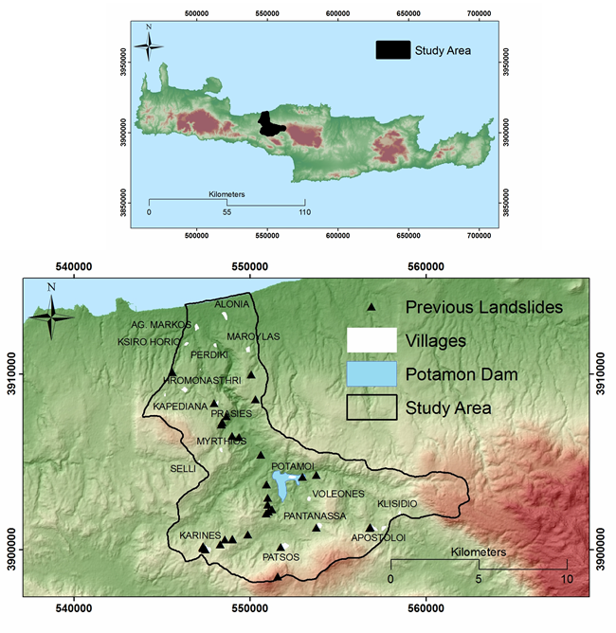
Figure 1: Location of the Potamon watershed situated in Crete Island.
- data and methodology

The different types of datasets used for the landslide susceptibility zonation of the Potamon watershed are:
- Geological maps of the Institute of Geology and Mineral Exploration (IGME) representing lithological and structural units at 1:50000 scale.
- Topographic maps of the Hellenic Military Geographical Service at a scale of 1:50000 to form a base map with 20-m contour interval.
- Satellite sensor data and in particular, a cloud-free Landsat ETM⁺ image acquired at 01 August 2011 with a spatial resolution of 30 m for the multi-spectral bands (7 bands) and 15 m for the panchromatic image.
- The Corine Land Cover map 2000 (CLC2000 100 m, version 1) of the European Environment Agency (EEA, Copenhagen, 2000; http://www.eea.europa.eu).
- Field data involving observations on geology, tectonic structures, and recorded landslide occurrences.
The data pre-processing involved in their implementation into ArcGIS Desktop 9.1 software environment. The several maps were geo-referenced to the local projection system of Greece (GGRS ‘87—Greek Geodetic Reference System).

Satellite image processing
In the current study a Landsat ETM⁺ satellite image acquired on 01 August 2011 was used. In a first step the image was geometrically and radiometrically corrected. The Digital Numbers (DNs) of the bands 4 and 3 were converted to radiance values according to the equation:
$Lλ={(L_{maxλ}-L_{minλ}}/{Q_{calmax}-Q_{calmin})*\left(Q_{cal}-Q_{calmin}\right)+L_{minλ}}$ (1)
where, L_{λ}= spectral radiance at the sensor's aperture [W/(m² sr μm)], Q_{cal}= quantized calibrated pixel value [DN], Q_{calmin}= minimum quantized calibrated pixel value corresponding to L_{MINλ} [DN], Q_{calmax}= maximum quantized calibrated pixel value corresponding to L_{MAXλ} [DN], L_{MINλ}= spectral at-sensor radiance that is scaled to Q_{calmin} [W/(m² sr μm)], L_{MAXλ}= Spectral at-sensor radiance that is scaled to Q_{calmax} [W/(m² sr μm)].

Normalized Difference Vegetation Index, the most widely used remote-sensing derived indicator of vegetation growth was then calculated using the equation:
$NDVI=(NIR-R)/(NIR+R)$ (2)
This index is an indicator of the energy reflected by the Earth related to various cover type conditions. NDVI values range between -1.0 and +1.0. When the measured spectral response of the earth surface is very similar to both bands, the NDVI values will approach zero. A large difference between the two bands results in NDVI values at the extremes of the data range. The results were incorporated to the adopted AHP model.

After the creation of the primary layers representing the landslides causative factors, various advanced GIS techniques, such as filtering, distance buffering, logical operations, vector to raster conversion, reclassification, and raster calculations were applied. For the landslide susceptibility mapping, which is the aim of this study, the following data layers (Fig. 2) were finally prepared and used.

Lithology map

The landslide phenomenon is closely related to the lithology and weathering properties of the materials. In the watershed under investigation, the rock outcrops are decomposed at different degrees. The lithological formations (Fig. 2) were classified into five broad categories based on landslide susceptibility: (a) limestones and marbles, (b) neogene sediments, (c) schists and ophiolites, (d) loose Quaternary deposits, and (e) flysch (Fig. 2).

Distance from faults

Tectonic structures, such as faults, are usually associated with extensive fractured zones and steep relief anomalies. These zones present favorable conditions for landslides. Therefore, major structural discontinuities produced by faults and fractures were included as a major conditioning factor in this study. A distance function was applied to create multiple buffer zones at distances of 0–100 m, 100–250 m, 250-500 m and >500 m from the faults, producing four classes: ‘‘nearest’’, ‘‘near,’’, ‘‘distant’’ and “very distant” .
Distance from roads
Extensive excavations, application of external loads, and vegetation removal are some of the most common actions taking place along the road network slopes, during their construction. These attended actions are also responsible for the landslide triggering. Five classes were produced: 0-25m, 25-50m, 50-100m,100-200m and >200m .

Distance from streams

Fluvial erosion of slopes toe is one of the most common triggering casual factors of the landslides, especially in areas with the intense morphological relief and dense drainage network with the deep valleys. The distance from rivers is therefore considered as an important factor in characterizing susceptible areas. Five classes were produced and incorporated in the AHP model: 0-50m, 50-100m, 100-300m, 300-600m, >600m.

Slope angle map

Slope angle and geometry are controlling factors in slope stability. Slope angle was extracted from the DEM, and the derived slope angle image has values ranging from 0 to 74º. The produced slope image was reclassified into five slope angle classes (0º-5º, 5º-15º, 15º-30º, 30º-45º, and >45º).

Altitude

Altitude affects directly the landslide manifestation as the high relief areas are usually occupied by the most cohesive formations (e.g., limestones) exposed in unfavorable climate conditions (e.g., intensive rainfalls). Within the limits of the study area, the relative relief ranges from 0 to 1167 m. In this study, as altitudes increase, their contribution to the landslide occurrence also increases (Table 1).

Slope aspect map

The aspect of a slope can influence indirectly the landslide initiation, because it controls the exposition to several climate conditions (duration of sunlight exposition, precipitation intensity, moisture retention, etc.) and as a result the vegetation cover. In this study, the aspect map of the study area was classified into nine classes; flat, SE, E, S, NE, SW, W, N, NW (Table 1). Based on hydrometeorological data of the study area, the NW oriented slopes are more violently affected by rainfalls.

Slope curvature map

The study area was classified according to slope curvature values: (i) convex, (ii) concave, and (iii) flat (planar). Generally, convex slopes are more stable as they disperse the runoff more equally down the slope, while concave slopes are considered unstable as they concentrate water at the lowest point and contribute to the built up of adverse hydrostatic pressure [22].

Land use map

Land use is also related with the triggering and causal factors of the landslides. For instance, some types of land use/cover, especially of woody vegetation with large and strong root systems, provide both hydrological and mechanical effects that generally stabilize slopes. On the contrary, landslides occur in bare soil or irrigated cultivated areas due to the lack of the previously mentioned effects. Therefore, the role of vegetation in the slope stability was evaluated by using the Corine Land Use 2000 map with 10 classes for the study area. The different land uses were ranked as shown in Table 1.

NDVI map

The NDVI map calculated using the Landsat ETM⁺ satellite image was classified in 6 different classes (Table 1) representing different vegetation coverage and conditions. Areas with low vegetative cover (such as bare soil, urban areas), as well as inactive vegetation (unhealthy plants) exhibit NDVI values fluctuating between -0.1 and +0.1. Clouds and water bodies will give negative or zero values.
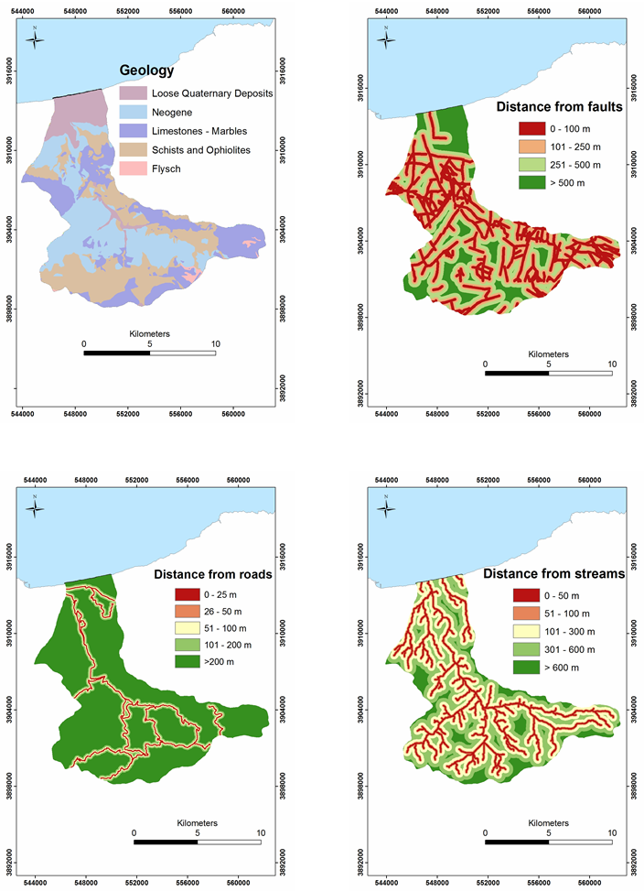

Figure 2 (section A): The landslide conditioning factors for the study area.

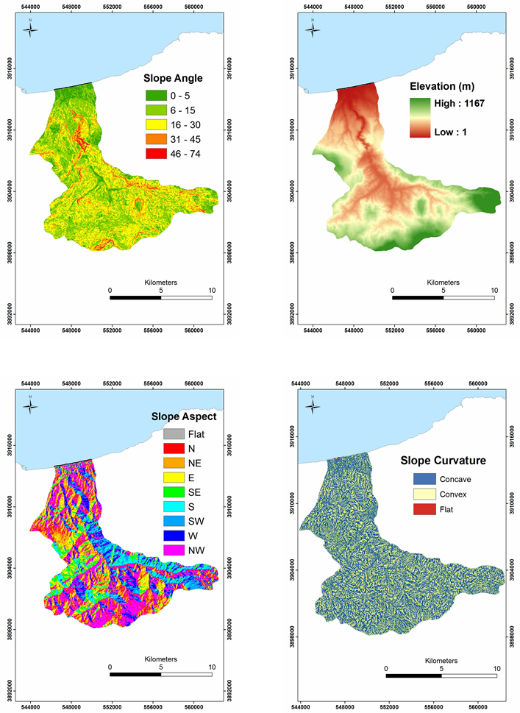

Figure 2 (section B): The landslide conditioning factors for the study area.

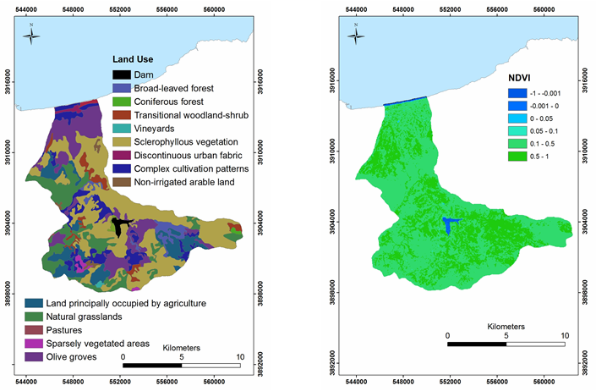

Figure 2 (section C): The landslide conditioning factors for the study area.

Analytical Hierarchy Process (AHP)

The analytical hierarchy process (AHP) is a semi-quantitative method in which decisions are taken using weights through pair-wise relative comparisons without inconsistencies in the decision process [10]. AHP is a multi-objective, multi-criteria, decision-making approach, which enables the user to arrive at a scale of preference drawn from a set of alternatives [10]. The AHP consists of the following five steps: (i) break down a decision problem into several factors; (ii) arrangement of these factors in a hierarchic order; (iii) assignment of numerical values [23] to determine the relative importance of each factor; (iv) set up of a comparison matrix and (v) computation of the normalized principal eigenvector, which gives the weigh to each factor [24]. According to Saaty and Vargas [25], the advantages of using AHP in landslide susceptibility analysis are: (i) all types of information related to landslides can be included in the decision process; (ii) all information is taken into account; (iii) decision rules are based on expert’s knowledge and experiences; (iv) when a consensus is reached, weights for each conditioning factor are obtained automatically by eigenvector calculation of the comparison matrix and (v) inconsistencies in the decision process can be detected using consistency index values developed by Saaty [10, 26] and corrected if needed. The main disadvantage of this method is the subjective preference in the ranking of factors. In order to calculate of CR, we used the following equation:
$CR= \frac{CI}{ RI}$ (3)
where RI is the average of the resulting consistency index depending on the order of the matrix given by Saaty [10] and CI is the consistency index and can be expressed as:
$CI= \frac{λ_{max}-n}{n-1}$ (4)
where λ_{max} is the largest or principal eigenvalue of the matrix and can be easily calculated from the matrix, and n is the order of the matrix. A CR of 0.1 or less is a reasonable level of consistency [27]. A CR above 0.1 requires revision of the judgment in the matrix due to an inconsistent treatment of particular factor ratings. Using the AHP method, the levels of the influence of conditioning factors (weights) as well as the influence of the classes within each factor (rates), were calculated (Table 1). In the current study, the CR for the ten conditioning factors is 0.037 which indicates a reasonable level of consistency in the pair-wise comparisons. The fact that all the CR values which are given in Table 1 are less than 0.1 proves that the preferences utilized to produce the comparison matrixes are consistent.

Table 1: Pairwise comparison matrix and normalized principal eigenvector for the ten landslide conditioning factors as well as for the classes within each factor.
Conditioning Factors and Classes  CR=0.037 |  | (1) | (2) | (3) | (4) | (5) | (6) | (7) | (8) | (9) | (10) | (11) | Normalized Principal Eigen- vector
(1)Geology |  | 1 |  |  |  |  |  |  |  |  |  |  | 0.304
(2)Faults |  | 1/3 | 1 |  |  |  |  |  |  |  |  |  | 0.158
(3)Landuse |  | 1/5 | 1/3 | 1 |  |  |  |  |  |  |  |  | 0.069
(4)Roads |  | 1/5 | 1/3 | 1/2 | 1 |  |  |  |  |  |  |  | 0.047
(5)Streams |  | 1/5 | 1/3 | 1 | 5 | 1 |  |  |  |  |  |  | 0.086
(6)Slope |  | 1/3 | 1 | 3 | 3 | 3 | 1 |  |  |  |  |  | 0.158
(7)Elevation |  | 1/7 | 1/5 | 1/3 | 1/2 | 1/3 | 1/5 | 1 |  |  |  |  | 0.028
(8)Aspect |  | 1/7 | 1/5 | 1/3 | 1/2 | 1/3 | 1/5 | 1 | 1 |  |  |  | 0.028
(9)Curvature |  | 1/7 | 1/5 | 1/3 | 1/2 | 1/3 | 1/5 | 1 | 1 | 1 |  |  | 0.028
(10)NDVI |  | 1/5 | 1/3 | 2 | 2 | 1 | 1/3 | 5 | 5 | 5 | 1 |  | 0.096
Lithology
CR= 0.0307
(1)Limestones-Marbles |  | 1 |  |  |  |  |  |  |  |  |  |  | 0.042
(2)Neogene |  | 3 | 1 |  |  |  |  |  |  |  |  |  | 0.084
(3)Schists and Ophiolites |  | 5 | 3 | 1 |  |  |  |  |  |  |  |  | 0.177
(4)LooseQuaternary Deposits |  | 6 | 4 | 2 | 1 |  |  |  |  |  |  |  | 0.273
(5)Flysch |  | 7 | 5 | 3 | 2 | 1 |  |  |  |  |  |  | 0.425
Faults
CR=0.0399
(1)0-100 |  | 1 |  |  |  |  |  |  |  |  |  |  | 0.553
(2)100-250 |  | 1/3 | 1 |  |  |  |  |  |  |  |  |  | 0.284
(3)250-500 |  | 1/5 | 1/4 | 1 |  |  |  |  |  |  |  |  | 0.101
(4)>500 |  | 1/7 | 1/5 | 1/2 | 1 |  |  |  |  |  |  |  | 0.061
Slope
CR=0.076
(1)0º-5º |  | 1 |  |  |  |  |  |  |  |  |  |  | 0.031
(2)6º-15º |  | 4 | 1 |  |  |  |  |  |  |  |  |  | 0.072
(3)16º-30º |  | 7 | 3 | 1 |  |  |  |  |  |  |  |  | 0.143
(4)31º- 45º |  | 8 | 5 | 3 | 1 |  |  |  |  |  |  |  | 0.260
(5)>45º |  | 9 | 7 | 5 | 3 | 1 |  |  |  |  |  |  | 0.494
Slope Aspect
CR=0.081
(1)Flat |  | 1 |  |  |  |  |  |  |  |  |  |  | 0.015
(2)N |  | 9 | 1 |  |  |  |  |  |  |  |  |  | 0.197
(3)NE |  | 8 | 1/5 | 1 |  |  |  |  |  |  |  |  | 0.079
(4)E |  | 5 | 1/6 | 1/3 | 1 |  |  |  |  |  |  |  | 0.042
(5)SE |  | 5 | 1/7 | 1/4 | 1/3 | 1 |  |  |  |  |  |  | 0.028
(6)S |  | 5 | 1/6 | 1/3 | 1 | 3 | 1 |  |  |  |  |  | 0.042
(7)SW |  | 8 | 1/5 | 1 | 3 | 4 | 3 | 1 |  |  |  |  | 0.079
(8)W |  | 9 | 1 | 5 | 6 | 7 | 6 | 5 | 1 |  |  |  | 0.197
(9)NW |  | 9 | 3 | 5 | 8 | 9 | 8 | 5 | 3 | 1 |  |  | 0.322
Slope Curvature
CR=0
(1)concave |  | 1 |  |  |  |  |  |  |  |  |  |  | 0.250
(2)convex |  | 3/2 | 1 |  |  |  |  |  |  |  |  |  | 0.375
(3)planar |  | 3/2 | 1 | 1 |  |  |  |  |  |  |  |  | 0.375
Altitude
CR=0.040
(1)0-100 |  | 1 |  |  |  |  |  |  |  |  |  |  | 0.015
(2)100-200 |  | 3/2 | 1 |  |  |  |  |  |  |  |  |  | 0.019
(3)200-300 |  | 2 | 3/2 | 1 |  |  |  |  |  |  |  |  | 0.021
(4)300-400 |  | 3 | 2 | 2 | 1 |  |  |  |  |  |  |  | 0.029
(5)400-500 |  | 4 | 3 | 3 | 2 | 1 |  |  |  |  |  |  | 0.042
(6)500-600 |  | 5 | 4 | 4 | 3 | 2 | 1 |  |  |  |  |  | 0.058
(7)600-700 |  | 6 | 5 | 5 | 4 | 3 | 2 | 1 |  |  |  |  | 0.080
(8)700-800 |  | 7 | 6 | 6 | 5 | 4 | 3 | 2 | 1 |  |  |  | 0.109
(9)800-900 |  | 8 | 7 | 7 | 6 | 5 | 4 | 3 | 2 | 1 |  |  | 0.149
(10)900-1000 |  | 9 | 8 | 8 | 7 | 6 | 5 | 4 | 3 | 2 | 1 |  | 0.203
(11)>1000 |  | 9 | 9 | 9 | 8 | 7 | 6 | 5 | 4 | 3 | 2 | 1 | 0.275
Streams
CR=0.058
(1)0-50 |  | 1 |  |  |  |  |  |  |  |  |  |  | 0.521
(2)50-100 |  | 1/4 | 1 |  |  |  |  |  |  |  |  |  | 0.242
(3)100-300 |  | 1/5 | 1/3 | 1 |  |  |  |  |  |  |  |  | 0.125
(4)300-600 |  | 1/7 | 1/5 | 1/3 | 1 |  |  |  |  |  |  |  | 0.065
(5)>600 |  | 1/7 | 1/5 | 1/3 | 1/2 | 1 |  |  |  |  |  |  | 0.048
Roads
CR=0.054
(1)0-25 |  | 1 |  |  |  |  |  |  |  |  |  |  | 0.503
(2)25-50 |  | 1/3 | 1 |  |  |  |  |  |  |  |  |  | 0.260
(3)50-100 |  | 1/5 | 1/3 | 1 |  |  |  |  |  |  |  |  | 0.134
(4)100-200 |  | 1/7 | 1/5 | 1/3 | 1 |  |  |  |  |  |  |  | 0.068
(5)>200 |  | 1/9 | 1/7 | 1/5 | 1/3 | 1 |  |  |  |  |  |  | 0.035
Land Use
CR=0.036
(1)Forests |  | 1 |  |  |  |  |  |  |  |  |  |  | 0.018
(2)Transitional woodland-shrub |  | 3/2 | 1 |  |  |  |  |  |  |  |  |  | 0.020
(3)Vineyards |  | 2 | 2 | 1 |  |  |  |  |  |  |  |  | 0.027
(4)Sclerophyllous vegetation |  | 3 | 3 | 2 | 1 |  |  |  |  |  |  |  | 0.039
(5)Discontinous urban fabric |  | 4 | 4 | 3 | 2 | 1 |  |  |  |  |  |  | 0.056
(6)Complex cultivation patterns |  | 5 | 5 | 4 | 3 | 2 | 1 |  |  |  |  |  | 0.078
(7)Non-irrigated arable land |  | 6 | 6 | 5 | 4 | 3 | 2 | 1 |  |  |  |  | 0.109
(8)Agricultural land |  | 7 | 7 | 6 | 5 | 4 | 3 | 2 | 1 |  |  |  | 0.152
(9)Natural grassland, pastures |  | 8 | 8 | 7 | 6 | 5 | 4 | 3 | 2 | 1 |  |  | 0.210
(10)Sparsely vegetated areas |  | 9 | 9 | 8 | 7 | 6 | 5 | 4 | 3 | 2 | 1 |  | 0.290
NDVI
CR=0.033
(1)-0.999 |  | 1 |  |  |  |  |  |  |  |  |  |  | 0.4340
(2)-0.001 |  | 1/2 | 1 |  |  |  |  |  |  |  |  |  | 0.2656
(3)0 - 0.005 |  | 1/5 | 1/3 | 1 |  |  |  |  |  |  |  |  | 0.1384
(4)0.005 - 0.1 |  | 1/6 | 1/4 | 1/3 | 1 |  |  |  |  |  |  |  | 0.0771
(5)0.1 - 0.5 |  | 1/7 | 1/5 | 1/3 | 1/2 | 1 |  |  |  |  |  |  | 0.0523
(6)0.5 – 1 |  | 1/9 | 1/7 | 1/5 | 1/3 | 1/2 | 1 |  |  |  |  |  | 0.0326

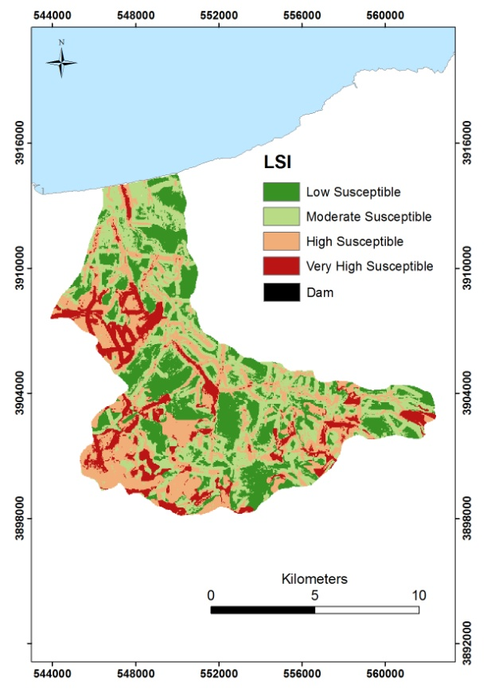

Figure 3: The final landslide susceptibility map of the study area.
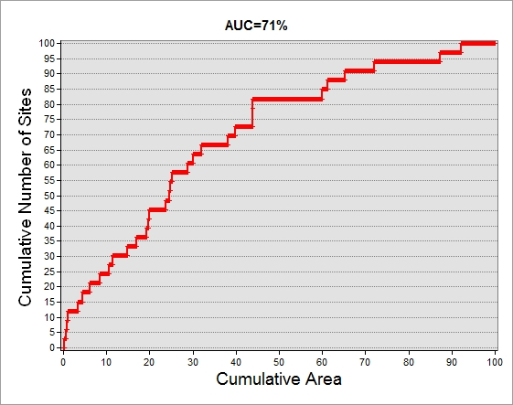

Figure 4: Prediction rate curve with 71% area under curve.

- landslide susceptibility map and validation of the results
The Landslide Susceptibility Index (LSI) for each grid cell was extracted by the summation of the raster thematic maps after their multiplication by the corresponding weights as shown in Table 1. The LSI is presented by the expression as given below:
$LSI= \sum_{i=1}^{n}{Weight*Class Rate}$ (5)
Where n is the total number of conditioning factors.

Landslide susceptibility index (LSI) map was produced within a raster based GIS and were classified into four susceptibility zones namely low, moderate, high and very high, in such a way that approximately 40 % of the study area has low LSI values, 30 % of the study area has moderate values, 20 % has high values and the 10 % of the study area has the highest LSI values [14]. The resulting landslide susceptibility map is shown in Fig. 3. In order to proceed to the validation of the landslide susceptibility map, the efficiency rate curves [14, 28 and 29] method was adopted. The ‘‘area under the curve’’ constitutes one of the most commonly used accuracy statistics for the prediction models in natural hazard assessments [10]. The efficiency curve was created by plotting the cumulative number of sites versus the cumulative area, both accumulated from high to low susceptibility values. The prediction rate curve explains how well the model predicts the landslides and gives a measure of the model performance [28]. The area under the curve can be used to assess the prediction accuracy qualitatively. The success rate curve was created and the ‘‘areas under the curve’’ was calculated equal to 71% for the susceptibility map using existing landslide location data.

- Conclusions
A landslide susceptibility map was produced for the Potamon Watershed area adopting the AHP method both for conditioning factors and the several classes within each factor. The produced landslide susceptibility map is considered to be substantial for the land degradation management of the study area and clearly presents the areas prone to landslides. Based on the prediction rate curve, the landslide susceptibility map is of good performance and can be used safely from the local authorities for slope management and land-use planning.

Acknowledgments

This work was implemented through the project entitled “Interdisciplinary Multi-Scale Research of Earthquake Physics and Seismotectonics at the Front of the Hellenic Arc (IMPACT-ARC)”in the framework of action “ARCHIMEDES III–Support of Research Teams at TEI of Crete” (MIS380353) of the Operational Program "Education and Lifelong Learning" and is co-financed by the European Union (European Social Fund) and Greek national funds.

References
- Brabb, E.E., “Innovative approaches to landslide hazard and risk mapping”, Proc., Fourth International Symposium on Landslides, vol. 1. Canadian Geotechnical Society, Toronto, Canada, 307–324 (1984).
- Fall, M., Azam, R., Noubactep, C., “A multi-method approach to study the stability of natural slopes and landslide susceptibility mapping”, Engineering Geology 82 (4): 241–263 (2006).
- Lee, E.M., Jones, D.K.C., “Landslide Risk Assessment”, Thomas Telford, London, 454 pp. (2004).
- Castellanos Abella, E.A. and van Westen, C.J., “Qualitative landslide susceptibility assessment by multicriteria analysis: A case study from San Antonio del Sur, Guantanamo, Cuba”, Geomorphology, 94 (3-4):453-466 (2008).
- Nash, D., “A comparative review of limit equilibrium methods of slope stability analysis”, in: M.G. Anderson and K.J. Richards, Editors, Slope Stability, Wiley, New York, pp. 11–75 (1987).
- Anbalagan, D., “Landslide hazard evaluation and zonation mapping in mountainous terrain”, Engineering Geology 32:269–277 (1992).
- Fell, R., Walker, B., Finlay, P., “Estimating the probability of landsliding”, Proc. 7th Austr. New Zeal. Conf. on Geomechanics, Adelaide, Institute of Engineers, Australia, Canberra, pp. 304–311(1996).
- Leroi, E., “Landslide risk mapping: problems, limitation and developments”, in: Cruden and Fell, Editors, Landslide Risk Assessment, Balkema, Rotterdam, pp. 239–250 (1997).
- Guzetti, F., Carrarra, A., Cardinali, M., Reichenbach, P., “Landslide hazard evaluation: a review of current techniques and their application in a multiscale study, Central Italy”, Geomorphology 31:181–216 (1999).
- Saaty, T.L., “The Analytical Hierarchy Process”, McGraw Hill, New York (1980).
- Barredo, J.I., Benavides, A., Hervas, J., Van Westen, C.J., “Comparing heuristic landslide hazard assessment techniques using GIS in the Tirajana basin, Gran Canaria Island, Spain”, International Journal of Applied Earth Observation and Geoinformation 2:9–23 (2000).
- Yalcin, A., “GIS –based landslide susceptibility mapping using analytical hierarchy process and bivariate statistics in Ardesen (Turkey): Comparisons of results and confirmations”, Catena 72: 1-12 (2008).
- Mondal, S., Maiti, R., “Landslide Susceptibility Analysis of Shiv-Khola Watershed, Darjiling: A Remote Sensing & GIS Based Analytical Hierarchy Process (AHP)”, Journal of Indian Society of Remote Sensing Vol. 40, 3, pp 483-496 (2012).
- Kayastha, P., Dhital, M.R., De Smedt, F., “Application of the Analytical Hierarchy Process (AHP) for landslide susceptibility mapping: a case study from the Tinau watershed, west Nepal”, Computers and Geosciences 52: 398-408 (2013).
- Pourghasemi, H.R., Moradi, H.R., Fatemi Aghda, S.M., “Landslide susceptibility mapping by binary logistic regression, analytical hierarchy process, and statistical index models and assessment of their performances”, Nat Hazards DOI 10.1007/s11069-013-0728-5 (2013).
- Alexakis, D.D., Agapiou, A., Tzouvaras, M., Themistocleous, K., Neocleous, K., Michaelides, S., Hadjimitsis, D.G., “Integrated use of GIS and remote sensing for monitoring landslides in transportation pavements: the case study of Paphos area in Cyprus”, Nat Hazards doi:10.1007/s11069-013-0770-3 (2013).
- Ayalew, L., Yamagishi, H., Ugawa, N., “Landslide susceptibility mapping using GIS-based weighted linear combination, the case in Tsugawa area of Agano River, Niigata Prefecture, Japan”, Landslides 1:73–81 (2004a).
- Ayalew, L., Yamagishi, H., Watanabe, N., Marui, H., “Landslide susceptibility mapping using a semi-quantitative approach, a case study from Kakuda-Yahiko Mountains, Niigata, Japan”, In: M. Free and A. Aydin Editors, Proceedings of the 4th Asian Symposium on Engineering Geology and the Environment, Geological Society of Hong Kong 7:99–105 (2004b).
- Ayalew, L., Yamagishi, H., “The application of GIS-based logistic regression for landslide susceptibility mapping in the Kakuda–Yahiko Mountains, Central Japan”, Geomorphology 65:15–31 (2005).
- Kouli, M., Loupasakis, C., Soupios, P., Vallianatos, F., “Landslide hazard zonation in high risk areas of Rethymno Prefecture, Crete Island, Greece”, Natural hazards 52 (3), 599-621 (2010).
- Koukis, G., Tsiambaos, G., Sabatakakis, N., “Landslide movements in Greece: Engineering geological characteristics and environmental consequences”, Proceedings of International Symposium of Eng. Geol. and the Envar, IAEG, Balkema, Rotterdam, pp. 789-792 (1997).
- Stocking, M.A., “Relief analysis and soil erosion in Rhodesia using multi- variate techniques”, Zeitchrift fur Geomorpholgie 16, 432–443 (1972).
- Saaty, T.L., “A scaling method for priorities in hierarchical structures”, Journal of Mathematical Psychology 15, 234–281 (1977).
- Saaty, T.L., “The Fundamentals of Decision Making and Priority Theory with the Analytic Hierarchy Process”, Vol VI. RWS Publications, 2nd ed., Pitsburg 478 pp. (2000).
- Saaty, T.L., Vargas, L.G., “Models, Methods, Concepts and Applications of the Analytic Hierarchy Process”, Kluwer, Dordrecht 333 pp. (2001).
- Long, N.T., De Smedt, F., “Application of an analytical hierarchical process approach for landslide susceptibility mapping in A Luoi district, Thua Thien Hue Province, Vietnam”, Environmental Earth Sciences 66 (7), 1739–1752 (2012).
- Malczewski, J., “GIS and multi-criteria decision analysis”, Wiley, New York, p 392 (1999).
- Chung, C.J.F., and Fabbri, A.G., “Probabilistic prediction models for landslide hazard mapping”, Photogrammetric Engineering and Remote Sensing 65:1389–1399 (1999).
- van Westen, C.J., Lulie Getahun, F., “Analyzing the evolution of the Tessina landslide using aerial photographs and digital elevation models”, Geomorphology 54, 77–89 (2003).
- Begueria, S., “Validation and evaluation of predictive models in hazard assessment and risk management”, Nat Hazards 37:315–329 (2006).

