Computational simulation and dimensioning of hybrid power plants with Compressed Air Energy Storage systems to support energy transition in insular systems

Dimitris Al. Katsaprakakis, Templalexis Ioannis, Giacomo Falcucci
Wind Energy and Power Plants Synthesis Laboratory,
Technological Educational Institute of Crete
Estavromenos, Heraklion Crete, Greece, Postal Code: 710 04
Tel.: (+30) 2810 379220, Fax: (+30) 2810 319478
e-mail: dkatsap@staff.teicrete.gr

Abstract
This article investigates the technically and economically optimum electricity storage technologies for small, insular, autonomous electrical grids, integrated with Renewable Energy Sources (RES) power plants. Three autonomous Greek islands are investigated as case studies: Symi, Astypalaia and Kastelorizo, with annual peak demand at 4.0 MW, 2.2 MW and 0.9 MW respectively. The investigated islands exhibit excellent wind and solar potential, with ideal sites for the installation of seawater Pumped Hydro Storage (PHS), for the two largest islands. Two different approaches are investigated, regarding the electricity storage plants: PHS systems (for the two largest islands) and electrochemical storage, alternatively realized with lead acid or lithium-ion batteries. Wind parks and photovoltaic stations are considered as the potential RES units. The dimensioning of the examined plants is optimized with a common target: the achievement of RES annual penetration percentage higher than 70%, ensuring, also, the investments’ economic feasibility, with electricity selling prices lower than the existing specific production cost. Given the appropriate land morphology for PHS installations, it is shown that wind-PHS still remains a competitive alternative for Symi and Astypalaia, despite their relatively small size, while for Kastelorizo, a wind-p/v- batteries features as the optimum option. 100% annual RES penetration can be achieved only with the PHS support, while with the electrochemical batteries the RES annual penetration can be between 80 and 90%. The economic feasibility is ensured with electricity selling prices between 200 and 350 €/kWh. The investments’ payback periods are estimated between 6 and 10 years.

Keywords
hybrid power plants; compressed air energy storage systems; weak insular power systems; RES penetration maximization; wind photovoltaic parks farms; computational simulation

1. Introduction

1.1. Energy transition in insular systems
The energy transition from fossil fuels to Renewable Energy Sources (RES) in insular systems has gained considerable attention by the European Commission during the last years, with the officially expressed political intention to support and promote this transition in administrative, technical and financial level [1]. Former scientific works have shown that in many cases the achievement of high annual RES penetration is relatively easily accessible, given the fulfillment of two very specific favorable conditions: the availability of high RES potential and the capability for the construction of cost-effective storage plants with large storage capacity [2, 3, 4]. The first of the above two parameters should be considered obvious. Not only the existence of high RES potential constitutes a crucial parameter, but, even more importantly, high RES potential should be available during peak demand periods [3]. Furthermore, the support from storage plants with high storage capacities plays a critical role. Large storage capacities can offer long periods of autonomy operation, namely of exclusive power demand coverage from the storage plant, without any intermediate energy storage from the RES units. This feature can be of significant importance with regard to the improvement of the energy supply security, especially in cases of non-interconnected, remote insular territories [5]. Large storage capacities are provided by Pumped Hydro Storage (PHS) systems, with considerably low specific set-up cost, calculated versus the plant’s storage capacity. Under favorable land morphology conditions, this feature can be as low as 30 €/kWh [5]. High RES potential and favorable land morphology for PHS installations can lead to the achievement of annual RES secure penetration percentages higher than 90% [6, 7, 8].
In cases of insular systems with low absolute altitudes (e.g. Baltic Sea or Caribbean Sea islands) or in cases of very small insular systems (peak power demand lower than 1 MW), the installation of PHS systems is not feasible, either for technical or economic reasons [5]. The alternative option of electrochemical batteries is characterized by a series of inadequacies, such as high procurement cost, short life period and low storage capacity [9, 10, 11, 12]. The low storage capacity of electrochemical batteries, practically, constitutes a direct consequent of the first two unfavorable features, which impose the installation of a limited battery units’ number, in order to ensure the economic feasibility of the project.
A more promising alternative storage technology, potentially applicable from very small to large size systems (with power demand from some hundreds of kWs to some tens of MWs), is the Compressed Air Energy Storage (CAES) systems. CAES systems have been extensively studied so far in the scientific literature. The state of the art on this specific topic is doubtlessly the adiabatic CAES (AA-CAES). Recent studies on AA-CAES focus on the dynamic modelling and simulation of the AA-CAES system [13], on the energy and exergy analysis of the involved thermal processes [14] and on fundamental dimensioning methods [15]. Extensive work has been also accomplished with regard to the combined operation of RES power plants with CAES systems, for large size interconnected systems [16, 17] or within the frame of liberalized, electricity wholesale market [18]. More sophisticated configurations, through the integrated operation with RES power plants and PHS systems [19], or with auxiliary storage plants, such as fuel cells [20], have been also studied. Finally, micro CAES systems have been investigated for remote consumptions of very small size [21, 22].
Despite the extensive accomplished work on the study of CAES systems and particularly on their combined operation with RES power plants, the articles focused on the configuration of hybrid power plants supported by CAES systems for increased RES penetration in autonomous insular systems are rather limited. Additionally, the examined topics are also rather restricted, investigating either the general configuration of wind – CAES systems [23], their economic evaluation [24] or their comparative evaluation with hydrogen storage plants for insular systems [25]. Advanced topics are also found, examining the daily power management of a tidal turbine farm and an ocean compressed air energy storage system [26] or the combined operation of a CAES system with floating photovoltaic panels [27].
Given the accomplished research, it is revealed that so far there is no article defining the general operation concept of a hybrid power plant consisting of a wind park, possibly a photovoltaic station and a CAES system, proposing a general and definite operation algorithm, aiming at the annual RES penetration maximisation in insular, autonomous systems and defining a certain dimensioning process. The scope of this article is to cover precisely this literature gap.

1.2. Scope and originality of the article
The scope of this article is to present an integrated and definite operation algorithm, along with the corresponding full mathematical background, of a hybrid power plant supported by a CAES system, aiming at high and secure RES penetration in insular, autonomous electrical grids. Additionally, the article highlights the technical and economic prerequisites and the parameters required to ensure the hybrid power plant’s economic feasibility.
For the realization of the proposed algorithm and the evaluation of the economic feasibility of the under consideration hybrid power plant, a characteristic case study is implemented, for the easternmost Greek island of Kastelorizo, located in the eastern Mediterranean, 72 n.m. east from the island Rhodes and 1.25 n.m. south from the southern Turkish coastline.

2. CAES systems’ layouts
The conventional CAES systems’ layout is presented in Figure 1. The compressor is provided with power and ambient air is compressed, most commonly in two compression stages with intermediate cooling. The outlet compressed air is cooled again before being stored in the air storage tank. In this way a percentage of the initially provided electricity is stored in the form of elastic energy, contained in the compressed air mass. The amount of the initially offered electricity converted to thermal energy during the compression process is disposed in the ambient, constituting, practically, energy losses of the energy storage cycle. When power is required, compressed air is released from the storage tank, heated by an external guaranteed heat source, typically fueled by a fossil fuel or, in best case by biomass fuel (with regard to RES penetration maximisation), in order to be eventually expanded in a most commonly two stages turbine. Intermediate air heating may be realized between the high and the low turbine expansion stages. With air heating, practically the disposed thermal energy during the compression phase is offered back to air before being expanded. This layout has been implemented in the first one of the two CAES systems of large size currently implemented, in Neuen Huntorf, Germany [28].
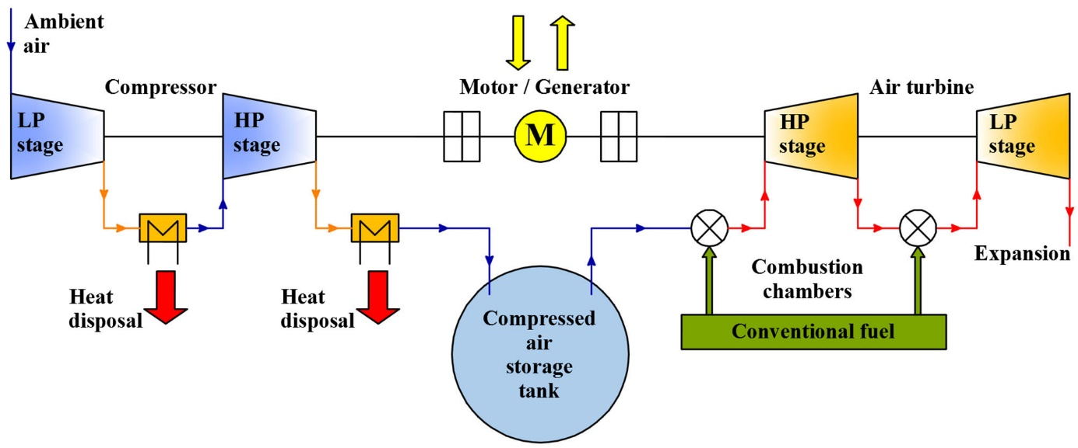
Figure 1: Fundamental layout of a conventional CAES system [29].

An improved implementation is presented in Figure 2. The main difference with regard to the conventional CAES layout presented previously is the introduction of a heat recuperator at the compressed air’s outlet from the storage tank. By leading the expanded hot air from the turbine’s low pressure stage in the recuperator, heat is transferred from the exhausted hot air towards the compressed air, which is pre-preheated, requiring, thus, less thermal energy before its expansion. This layout has been realized in the second one of the two CAES systems of large size currently constructed, in McIntosh, U.S.A. With both the above layouts, pressures from 40 to 70 bars can be achieved (for large size systems), while the turbine’s inlet air temperature can be as high as 1,200 ºC [29].

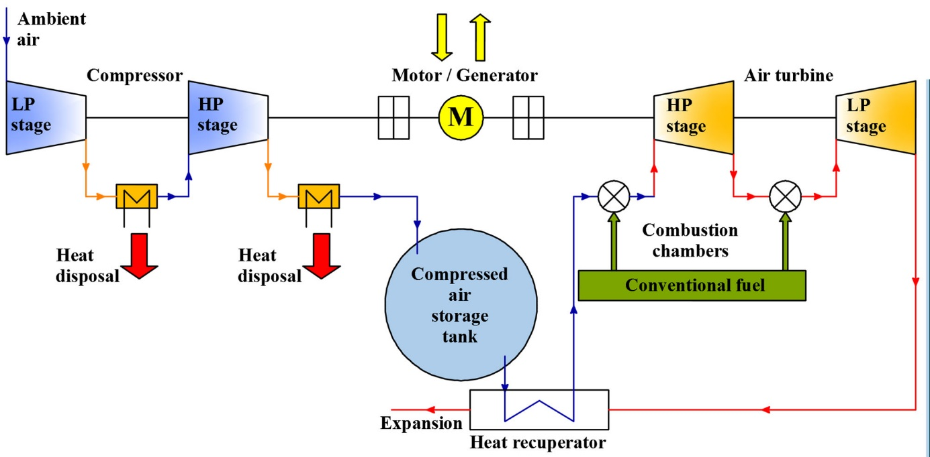
Figure 2: Fundamental layout of a conventional CAES system with a recuperator [29].

The main features of these two implemented and currently operating CAES systems are indicatively presented in Table 1.
Table 1: Fundamental features of the two existing conventional CAES systems.
Technical – economic features | Neuen Huntorf, Germany | McIntosh, Alabama, U.S.A.
Power (MW) | 321 | 110
Storage capacity (MWh) | 1,160 | 2,640
Storage tank volume (m³) | 310,000 (2 caverns) | 560,000
Maximum storage pressure (bar) | 70 | 75
Turbines’ total flow rate (kg/s) | 416 | 154
Compressors’ total flow rate (kg/s) | 104 | 96
Set-up cost ($ - 2010) | 167,000,000 | 65,000,000
Storage specific cost ($/kWh) | 143,966 | 24,621
Set-up specific cost ($/kW) | 520.25 | 590.91

Finally, the third layout is the adiabatic CAES. Air is compressed in one compression stage. Compression in two stages is technically difficult, although, theoretically, not impossible. Compressed air, before being stored in the air storage tank, is cooled during its passage through a thermal storage insulated tank. Theoretically, all the contained thermal energy in the under compression air mass flow rate should be disposed in this thermal storage tank, under appropriate temperature for the turbine’s operation (at the range of 600 ºC). Thermal energy should remain stored in the thermal storage tank with the minimum possible heat losses to the ambient, until it is provided back for the released compressed air, before being expanded in the turbine. Currently no adiabatic CAES systems have been constructed. Apart from the increased set-up cost, imposed by the necessity for a thermal storage tank, there are also some very critical technical issues still remaining unsolved, such as the construction of thermal storage tanks with high storage capacities (up to 1,800 MWh_{th}) and with adequate insulation [29]. Additionally, due to relatively low inlet air temperature in the turbine, air should be compressed in higher pressure (up to 100 bars), in order to store the energy amount required for the turbine’s supply. However, with conventional compressors, such high pressures cannot be achieved. So, currently, the concept of adiabatic CAES systems currently is still under research [30].

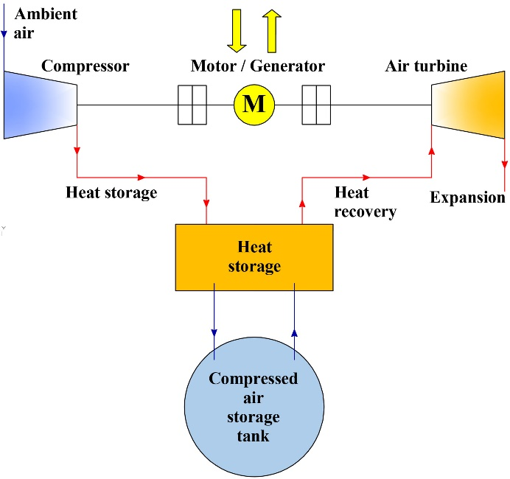
Figure 3: Fundamental layout of an adiabatic CAES system.

3. The under consideration hybrid power plant
The general layout of the under consideration hybrid power plant is presented in Figure 4. It consists of the RES units, which can be either a wind park, a photovoltaic station or both technologies, a CAES system, undertaking the role of the energy storage plant, and thermal generators, as back-up units. Unlike PHS systems, which can be introduced in electrical grids of medium and large size, this layout can be employed in a variety of electrical systems, starting from very small size (peak demand at the range of some hundreds or even tens of kW), introducing the so-called micro-CAES instead of electrochemical storage devices, and ending at large size systems, such as the ones presented in Table 1.
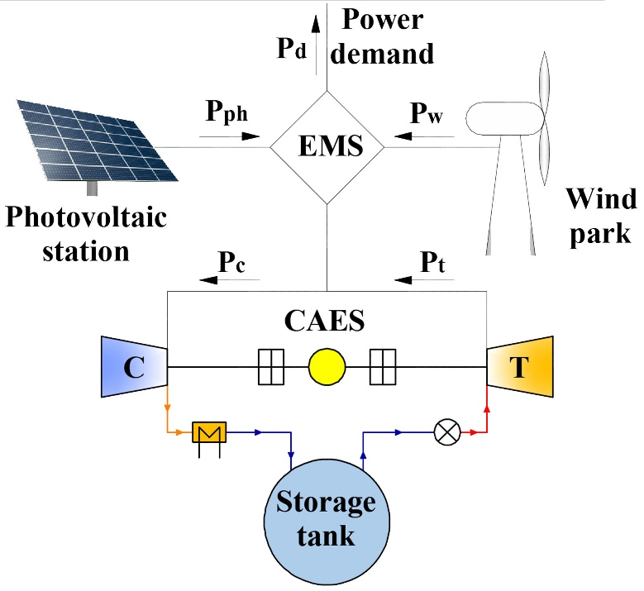
Figure 4: The layout of the introduced hybrid power plant.
The scope of the investigated hybrid power plant will be the maximisation of the annual RES penetration in electrical grids. Although the applicability of the introduced hybrid power plant can be certainly expanded also in mainland, interconnected grids, in this article, for simplicity and practicality, it will be investigated for insular, autonomous grids. The RES annual maximisation in insular grids with the support of the introduced hybrid power plant is approached by the appropriately formulated operation algorithm. In general lines, the RES units can penetrate directly in the electrical grid up to a maximum percentage, with regard to power demand. This maximum RES direct penetration percentage is imposed by the system’s security and stability requirements. Any potential RES production surplus can be stored in the storage plant (CAES system). The remaining power demand after the RES direct penetration should be covered by the storage plant, namely the CAES system’s turbine. In case of low storage energy in the storage plant, the remaining power demand is undertaken by the thermal generators.

3.1. Operation algorithm of RES – CAES hybrid power plants
The operation algorithm of the under consideration hybrid power plant is described in the steps below at the scale of the introduced calculation time step, which, most typically, can be of 10-minutes, 30-minutes or hourly duration. The operation algorithm is applied for every calculation time step and for a whole annual period.
- Firstly, the power production P_{RES} available from the RES units and the power demand P_{d} are introduced. Additionally, the maximum percentage p_{max} for the R.E.S. plant direct penetration versus the current power demand is defined.
- The direct RES penetration P_{RESp} will obviously be:
- if P_{RES} ≥ p_{max}∙P_{d}, then P_{RESp} = p_{max}∙P_{d}
- if P_{RES} < p_{max}∙P_{d}, then P_{RESp} = P_{RES}.
- Having calculated the RES direct penetration, the following are calculated:
  - a potential RES power surplus: P_{RES} – P_{RESp}
  - a remaining power demand: P_{d} – P_{RESp}.
- The next step is the calculation of the air mass m_{comp} that should be stored in the CAES air storage tank, in order to store the available power surplus P_{RES} – P_{RESp}. This mass can be calculated with the following relationship:
$${\text{m}}_{\text{comp}}\text{=}\frac{\text{(}{\text{P}}_{\text{RES}}\text{-}{\text{P}}_{\text{RESp}}\text{)∙}{\text{η}}_{\text{el,M}}\text{∙}{\text{η}}_{\text{m,M}}\text{∙}{\text{η}}_{\text{m,comp}}\text{∙t}}{{\text{Δ}\text{h}}_{\text{c}}}$$ | (1)
where:
η_{el,M}, η_{m,M}, η_{m,comp} : | the motor’s electrical and mechanical efficiency and the compressor’s mechanical efficiency respectively during the current time step;
Δh_{c} : | the air’s specific enthalpy difference in the compressor;
t : | the duration of the calculation time step.

- At the same time, air mass m_{turb} should be removed from the CAES storage tank, so as the remaining power demand P_{d} – P_{RESp} will be produced by the turbine. This air mass is given by the following relationship:
$${\text{m}}_{\text{turb}}\text{=}\frac{\text{(}{\text{P}}_{\text{d}}\text{-}{\text{P}}_{\text{RESp}}\text{)∙t}}{{\text{Δ}\text{h}}_{\text{t}}\text{∙}{\text{η}}_{\text{el,G}}\text{∙}{\text{η}}_{\text{m,G}}\text{∙}{\text{η}}_{\text{m,turb}}}$$ | (2)
where:
η_{el,G}, η_{m,G}, η_{m,turb} : | the generator’s electrical and mechanical and the turbine’s mechanical average efficiency;
Δh_{t} : | the air’s specific enthalpy difference in the turbine.
- The air mass m_{st}(j) remaining in the air storage tank at the end of the current calculation time step j will be:
m_{st}(j) = m_{st}(j-1) + m_{comp} – m_{turb}.
where m_{st}(j-1) is the air mass contained in the air storage tank at the end of the previous calculation time step j-1.
- The new pressure p_{tank}(j) in the air storage tank, at the end of the current calculation time step, is calculated with the relationship:
$${\text{p}}_{\text{tank}}\text{(j)=}\frac{{\text{m}}_{\text{st}}\text{(j)}}{{\text{V}}_{\text{st}}}\text{∙}{\text{R}}_{\text{m}}\text{∙}{\text{T}}_{\text{tank}}\text{(j)}$$ | (3)
where:
V_{st} : | the volume capacity of the storage tank;
T_{tank}(j) : | the air temperature in the storage tank at the current calculation time step;
R_{m}: | the atmospheric air constant.
The atmospheric air constant R_{m} is given by the following relationship versus the dry air constant R_{d} (R_{d} = 286.9 J/kg⋅K) and the ratio r of the humid versus the dry air density ρ_{h} and ρ_{d} respectively
$${\text{R}}_{\text{m}}\text{=}{\text{R}}_{\text{d}}\text{∙}\left(\text{1+0.61∙r}\right)$$ | (4)
$$\text{r=}\frac{{\text{ρ}}_{\text{h}}}{{\text{ρ}}_{\text{d}}}$$ | (5)
The ratio r can be retrieved from Figure 4, versus the ambient air temperature and the atmospheric relative humidity [30].

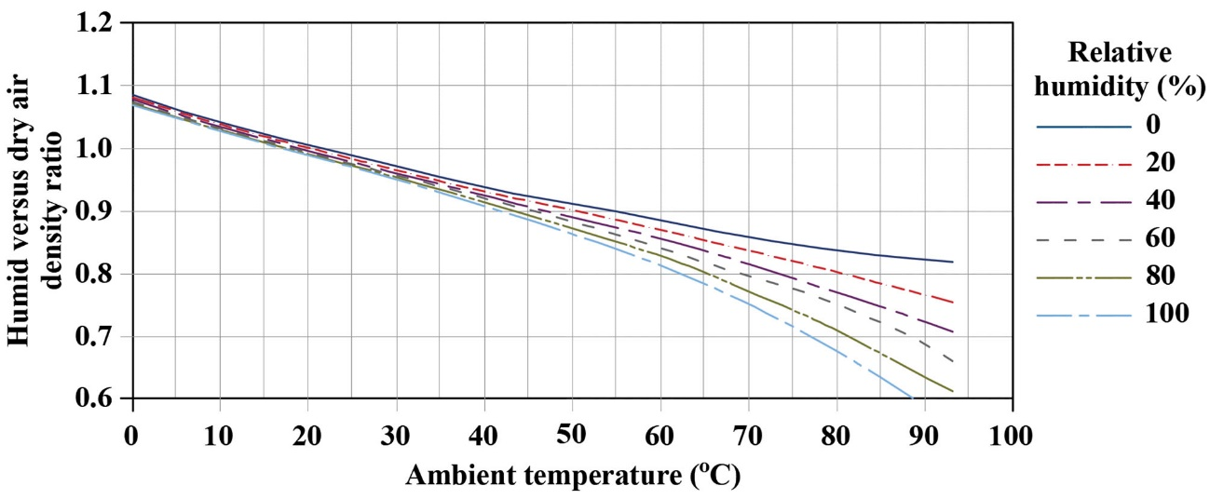
Figure 5: Typical fluctuation curves of the ratio r versus the ambient air temperature, for different atmospheric relative humidity [30].

Since the compressed air is cooled down after its compression, the air temperature T_{tank}(j) in the storage tank can be approximately assumed equal to the current ambient temperature.
- The air pressure p_{tank}(j) in the air storage tank is checked whether it exceeds or not the tank’s maximum pressure p_{max}
- If p_{tank}(j) > p_{max}, then:
turbine power production: P_{turb} = P_{d} – P_{RESp}
thermal generators’ power production: P_{th} = 0
power storage: P_{st} = 0
RES power production surplus: P_{sur} = P_{RES} – P_{RESp}
m_{st}(j) = m_{st}(j-1) – m_{turb}
- If p_{tank}(j) ≤ p_{max}, we proceed to the next step.
- The air pressure p_{tank}(j) in the air storage tank is checked whether it is lower or not than the minimum air pressure p_{min} in the tank. This minimum pressure in the tank can be defined by the minimum expansion ratio of the involved turbine model:
- If p_{tank}(j) < p_{min}, then:
P_{turb} = 0
P_{th} = P_{d} – P_{RESp}
P_{st} = P_{RES} – P_{RESp}
P_{sur} = 0
m_{st}(j) = m_{st}(j-1) + m_{comp}.
- If p_{min} ≤ p_{tank}(j) ≤ p_{max}, then:
P_{turb} = P_{d} – P_{RESp}
P_{th} = 0
P_{st} = P_{RES} – P_{RESp}
P_{sur} = 0
m_{st}(j) = m_{st}(j-1) + m_{comp} – m_{turb}.
- The pressure p_{tank}(j) in the air storage tank at the end of the current calculation time step is calculated again by the relationship 3, introducing the eventually remaining air mass m_{st}(j) in the tank.
The above described operation algorithm is graphically presented in Figure 6. As seen in this figure, the operation algorithm can be simulated iteratively, varying the involved RES production technologies nominal power following a predefined increment step, aiming at the optimization of the hybrid power plant’s dimensioning criteria, which in Figure 6 are shown to be the economic indices of the required investment. Alternative, the achievement of annual RES penetration percentage higher than a minimum threshold can be introduced as the dimensioning criterion.

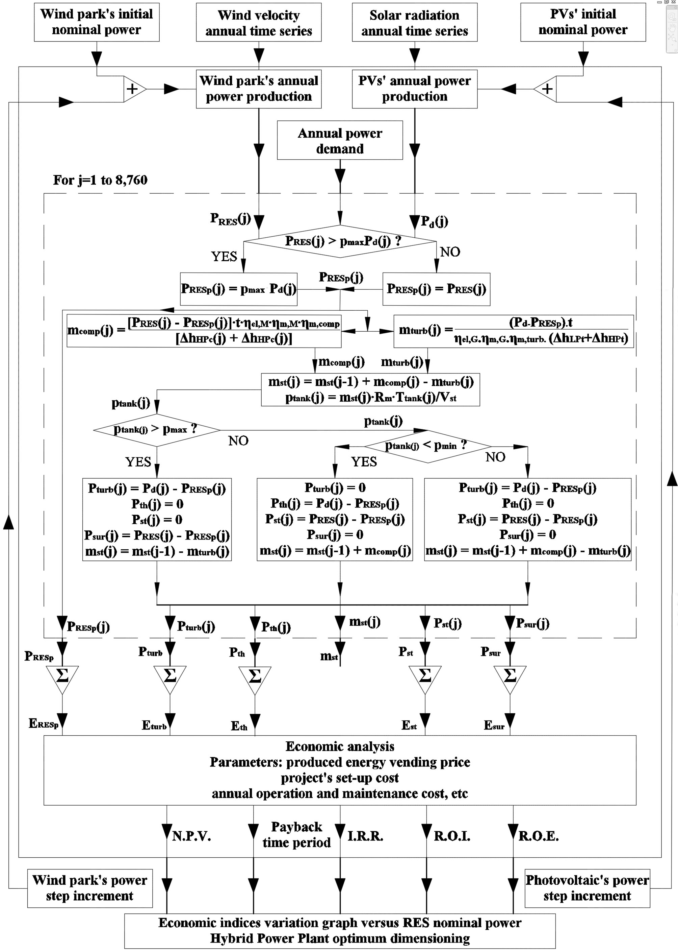
Figure 6: Operation algorithm of the examined hybrid power plant.

3.2. Theoretical background
In the above presented algorithm, it is seen that the air’s specific enthalpy differences in the compressor and the turbine are required. Starting with the compressor, the air’s specific enthalpies difference is written as:

Δh_{c} = h_{cout} – h_{cin} | (6)

where h_{cin} and h_{cout} are the inlet and outlet air specific enthalpies respectively. The first one can be found on the atmospheric air psychrometric chart, once two properties are known (e.g. the dry bulb temperature and the relative humidity) [30]. The second one can be calculated with the following relationship:

${\text{h}}_{\text{cout}}\text{=}{\text{h}}_{\text{air}}\text{+}{\text{h}}_{\text{w}}\text{=}{\text{c}}_{\text{pair}}\text{∙}{\text{T}}_{\text{c,out}}\text{+w∙}\left({\text{c}}_{\text{pw}}\text{∙}{\text{T}}_{\text{c,out}}\text{+}{\text{h}}_{\text{we}}\right)$ | (7)

where:
h_{air} = c_{pair}∙Τ_{c,out}: | the compressed air specific enthalpy (in kJ/kg)
h_{w} = w∙(c_{pw}∙Τ_{c,out}+ h_{we}) : | the specific enthalpy of the outlet water vapor from the compressor (in kJ/kg)
c_{pair} : | the specific heat capacity of the compressed air (in kJ/kg∙K)
w : | the humidity ratio (in kg of water vapor per kg of dry air) of the compressed air
c_{pw} : | the specific heat of water, assumed equal to 4.184 kJ/(kg∙K)
h_{we} : | the evaporation heat of water at 0 ºC, assumed equal to 2,501 kJ/kg
Τ_{c,out} : | the outlet air temperature from the compressor in Κ.

The specific heat capacity of compressed air c_{pair} can be found in graphs or tables versus the compressed air pressure and temperature [31]. The humidity ratio of the compressed air can be found on the ambient air psychrometric chart, for the inlet air stream conditions. The outlet air temperature is given by the relationship:

$${\text{η}}_{\text{c}}\text{=}\frac{{\text{T}}_{\text{c,out}}^{\text{is}}\text{-}{\text{T}}_{\text{c,in}}}{{\text{T}}_{\text{c,out}}\text{-}{\text{T}}_{\text{c,in}}}\text{⇔}{\text{T}}_{\text{c,out}}\text{=}\frac{{\text{T}}_{\text{c,out}}^{\text{is}}\text{-}{\text{T}}_{\text{c,in}}}{{\text{η}}_{\text{c}}}\text{+}{\text{T}}_{\text{c,in}}$$ | (8)

where η_{c} the isentropic compression efficiency, T_{c,in} the inlet air temperature in the compressor and ${\text{T}}_{\text{c,out}}^{\text{is}}$ the outlet air temperature following an isentropic compression, which is given by the following relationship, once the compression ratio is known:

$$\frac{{\text{T}}_{\text{c,out}}^{\text{is}}}{{\text{T}}_{\text{c,in}}}\text{=}{\left(\frac{{\text{p}}_{\text{c,out}}}{{\text{p}}_{\text{c,in}}}\right)}^{\frac{\text{k-1}}{\text{k}}}$$ | (9)

where k is the ratio of the outlet air specific heat under constant pressure c_{P} and volume c_{V}.
The power absorbed by the compressor is given by the relationship:

$${\text{P}}_{\text{c}}\text{=}{\dot{\text{m}}}_{\text{comp}}\text{∙}{\text{c}}_{\text{pair}}\text{∙}\left({\text{T}}_{\text{c,out}}\text{-}{\text{T}}_{\text{c,in}}\right)$$ | (10)

Similarly, the air’s specific enthalpies difference in the turbine can be written as:

Δh_{t} = h_{tin} – h_{tout} | (11)

The inlet air specific enthalpy h_{tin} depends on the inlet air temperature T_{t,in}, which, in turn, depends on the demand for power production from the turbine, according to the following relationship:

$${\text{P}}_{\text{t}}\text{=}{\dot{\text{m}}}_{\text{turb}}\text{∙}{\text{c}}_{\text{pair}}\text{∙}\left({\text{T}}_{\text{t,in}}\text{-}{\text{T}}_{\text{t,out}}\right)$$ | (12)

where T_{t,out} is the outlet air temperature from the turbine. Given the air mass flow rate in the turbine, the required inlet air temperature can be calculated with the above relationship, following a trial and error iterative process, until the output power P_{t} from the turbine meets the requirement for the current time calculation step. Eventually, once the inlet air temperature has been determined, following the above iterative process, the inlet air specific enthalpy can be also calculated with relationship (7), by replacing the T_{c,out} with T_{t,in}. All the rest involved magnitudes are known (w, c_{pair}, h_{we}, c_{pw}). The humidity ratio w can be considered equal to the one of the inlet air stream in the compressor, considering that the whole CAES network is a closed system, without any water vapor interchange between it and the ambient environment.
The outlet air specific enthalpy h_{tout} is also calculated with relationship (7), by replacing T_{c,out} with the outlet air temperature from the turbine T_{t,out}. The latter is given by the relationship:

$${\text{η}}_{\text{t}}\text{=}\frac{{\text{T}}_{\text{t,in}}\text{-}{\text{T}}_{\text{t,out}}}{{\text{T}}_{\text{t,in}}\text{-}{\text{T}}_{\text{t,out}}^{\text{is}}}\text{⇔}{\text{T}}_{\text{t,out}}\text{=}{\text{T}}_{\text{t,in}}\text{-}{\text{η}}_{\text{t}}\text{∙}\left({\text{T}}_{\text{t,in}}\text{-}{\text{T}}_{\text{t,out}}^{\text{is}}\right)$$ | (13)

where η_{t} the isentropic efficiency and ${\text{T}}_{\text{t,out}}^{\text{is}}$ the outlet air temperature following an isentropic expansion, which can be calculated with the following relationship, once the expansion ratio is known:

$$\frac{{\text{T}}_{\text{t,in}}}{{\text{T}}_{\text{t}\text{,out}}^{\text{is}}}\text{=}{\left(\frac{{\text{p}}_{\text{t,in}}}{{\text{p}}_{\text{t,out}}}\right)}^{\frac{\text{k-1}}{\text{k}}}$$ | (14)

Finally, the thermal power ${\dot{\text{Q}}}_{\text{t}}$ provided for the compressed air heating before its expansion in the turbine is given by the following relationship:

${\dot{\text{Q}}}_{\text{t}}\text{=}{\dot{\text{m}}}_{\text{turb}}\text{∙}{\text{c}}_{\text{pair}}\text{∙}\left({\text{T}}_{\text{t,in}}\text{-}{\text{T}}_{\text{st}}\right)$ | (15)

where T_{st} the air temperature in the storage tank, which can be roughly assumed equal to the ambient temperature. A process for the accurate calculation of this temperature is given in [32].

3.3. Realization of the CAES hybrid power plant simulation
As seen in the previous section, a significant amount of thermodynamic parameters is involved in the theoretical background which defines the operation of a CAES system. Furthermore, some critical parameters depending on the introduced compressor or turbine model, such as the compression or the expansion ratio, their isentropic efficiencies and the air mass flow rates are required for the integration of the overall calculation process. These critical parameters can be known only with the introduction of the characteristic charts of the involved compressor and turbine models. In this way, as it will be shown below, the computational simulation becomes easier and faster, avoiding the execution of a considerable part of the above presented theoretical background.
In Figures 7 and 8 characteristic charts for a typical compressor and turbine model are respectively presented.

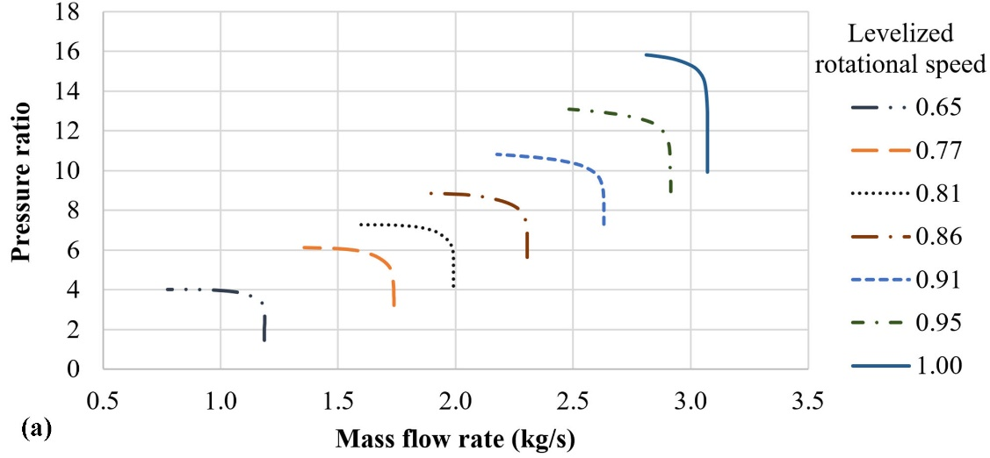
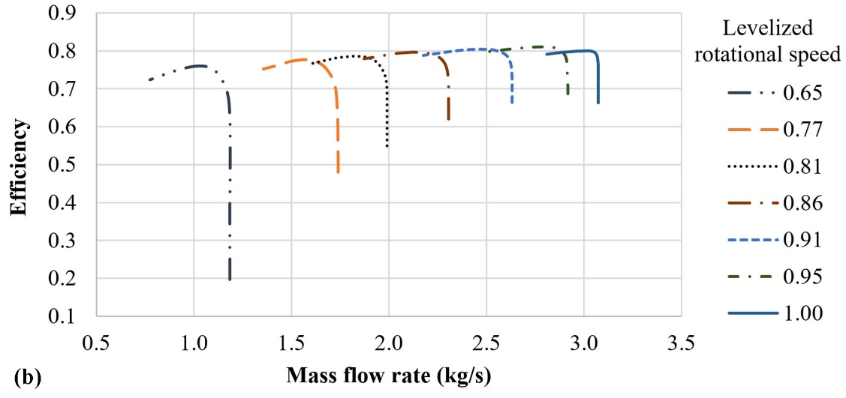
Figure 7: Characteristic charts of a typical compressor model with a nominal input power at the range of 1.3 MW.

As seen in these Figures, the characteristic charts are given in the form of pressure / expansion ratio and efficiency fluctuation curves versus the mass flow rate through the compressor or the turbine and their rotational speeds.

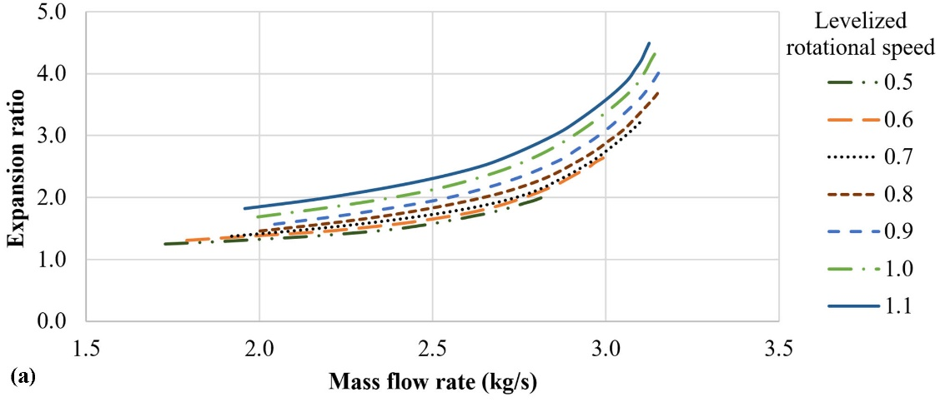
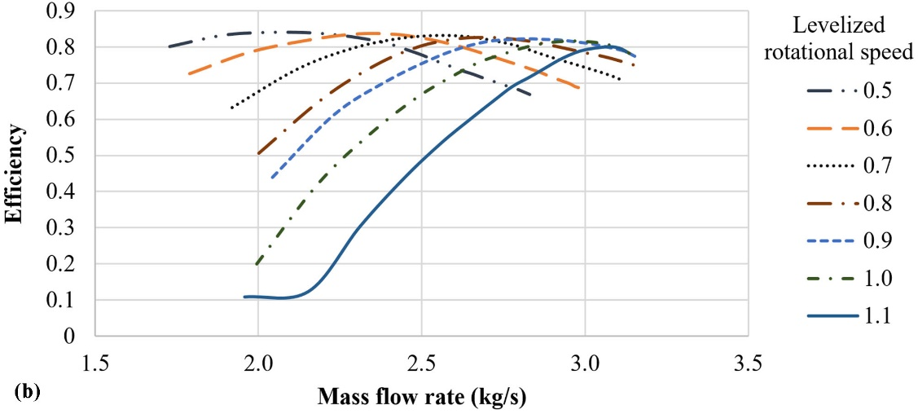
Figure 8: Characteristic charts of a typical turbine model with a nominal output power at the range of 1.0 MW.

With the introduction of the above characteristic charts, all the model-specific magnitudes required for the system’s simulation are introduced, while, the overall process is considerably simplified. Specifically, the realization process of the system’s operation algorithm follows the steps below:
- The ultimate target for every calculation time step is the determination of the compressor’s and the turbine’s operation point, which is defined by the calculation of the absorbed or produced power respectively and the corresponding air mass flow rates.
- The data for every calculation time step are:
  - the available power for storage, namely the power required to be absorbed by the compressor
  - the power required to be produced by the turbine
  - the available pressure in the air storage tank from the previous calculation time step.
- Regarding the compressor’s operation point:
  - from the compressor’s charts, all the operation points with compression ratio higher than the pressure in the air storage tank from the previous time step are selected
  - these selected points are put in a descending order, versus the compressor’s efficiency
  - following the descending order of the selected operation points:
    - knowing the compression ratio, the isentropic outlet temperature ${\text{T}}_{\text{c,out}}^{\text{is}}$ is calculated with relationship (9)
    - knowing the isentropic efficiency, the real outlet temperature T_{c,out} is calculated with relationship (8)
    - the power absorbed by the compressor is iteratively calculated with the relationship (10), following the descending order of the selected operation points, until it becomes lower than the available power for storage, determining, in this way, the compressor’s operation point.
- Regarding the turbine’s operation point:
  - from the turbine’s operation charts, all the operation points with expansion ratio lower than the existing pressure in the air storage tank from the previous calculation time step are selected
  - these selected points are put in a descending order, versus the turbine’s efficiency
  - following the descending order of the selected operation points:
    - an initial value for the turbine inlet temperature T_{t,in} is assumed
    - knowing the expansion ratio, the isentropic outlet temperature ${\text{T}}_{\text{t,out}}^{\text{is}}$ is calculated with relationship (14)
    - knowing the isentropic efficiency, the real outlet temperature T_{t,out} is calculated with relationship (13)
    - the power produced by the turbine is iteratively calculated with the relationship (12), varying the inlet temperature T_{t,in} and following the descending order of the selected operation points, until it becomes equal to the required power production the demand coverage, determining, in this way, the turbine’s operation point.
- Knowing the air mass flow rates in the compressor and the turbine, the final air mass flow stored in the air storage tank is calculated according to the process presented in section 3.1.
- The new pressure in the air storage tank is eventually calculated with the relationship (3).
- Finally, the thermal power required for the heating of the released air from the storage tank before its expansion in the turbine is calculated with the relationship (15).
It is obvious that the above realization process of the proposed operation algorithm, based on the use of the compressor and turbine operation charts is significantly simplified. This approach will be applied implemented in the case study presented in the next section for the small, Greek island of Kastelorizo.

4. Application

4.1. The island of Kastelorizo
The island of Kastelorizo is the easternmost island of Greece, located 72 n.m. east from the island Rhodes and 1.25 n.m. south from the southern Turkish coastline. Its geographical position is shown in Figure 9.

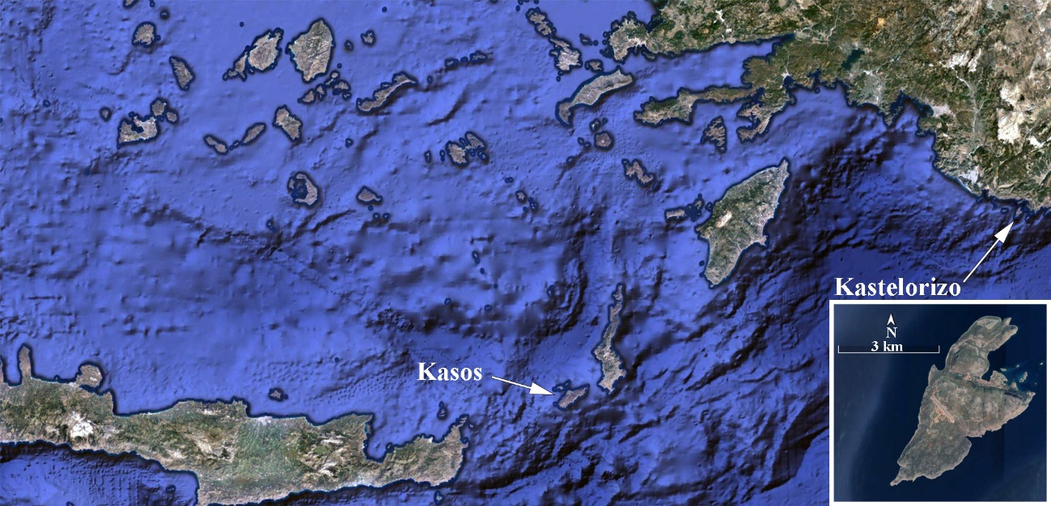
Figure 9: Geographical location and the map of the island of Kastelorizo.

Kastelorizo is a small, non-interconnected island, with a permanent population of 498 inhabitants and a total surface of 9,113 km². The annual peak demand and the annual electricity consumption in 2018 were 0.99 MW and 3,510 MWh respectively. The annual power demand time series for the same year is presented in Figure 10. The impact of the intensive seasonality which characterizes the executed activities on the island, due to the tourist sector, is clearly depicted in Figure 10, with the annual peak power demand in summer being almost double compared to the peak demand during the rest of the year.

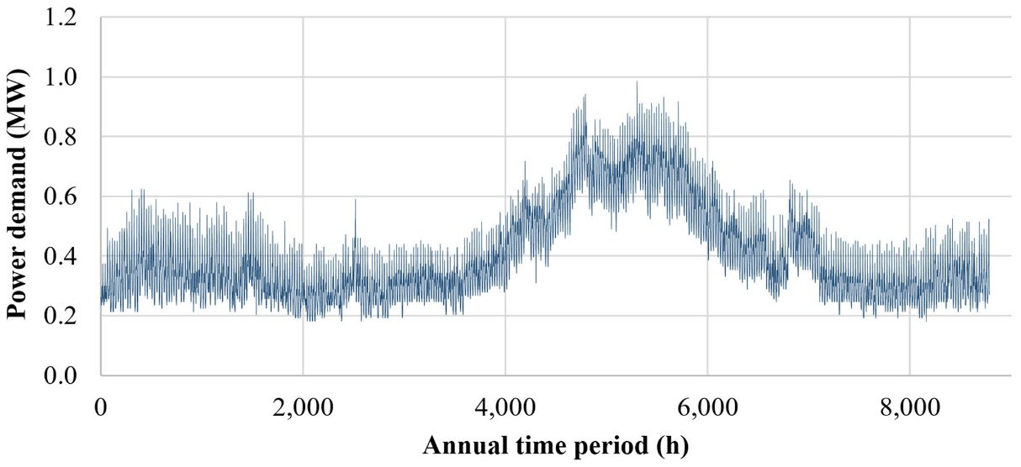
Figure 10: Annual electrical power demand fluctuation in 2018 in Kastelorizo.

The electricity production in the island is exclusively based on the operation of a small, autonomous thermal power plant, equipped with nine diesel generators, with nominal electrical output from 90 to 450 kW and total installed power production capacity of 2.1 MW. All of them operate with imported diesel oil, with a final procurement price (including transportation cost and taxes) higher than 0.90 €/L. No electricity production technology from RES has been currently installed in the island. The annual diesel oil consumption in the thermal power plant is calculated with the computational simulation of the insular, autonomous system at 1,027 kL. The high diesel oil procurement price, the lack of any electricity production from RES power plants and the requirement for spinning reserve maintenance to ensure the weak grid’s dynamic security contribute to the configuration of remarkably high total electricity production specific cost, which, indeed, in 2012 was officially formulated at 492.94 €/MWh (including fixed and variable operation cost) [34].
Due to its far geographical position, with regard to the nearest Greek island, and its small size, as an autonomous electrical system, Kastelorizo most probably will never be connected with another mainland or insular grid. This fact, together with the exclusive existing dependence of the insular electrical system on imported fossil fuel, the consequent high electricity production cost and, additionally, its strategic position for the country in the eastern Mediterranean, impose the transition from the existing condition to the exploitation of the locally available RES.
Remarkable wind potential and solar radiation are available in the island. The wind potential map is depicted in Figure 11. The wind potential was evaluated on the basis of annual wind certified measurements, captured in the island of Kasos (137 n.m. southwest of Kastelorizo). The position of Kasos is also depicted in Figure 9. Additionally, annual total incident solar radiation measurements (including direct, diffused and reflected radiation) were available from a meteorological station installed in the island of Samos, 170 n.m. to the northeast from Kastelorizo, on flat surface with 35º installation angle versus the horizontal plane. The annual wind velocity and incident solar radiation time series are presented in Figure 12, as provided by the above mentioned stations.

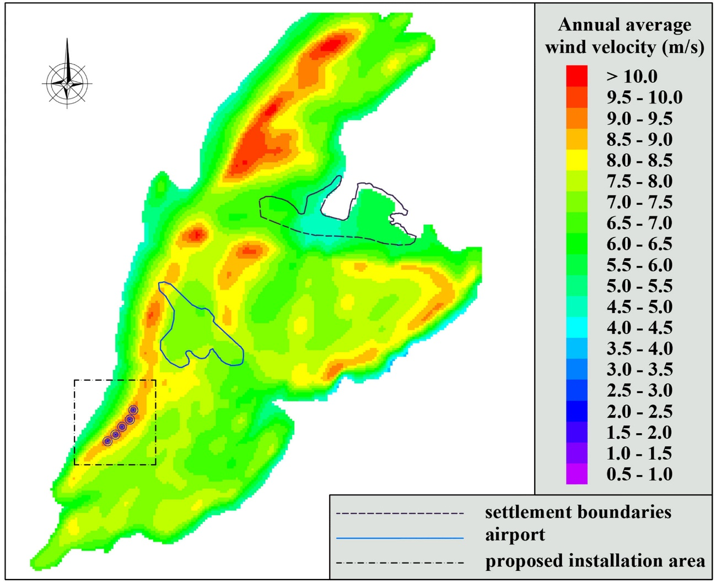
Figure 11: Wind potential map of the island of Kastelorizo.

The annual average wind velocity is calculated from the available time series at 11.4 m/s. The Weibull distribution C and k parameters are calculated equal to 13.2 m/s and 2.8 respectively. The above figures reveal the availability of considerably high wind potential in the island of Kasos and, sensibly, in the island of Kastelorizo, due to the similar geographical, climate and land morphology conditions. As seen in the wind potential map presented in Figure 11, there are several sites with expecting annual average wind velocity higher than 10 m/s. Additionally, by integrating the annual time series of the incident total solar radiation, the annual incident solar irradiation is calculated at 2,158 kWh/m², revealing also the availability of remarkable solar radiation.

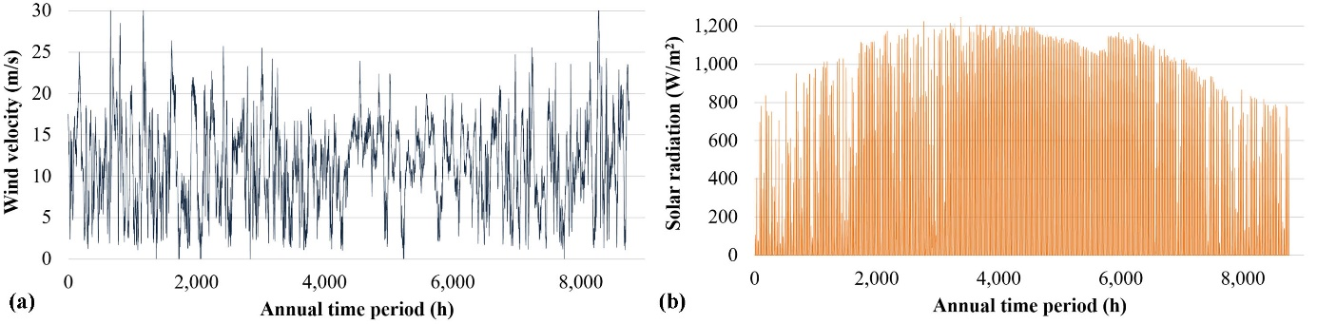
Figure 12: Annual time series of the employed wind velocity and the Global Horizontal Irradiance measurements.

Summarizing the above mentioned facts, we may conclude that Kastelorizo constitutes an ideal field for the introduction of hybrid power plants for the following reasons:
- the current, exclusive dependence of the electricity production on imported, expensive fossil fuels
- the currently formulated remarkably high electricity production specific cost
- the significantly low probability for the island’s electrical interconnection
- the considerable available wind potential and solar radiation.

4.2. The introduced hybrid power plant
The size of the power demand and the annual electricity consumption in Kastelorizo does not justify the introduction of a PHS system, despite the favourable land morphology in the island. The introduction of lead acid or lithium-ion batteries has been also investigated in former articles [5, 35], giving relatively high set-up costs and low storage capacities, which, in turn, impose short autonomy operation periods. Hence, the specific insular system features as an excellent case for the introduction of a hybrid power plant supported by a CAES system.
In Figure 11 the proposed location for the installation of the wind park is also shown, accounting, apart from the available wind potential, the positions of the airport and the existing on-shore human activities, limited within the unique settlement’s boundaries. The proposed location is on a mountain ridge, open from the north west to the sea, accepting, thus, the wind from its prevailing blowing direction straight from the open sea, undiminished from any physical or technical obstacles. At the same location, any required photovoltaic plant can be also installed, as well as the CAES system.
The hybrid power plant is introduced aiming at the maximisation of the annual RES penetration. To this end, the achievement of annual RES penetration percentage higher than 80% is set as the major dimensioning criterion, of course ensuring, concurrently, the economic feasibility of the investment, evaluated by specific economic indices.
For the dimensioning of the hybrid power plant, the process presented in section 3 is applied. The required data for the realization of the proposed algorithm and the applied process are:
- The power demand annual time series, with hourly average values, presented in Figure 10.
- The annual wind velocity time series with hourly average values, presented in Figure 12a.
- The annual total incident solar radiation time series with hourly average values, presented in Figure 12b.
- A wind turbine power curve, for the calculation of the annual wind power production time series on hourly step, versus the available wind velocity. For this reason, given the size of the system, the Enercon E-33 / 330 kW wind turbine power curve was introduced.
- Given the available solar radiation time series, the final electrical power output per kW of installed photovoltaic panels is calculated, by applying the fundamental calculation procedure, described thoroughly in [36, 37].
- The compressor’s and turbine’s characteristic charts presented in Figures 7 and 8 are also introduced, so as the process presented in section 3.3 could be applied. In this way, the corresponding compressor’s and turbine’s models are introduced.
- Given the size of the system, several executions were carried out regarding the capacity and the nominal pressure of the air storage tank, so as it can support annual RES penetration in the island higher than 80%. It was eventually concluded that an air storage tank with 20,000 m³ volume capacity and a nominal pressure of 10 bars will be required. As an initial condition, the air pressure in tank at the beginning of the calculation (1st hour of the annual period) is set equal to 5 bars.
- Finally, the maximum RES penetration percentage p_{max} is set equal to 40% versus the current power demand.
The simulation of the hybrid plant’s annual operation is executed iteratively, by applying the proposed operation algorithm and the process described in section 3.3, varying, each time, the nominal power of the installed RES technologies (wind park and photovoltaic station), as well as the compressor’s and the turbine’s units number and keeping the size of the air storage tank the same. A relevant software application was also developed, for the realization of this process and the introduced operation algorithm. The results of some indicative scenarios are presented in Table 2.
As seen in Table 2, the major criterion of annual RES penetration above 80% is achieved with the scenarios 3, 5 and 6 and almost achieved with the scenario 2. Hence, the optimum dimensioning scenario will be imposed by the economic evaluation, presented in the next section.
What is very impressive from the results presented in Table 2 is the high RES surplus occurred when a second compressor unit is introduced. This is because with the second compressor unit there is always the option to approach higher operation efficiencies, requiring, thus, less electricity input from the RES units and leading, eventually, to higher RES surplus. Of course, this significant RES surplus can be exploited with the introduction of additional electrical loads in the grid, such as desalination plants, new stock farming or agricultural activities, creating the perspectives towards the sustainable development of the local community, reducing its dependence on tourism [3, 38]. This issue is beyond the scope of this article.

Table 2: Dimensioning procedure results.
Magnitude | Dimensioning scenario
Magnitude | 1 | 2 | 3 | 4 | 5 | 6
Wind turbines number | 4 | 4 | 4 | 5 | 5 | 5
Wind park power (MW) | 1.32 | 1.32 | 1.32 | 1.65 | 1.65 | 1.65
Photovoltaic station power (MW) | 0 | 1.0 | 1.0 | 0 | 0.5 | 0.5
Compressor units | 1 | 1 | 2 | 1 | 1 | 2
Turbine units | 1 | 1 | 1 | 1 | 1 | 1
Annual energy results
RES direct penetration (MWh) | 1,159 | 1,274 | 1,274 | 1,188 | 1,279 | 1,278
Turbine production (MWh) | 1,190 | 1,513 | 1,615 | 1,441 | 1,540 | 1,554
Back-up units production (MWh) | 1,161 | 723 | 621 | 881 | 691 | 678
Total production (MWh) | 3,510 | 3,510 | 3,510 | 3,510 | 3,510 | 3,510
Electricity storage (MWh) | 4,191 | 5,230 | 4,125 | 5,117 | 5,497 | 4,266
RES rejection (MWh) | 152 | 395 | 1,474 | 573 | 788 | 2,018
Thermal energy consumed for compressed air heating (MWh) | 11,484 | 13,884 | 14,215 | 12,888 | 13,757 | 13,590
Diesel oil consumed for compressed air heating (kL) | 1,120 | 1,355 | 1,387 | 1,257 | 1,342 | 1,326
R.E.S. penetration (%) | 66.9 | 79.4 | 82.3 | 74.9 | 80.3 | 80.7
R.E.S. production surplus (%) | 2.7 | 5.7 | 21.4 | 8.3 | 10.4 | 26.7

5. Economic evaluation

6. Conclusions

References
- https://ec.europa.eu/energy/en/topics/energy-strategy-and-energy-union/clean-energy-eu-islands (last accessed on 18/7/2019).
- D. Al. Katsaprakakis, D. G. Christakis. Maximisation of R.E.S. penetration in Greek insular isolated power systems with the introduction of pumped storage systems. European Wind Energy Conference and Exhibition 2009; 7: 4918-4930.
- Dimitris Al Katsaprakakis, Manolis Voumvoulakis. A hybrid power plant towards 100% energy autonomy for the island of Sifnos, Greece. Perspectives created from energy cooperatives. Energy 2018; 161: 680-698.
- Dimitris Al Katsaprakakis, Bjarti Thomsen, Irini Dakanali, Kostas Tzirakis. Faroe Islands: Towards 100% R.E.S. penetration. Renewable Energy 2019; 135, 473-484.
- Dimitris Katsaprakakis, Irini Dakanali. Comparing electricity storage technologies for small insular grids. Energy Procedia 2019; 159: 84-89.
- Dimitris Al. Katsaprakakis, Dimitris G. Christakis. A wind parks, pumped storage and diesel engines power system for the electric power production in Astypalaia. European Wind Energy Conference and Exhibition 2006; 1: 621-636.
- C. Bueno, J.A. Carta. Wind powered pumped hydro storage systems, a means of increasing the penetration of renewable energy in the Canary Islands. Renewable and Sustainable Energy Reviews 2006; 10: 312-340.
- M. Kapsali, J.S. Anagnostopoulos, J.K. Kaldellis. Wind powered pumped-hydro storage systems for remote islands: A complete sensitivity analysis based on economic perspectives. Applied Energy 2012; 99: 430-444.
- Fontina Petrakopoulou. On the economics of stand-alone renewable hybrid power plants in remote regions. Energy Conversion and Management 2016; 118: 63-74.
- Daniele Groppi, Davide Astiaso Garcia, Gianluigi Lo Basso, Fabrizio Cumo, Livio De Santoli. Analysing economic and environmental sustainability related to the use of battery and hydrogen energy storages for increasing the energy independence of small islands. Energy Conversion and Management 2018; 177: 64-76.
- E. M. G. Rodrigues, R. Godina, J. P. S. Catalão. Modelling electrochemical energy storage devices in insular power network applications supported on real data. Applied Energy 2017; 188: 315-329.
- P. Blechinger, C. Cader, P. Bertheau, H. Huyskens, R. Seguin, C. Breyer. Global analysis of the techno-economic potential of renewable energy hybrid systems on small islands. Energy Policy 2016; 98: 674-687.
- Youssef Mazloum, Haytham Sayah, Maroun Nemer. Dynamic modeling and simulation of an Isobaric Adiabatic Compressed Air Energy Storage (IA-CAES) system. Journal of Energy Storage 2017; 11: 178-190.
- Lukasz Szablowski, Piotr Krawczyk, Krzysztof Badyda, Sotirios Karellas, Emmanuel Kakaras, Wojciech Bujalski. Energy and exergy analysis of adiabatic compressed air energy storage system. Energy 2017; 138: 12-18.
- Naser M. Jubeh, Yousef S. H. Najjar. Green solution for power generation by adoption of adiabatic CAES system. Applied Thermal Engineering 2012; 44: 85-89.
- Omar Ramadan, Siddig Omer, Yate Ding, Hasila Jarimi, Xiangjie Chen, Saffa Riffat. Economic evaluation of installation of standalone wind farm and wind + CAES system for the new regulating tariffs for renewables in Egypt. Thermal Science and Engineering Progress 2018; 7: 311-325.
- Jinyang Fan, Wei Liu, Deyi Jiang, Junchao Chen, William Ngaha Tiedeu, Jie Chen, Deaman JJK. Thermodynamic and applicability analysis of a hybrid CAES system using abandoned coal mine in China. Energy 2018; 157: 31-44.
- Federico de Bosio, Vittorio Verda. Thermoeconomic analysis of a Compressed Air Energy Storage (CAES) system integrated with a wind power plant in the framework of the IPEX Market. Applied Energy 2015; 152: 173-182.
- Tomás P. L. Camargos, Daniel L. F. Pottie, Rafael A. M. Ferreira, Thales A. C. Maia, Matheus P. Porto. Experimental study of a PH-CAES system: Proof of concept. Energy 2018; : 165, Part A: 630-638.
- Saber Sadeghi, Ighball Baniasad Askari. Prefeasibility techno-economic assessment of a hybrid power plant with photovoltaic, fuel cell and Compressed Air Energy Storage (CAES). Energy 2019; 168: 409-424.
- Bernardo Llamas, Carlos Laín, M. Cruz Castañeda, Juan Pous. Mini-CAES as a reliable and novel approach to storing renewable energy in salt domes. Energy 2018; 144: 482-489.
- S. Rehman, et al. Feasibility study of a wind–pv–diesel hybrid power system for a village. Renewable Energy 2012; 38: 258–268.
- D. Zafirakis, J. K. Kaldellis. Autonomous dual-mode CAES systems for maximum wind energy contribution in remote island networks. Energy Conversion and Management 2010; 51: 2150-2161.
- D. Zafirakis, J. K. Kaldellis. Economic evaluation of the dual mode CAES solution for increased wind energy contribution in autonomous island networks. Energy Policy 2009; 37: 1958-1969.
- S. Karellas, N. Tzouganatos. Comparison of the performance of compressed-air and hydrogen energy storage systems: Karpathos island case study. Renewable and Sustainable Energy Reviews 2014; 29: 865-882.
- L. Sheng, Z. Zhou, J. F. Charpentier, M. E. H. Benbouzid. Stand-alone island daily power management using a tidal turbine farm and an ocean compressed air energy storage system. Renewable Energy 2017; 103: 286-294.
- R. Cazzaniga, M. Cicu, M. Rosa-Clot, P. Rosa-Clot, C. Ventura. Compressed air energy storage integrated with floating photovoltaic plant. Journal of Energy Storage 2017; 13: 48-57.
- Crotogino F.KBB Underground Technologies GmbH, Hannover, Compressed Air Storage, Internationale Konferenz “Energieautonomie durch Speicherung Erneuerbarer Energien”, 30–31. Oktober 2006.
- S. Karellas, N. Tzouganatos. Comparison of the performance of compressed-air and hydrogen energy storage systems: Karpathos island case study. Renewable and Sustainable Energy Reviews 2014; 29: 865-882.
- 2009 ASHRAE Handbook – Fundamentals (SI Edition); American Society of Heating, Refrigerating and Air-Conditioning Engineers, Inc. Chapter 6: Psychrometrics: Atlanta, GA, U.S.A., 2009.
- Joseph Hilsenralh, C. W. Beckett, W. S. Benedict, Lilla Fano, H. J. Hoge, J. F. Masi, R. L. Nuttoll, Y. S. Touloukian, and H. W. Woolley. Tables of thermal properties of gases. National Bureau of Standards Circular 564. Government Printing Office, Washington 25, D. C., U.S.A., 1955.
- Caichu Xia, Yu Zhou, Shuwei Zhou, Pingyang Zhang, Fei Wang. A simplified and unified analytical solution for temperature and pressure variations in compressed air energy storage caverns. Renewable Energy 2015; 74: 718-726.
- Meyer F. Integration von regenerativen Stromerzeugern. Druckluft-Speicherk- raftwerke, Projektinfo 05/2007.
- Greek Official Governmental Gazette 1873B/10-7-2014 (in Greek):
http://www.rae.gr/site/file/categories_new/about_rae/actions/decision/2014/2014_A0356?p=files&i=0 (last accessed on 18/7/2019).
- Dimitris Al. Katsaprakakis, Irini Dakanali, Constantinos Condaxakis, Dimitris G. Christakis. Comparing electricity storage technologies for small insular grids. Applied Energy 2019; 251: 113332.
- Ioannis E. Fragkiadakis. Photovoltaic systems. 1st ed. Thessaloniki: Ziti Editions; 2004 (in Greek).
- Dimitris Al. Katsaprakakis, Nikos Papadakis, George Kozirakis, Yiannis Minadakis, Dimitris Christakis, Konstantinos Kondaxakis. Electricity supply on the island of Dia based on renewable energy sources (R.E.S.). Applied Energy 2009; 86: 516-527.
- Dimitris Al. Katsaprakakis, Dimitris G. Christakis. The exploitation of electricity production projects from Renewable Energy Sources for the social and economic development of remote communities. The case of Greece: An example to avoid. Renewable and Sustainable Energy Reviews 2016; 54: 341-349.

Author responsible for correspondence at all stages of refereeing and publication

