HELLENIC MEDITERRANEAN UNIVERSITY
SCHOOL OF ENGINEERING
DEPARTMENT OF ELECTRICAL AND COMPUTER ENGINEERING

ARTIFICIAL NEURAL NETWORKS

Professor: George M. Papadourakis, Ph.D.

EXERCISES #3

- Below is a diagram of a self–organizing map:
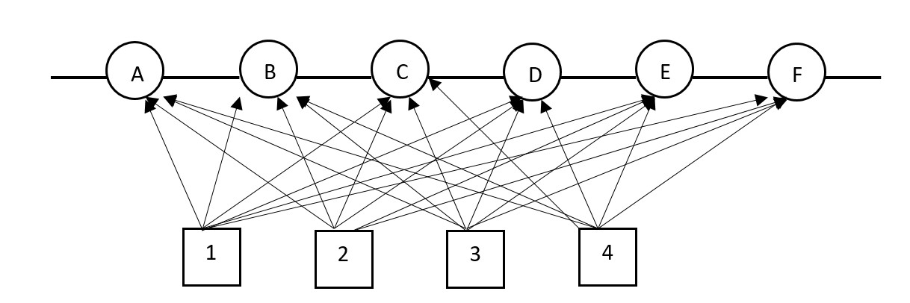
Answer the following questions:
- How many input nodes does this SOM have?
- How many output nodes does this SOM have?
- How many dimensions are in the input space that this SOM is analyzing?
- How many weights does each of the output nodes have?
- How many dimensions does the output lattice of this SOM have?
- How many output nodes can fire simultaneously?
- Is it important what value the output node sends when it fires?
- How many clusters can this SOM detect in the input data?
- If node D is the winner, which output nodes are its immediate neighbors?

- Consider the following self–organizing map:

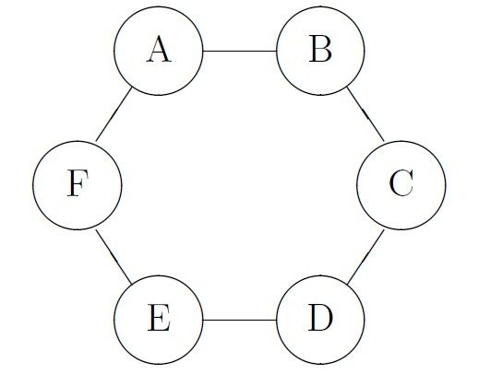

The output layer of this map consists of six nodes, A, B, C, D, E and F, which are organized into a two–dimensional lattice. Each of the output nodes has two inputs $x_{1}$ and $x_{2}$ (not shown on the diagram). The values of the weights for all output in the SOM nodes are given in the table below:

Node | A | B | C | D | E | F
w₁ | 0.1 | 0 | 0.3 | -0.2 | 0.3 | -0.4
w₂ | 0.2 | 0.4 | -0.2 | -0.3 | 0.2 | 0.1

- Calculate which of the six output nodes is the winner if the input pattern is $x$ = (0.2,−0.4).
- After the winner for a given input x has been identified, the weights of the nodes in SOM are adjusted using adaptation formula:

$$w\left(t+1\right)=w\left(t\right)+ηh[x-w\left(t\right)]$$

where $η$ is the learning rate, and $h$ is the neighborhood function. Let $η=0.5$ and the neighborhood be defined as:

$$h=\left\{\begin{aligned} 1 if the node is the winner \\ 0.5 if the node is immediate neighbor \\ 0 otherwise \end{aligned}\right.$$

Adjust the weights in the SOM.

- What are the main similarities and differences between feed–forward neural networks and self–organizing maps?

- In a Kohonen neural net with 1000 constant training cycles and initial learning rate 0.15, in how many cycled the learning rate will become 0.03?

- Below is a diagram of a self–organizing map:
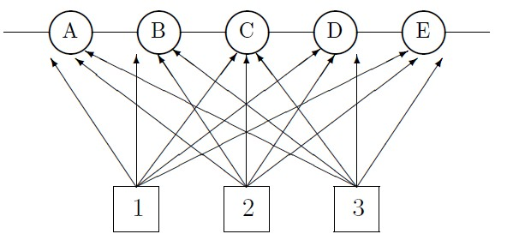
The SOM is used to classify types of airplanes based on three parameters: Size, speed and passenger load. The weights of the output nodes are shown in the table below:

Node | A | B | C | D | E
w₁ | 0.6 | 1.0 | 0.2 | 0.4 | 1.0
w₂ | 0.4 | 0.2 | 1.0 | 0.6 | 0.4
w₃ | 1.0 | 0.2 | 0.2 | 0.4 | 1.0

Each of the three parameters is assessed on a scale from 0.2 to 1. For example, small airplanes have size 0.2, while huge planes would have value 1. Each plane is represented as a three–dimensional vector with coordinates corresponding to these three parameters. Answer each of the following questions justifying your answers
- How many types of planes can this SOM classify?
- Which node will be the winner, if a vector representing a fighter jet (0.3,0.9,0.2), is fed into the input? Show your calculations.
- Which node will be the winner, if a vector representing a jumbo passenger jet (0.9,0.5,0.9), is fed into the input? Show your calculations.

