Search for scientific publications in popular scientific repositories
(Αναζήτηση Δημοσιεύσεων σε δημοφιλείς επιστημονικές βάσεις)
  - M Tsiknakis, Oct 2025
The following is a presentation of how to search for literature in some of the popular scientific publication databases for engineers.

IEEE Xplore
https://ieeexplore.ieee.org/search/advanced
- Use the search function of the database
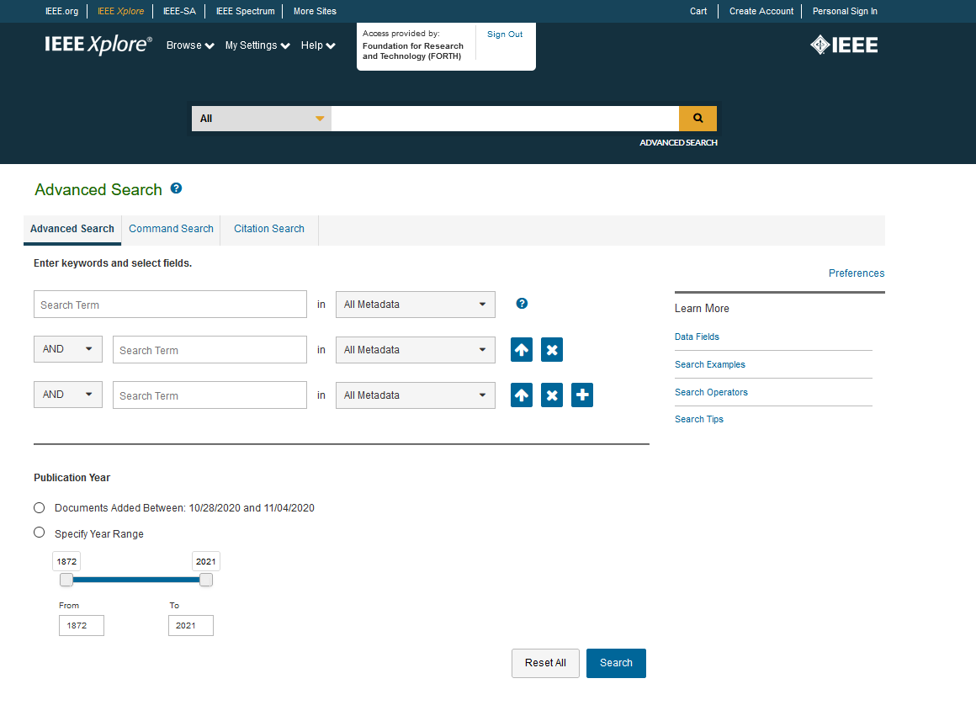

2. Query Formulation
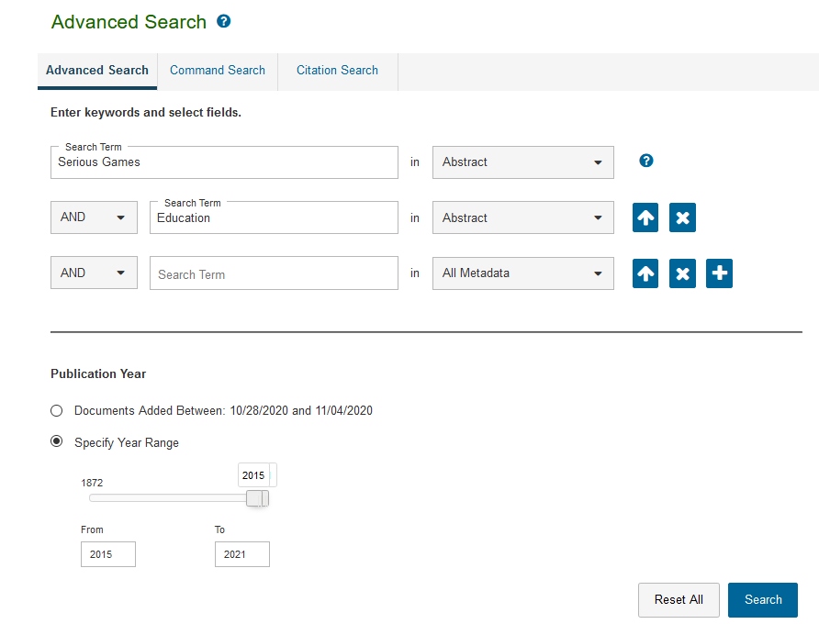
3. Query Results
170 results


Scopus
https://www.scopus.com/search/form.uri?display=basic
You will need to access Scopus from the Institutional Network, so that HEALlink is used – making sure that you are legal user from one of the Academic or Research organisations paying through HEALlink the subscription to ELSEVIER (Scopus).
- Use the search function of the database
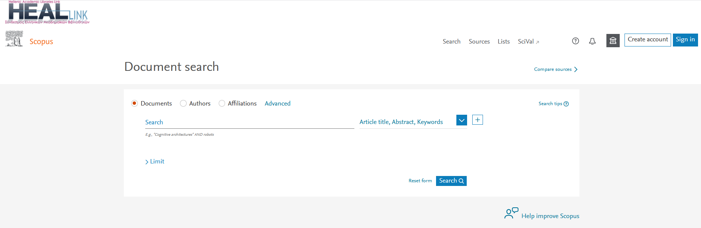
2. Query Formulation
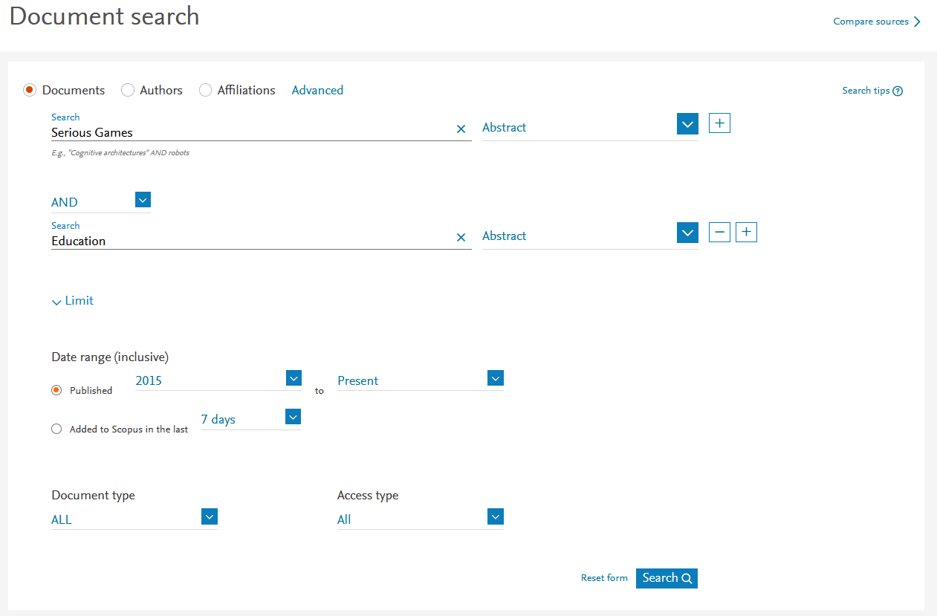

3. Query Results
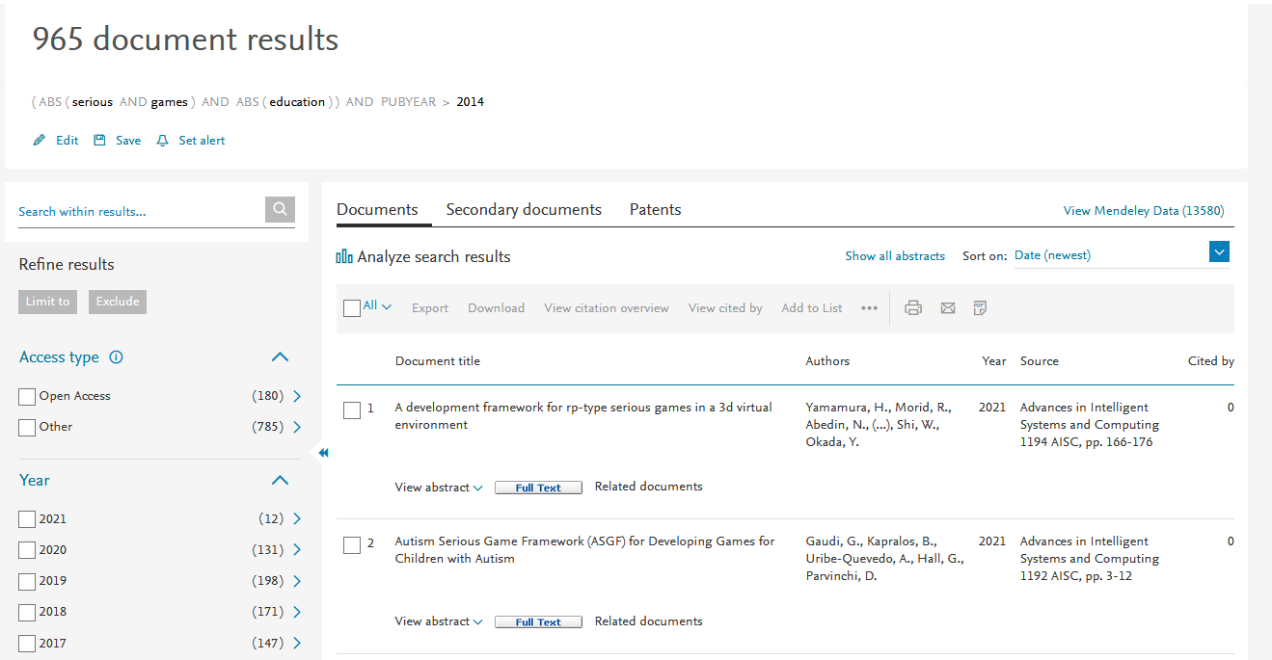

ACM Digital Library
https://dl.acm.org/search/advanced

- Use the search function of the database
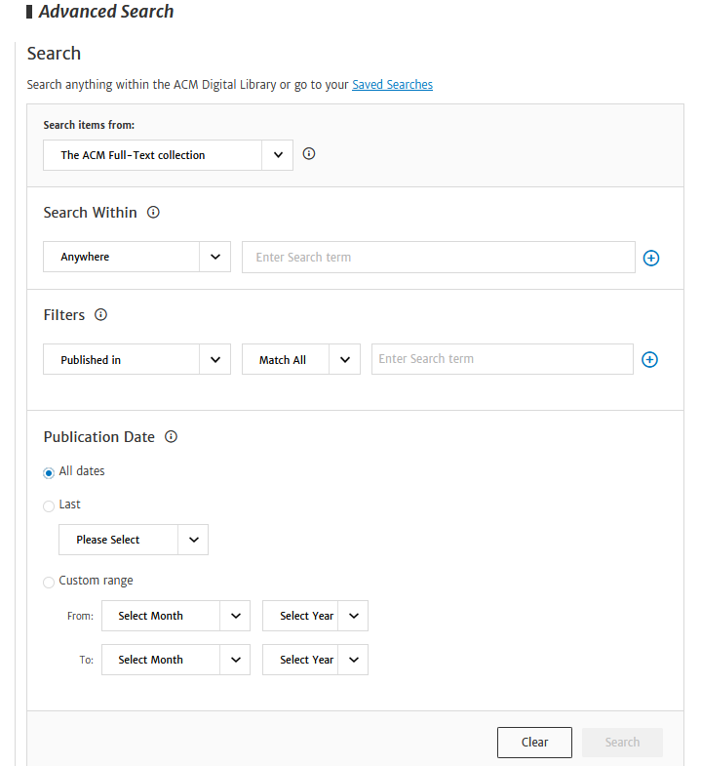

2. Query Formulation
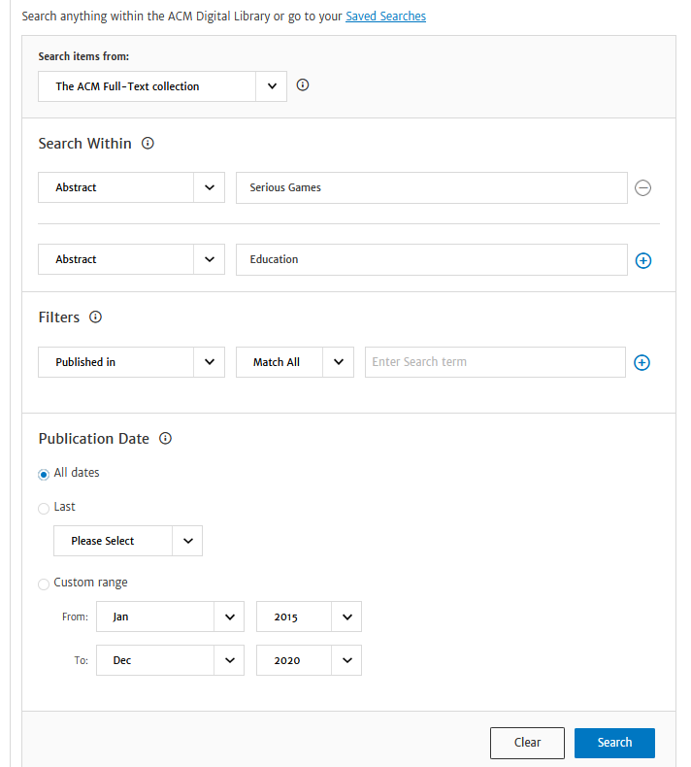
3.Query execution
849 results
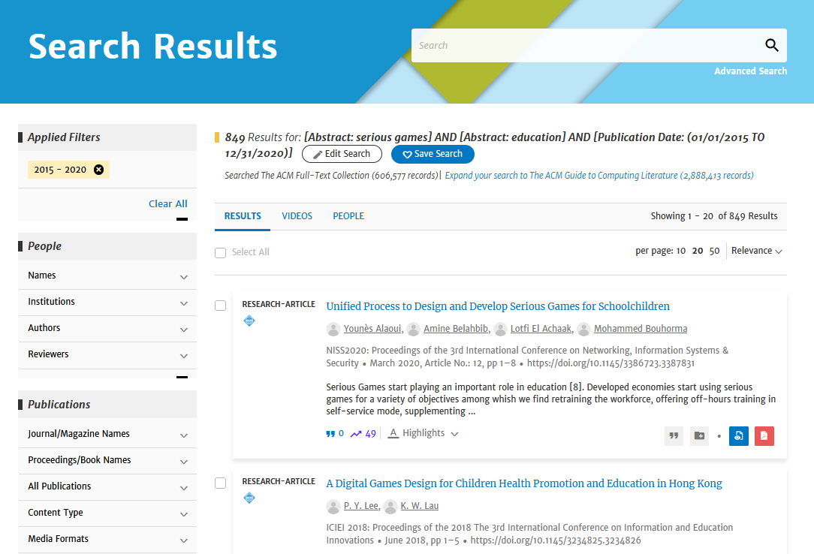

Medline (PubMed)
https://pubmed.ncbi.nlm.nih.gov/advanced/
- Use the search function of the database
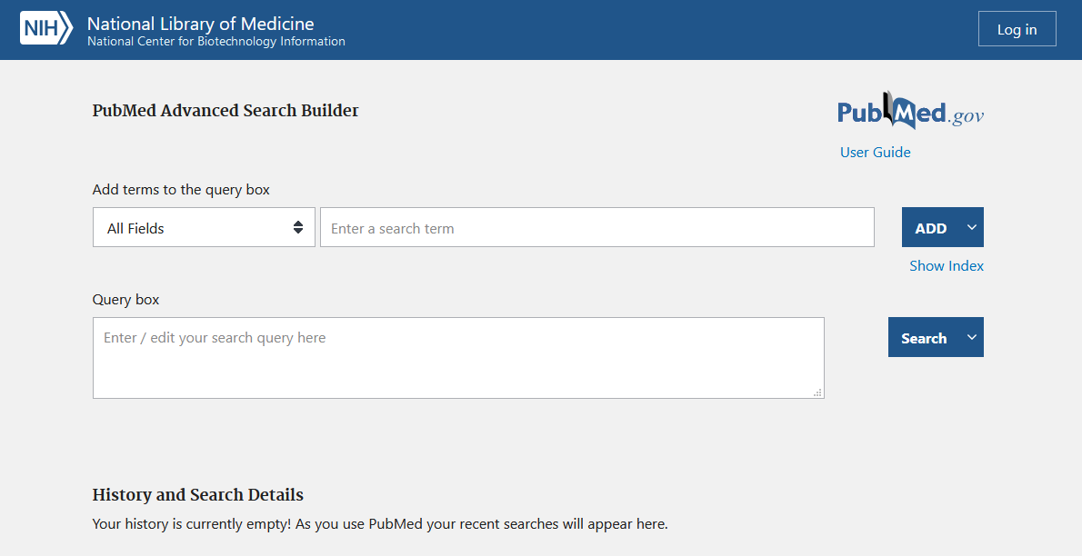
2. Query Formulation
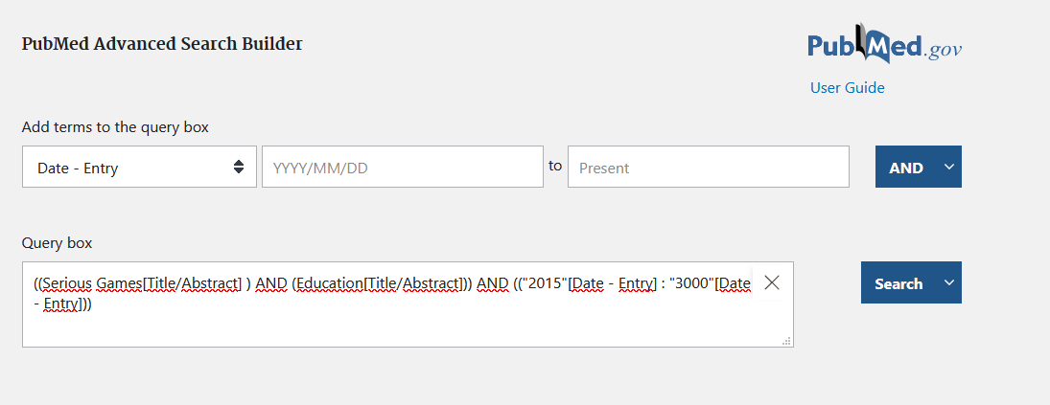
3. Query Results
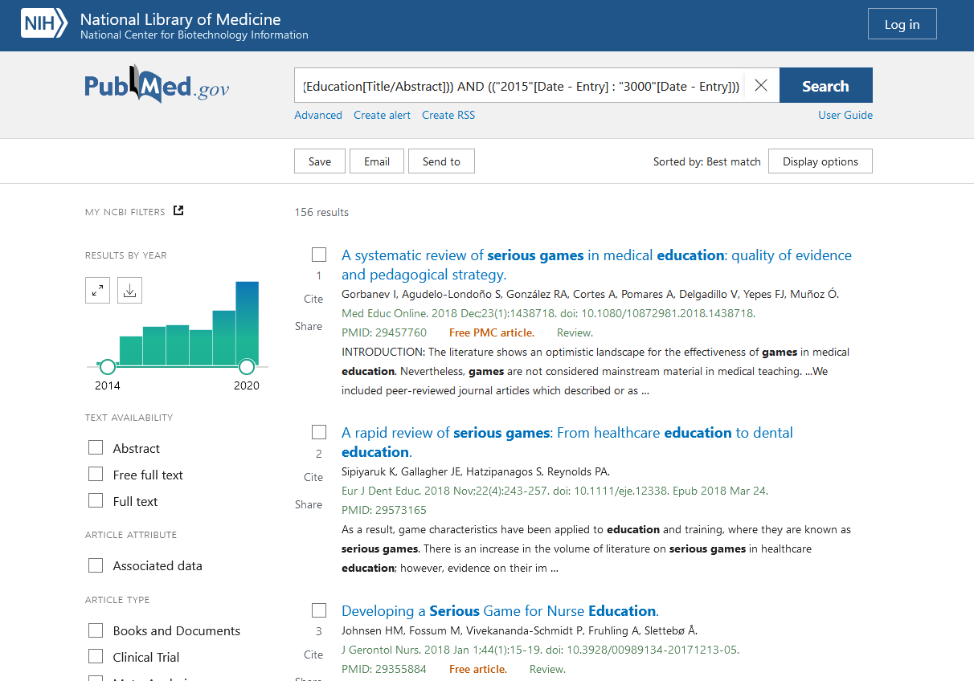
4. Save Results
