

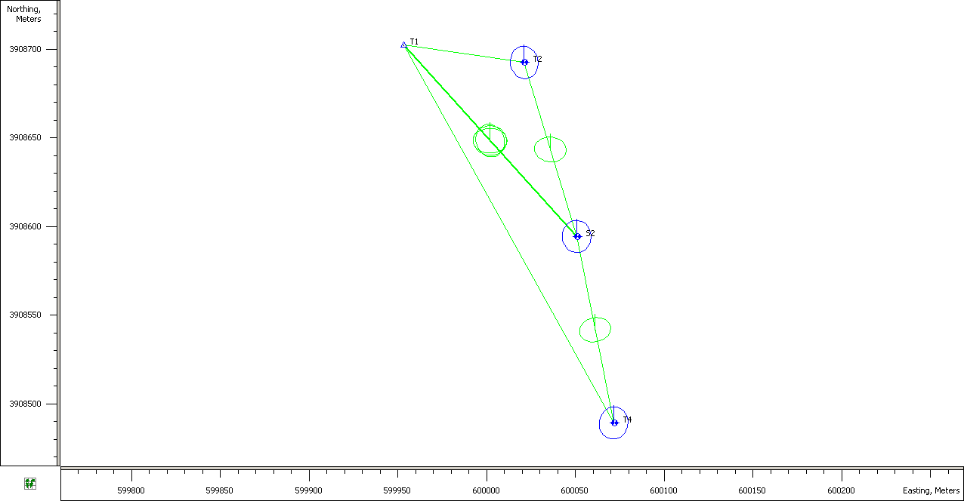
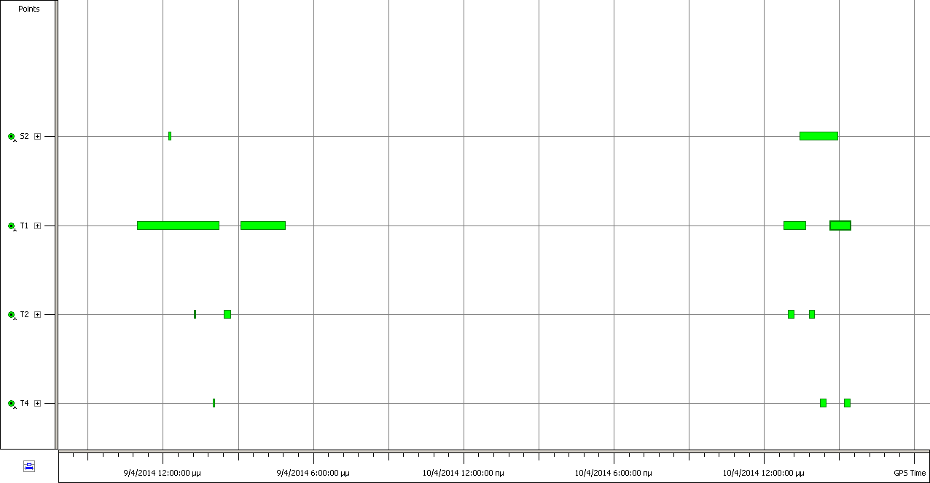

Adjustment Summary
Adjustment type: Plane + Height, Minimal constraint
Confidence level: 95 %
Number of adjusted points: 4
Number of plane control points: 1
Number of used GPS vectors: 7
A posteriori plane UWE: 1.293373 , Bounds: ( 0.5220153 , 1.480287 )
Number of height control points: 1
A posteriori height UWE: 1.949305 , Bounds: ( 0.3478505 , 1.668832 )
Used GPS Observations
Name | dN (m) | dE (m) | dHt (m) | Horz RMS (m) | Vert RMS (m)
S2−T1 | 108.076 | -97.506 | -14.408 | 0.006 | 0.011
S2−T1 | 108.071 | -97.515 | -14.458 | 0.005 | 0.011
S2−T1 | 108.082 | -97.513 | -14.424 | 0.004 | 0.006
S2−T2 | 98.142 | -29.534 | -10.669 | 0.001 | 0.003
S2−T4 | -105.154 | 20.742 | -6.990 | 0.001 | 0.002
T1−T2 | -9.931 | 67.981 | 3.751 | 0.006 | 0.009
T1−T4 | -213.224 | 118.256 | 7.452 | 0.003 | 0.006
GPS Observation Residuals
Name | dN (m) | dE (m) | dHt (m) | Horz RMS (m) | Vert RMS (m)
S2−T1 | 108.076 | -97.506 | -14.408 | 0.006 | 0.011
S2−T1 | 108.071 | -97.515 | -14.458 | 0.005 | 0.011
S2−T1 | 108.082 | -97.513 | -14.424 | 0.004 | 0.006
S2−T2 | 98.142 | -29.534 | -10.669 | 0.001 | 0.003
S2−T4 | -105.154 | 20.742 | -6.990 | 0.001 | 0.002
T1−T2 | -9.931 | 67.981 | 3.751 | 0.006 | 0.009
T1−T4 | -213.224 | 118.256 | 7.452 | 0.003 | 0.006

Control Points
Name | Grid Northing (m) | Grid Easting (m) | Elevation (m) | Code
T1 | 3908702.485 | 599953.131 | 56.845
Adjusted Points
Name | Grid Northing (m) | Grid Easting (m) | Elevation (m) | Code
S2 | 3908594.410 | 600050.643 | 71.286
T2 | 3908692.552 | 600021.110 | 60.609
T4 | 3908489.257 | 600071.386 | 64.305

GPS Occupations
Point Name | Original Name
T1 | T1
T1 | T1
T2 | T2
T1 | T1
T1 | T1
T2 | T2
T4 | T4
T4 | T4
S2 | S2
T2 | T2
T2 | T2
T4 | T4
T2 | T2
S2 | S2

Name | Grid Northing (m) | Grid Easting (m) | Elevation (m) | Std Dev n (m) | Std Dev e (m) | Std Dev Hz (m) | Std Dev u (m) | Code | Convergence
S2 | 3908594.41 | 600050.643 | 71.286 | 0.002 | 0.002 | 0.003 | 0.007 |  | 0°38'10.7269"
T1 | 3908702.485 | 599953.131 | 56.845 | 0 | 0 | 0 | 0 |  | 0°38'08.5772"
T2 | 3908692.552 | 600021.11 | 60.609 | 0.003 | 0.002 | 0.004 | 0.009 |  | 0°38'10.1257"
T4 | 3908489.257 | 600071.386 | 64.305 | 0.002 | 0.002 | 0.003 | 0.008 |  | 0°38'11.1214"

