FarmIT – smart farm management IT system
Develop a low-cost digital assistant to farmers looking to be more sustainable and ethical. Develop an integrated system able to manage the use of water, watering, and fertigation. Providing visual maps of the farm with production, amount of water and fertilizers used.

Company
Sociedade Agricola Casal da Cotovia, Lda
Its family owned grower of Blueberries. It operates 100% under organic agriculture principles and certifications. It has a strong compromise with sustainability: environmental, social and economical.
INIAV is the State Laboratory, in the area of competences of Agriculture, Forestry and Rural Development, which develops research activities in the agronomic and veterinary areas, https://www.iniav.pt/

Contact person
Filipe Sampaio Rodrigues, Sampaio.rodrigues@gmail.com

Project brief description
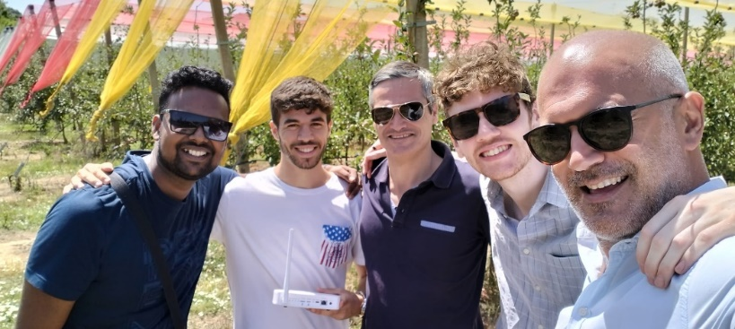
Efficient use of water and zero-waste agriculture
Develop a low-cost digital assistant to farmers looking to be more sustainable and ethical.
Objective is to develop an integrated system composed of:
- meteorological stations
- connection to public weather forecasting platforms
- soil moisture sensors: reliable, low cost, with long-distance radio communication, with low energy consumption
- fertilizer sensors in the soil: reliable, low cost, with long distance radio communication, with low energy consumption
- electro conductivity sensors of water and wastewater
- flow and pressure sensors in irrigation ducts
- water level sensors in tanks, ponds and wells
- server with A.I. algorithm that "learns", improving its performance with each cycle and each iteration
Able to manage the use of water, watering and fertigation. Providing visual maps of the farm with: production, amount of water and fertilizers used, etc.

